启用前绝密 考试时间：2020 年5 月29 日15:00-17:00

成都七中高 2020 届高三“三诊”模拟考试
英 语
考试时间：120 分钟 满分：150 分

注意事项：
- 答题前，考生务必将自己的学校、姓名、班级、准考证号填写在答题卡上相应的位置；
- 全部答案在答题卡上完成，答在本试题上无效；
- 回答选择题时，选出每小题答案后，用2B铅笔把答题卡上对应题目的答案标号涂黑。如需改动，用橡皮擦干净后，再选涂其他答案标号。回答非选择题时，将答案用0.5毫米黑色笔迹签字笔写在答题卡上。

第一部分 听力（共两节，满分 30 分）第一节（共 5 小题；每小题 1.5 分，满分 7.5 分）听下面 5 段对话。每段对话后有一个小题，从题中所给的 A 、B、 C 三个选项中选出最佳选
项。听完每段对话后，你都有 10 秒钟的时间来回答有关小题和阅读下一小题。每段对话仅读一遍。例：How much is the shirt?
A. £ 19. 15. B. £ 9. 18. C. £ 9. 15.
答案是 C。
- What do we know about the man? A. He wants to read more books.
  - He gets high marks at school.
  - He doesn’t agree with the woman.
- Who is the man?
  - The woman's husband. B. The woman's boss. C. A policeman.
- Where is the bus station?
  - It's near the post office.
  - It’s two blocks down the street.
  - It’s on the right side of the street.
- To whom is the woman probably speaking?
  - A salesman. B. A manager. C. A repairman.
- What is the woman’s advantage to do the job? A. She has a lot of kids.
  - She has work experience.
  - She is strong enough for the job.
第二节（共 15 小题；每小题 1.5 分，满分 22.5 分）
听下面 5 段对话或独白。每段对话或独白后有几个小题，从题中所给的 A、B、C 三个选项中
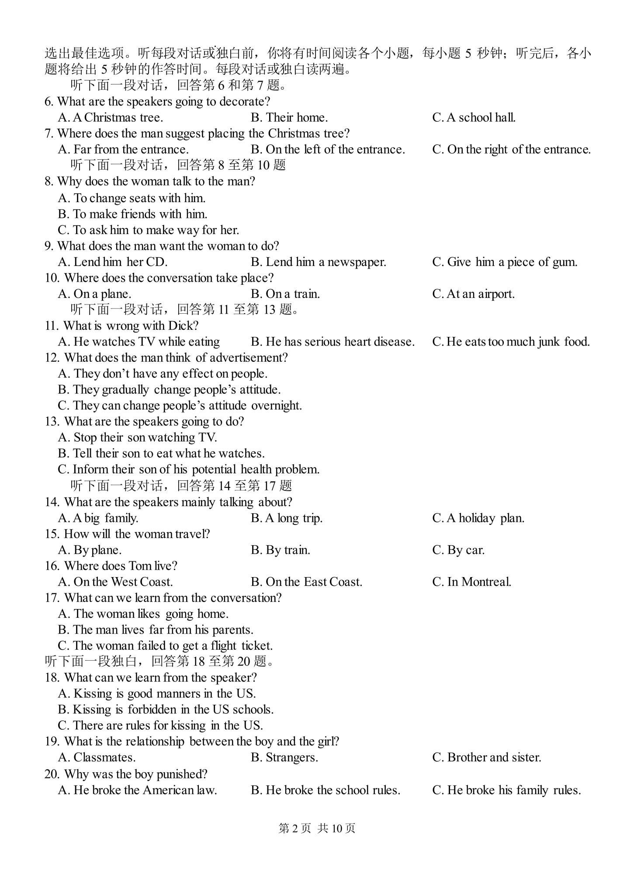

第二部分阅读理解（共两节，满分 40 分）
第一节（共 15 小题；每小题 2 分，满分 30 分）阅读下列短文，从每题所给的四个选项（A、B、C 和 D）中，选出最佳选项，并在答题卡上将该项涂黑。
A
SALISBURY
Summer School
2020 TRAVEL FORM
Please complete and return
Student’s Name:________ Cell number: ________
Travel Plans: Please specify the means of traveling to and from the school.
Students traveling with parents by car should plan to arrive on Sunday, July 1 and depart Salisbury School on Saturday, August 4, the next day after Progress Day. Please indicate:
Students will be arriving and departing with parents.
Students will be traveling by train or bus to/from the school.
New York City — via Train:
(Metro-North Railroad — Harlem Line: Wassaic Station & Grand Central Station)
The Wassaic Station is the closest to the school — approximately 10 miles. Contact information: 845473-8424 or http:// www.mta.info/mnr.
Bus Line from NYC:
The Bonanza bus stop in Canaan, CT is approximately 5 miles from the school. Schedules can be accessed at http://www.bonanza-bus.transit-info.com.
Local Taxi Services:
Lakeville Taxi 860-435-8000 and 800-675-0670
Airport Pickup, Saturday, June 30
Please note: My child will travel to JFK Airport (New York City) where a Salisbury representative will pick students up.
The shuttle (班车) will leave from JFK at 6 o’clock in the afternoon for the return to Salisbury. Please provide all flight information in the space below including the cell phone contact number for your child. We will provide the cell phone number of the representative later. This is the preferred arrival date for all students from home and abroad traveling through JFK, which can be guaranteed by taking the airplane.
Airline & Flight # :_________ NYC Arrival time:_________
Please note: My child will depart on August 4 by shuttle through JFK.
Depending on flight times, students may experience a long wait for their flight departures. Airline & Flight # :_________ Departure time:_________
- What day is Progress Day?
  - Thursday. B. Friday. C. Saturday. D. Sunday.
- What should students keep in mind to take the shuttle on June 30?
  - Booking a bus ticket in advance. B. Arriving before 6 pm.
C. Waiting for a long time in the airport. D. Choosing a Salisbury representative.
- Whom is this form mainly intended for?
  - The students’ parents. B. Teachers of the school.
C. The driver of the shuttle. D. Home and foreign students.
B
Recently, a group of scientists decided to find out what the funniest joke in the world was. This was obviously a difficult task, as no two people really agree about what is funny and what is not—especially when they are from different countries.
Here is the joke which the experts decided was the funniest joke in the world：
Two hunters were out in the woods. One of them fell to the ground. He didn’t seem to be breathing; his eyes were closed. The other hunter took out his mobile phone and called the emergency services.
“My friend is dead!” he cried to the operator. “What can I do？”The operator said，“Don’t worry. First, make sure he’s dead.” There was a silence, and then a shot was heard. Bang! The hunter’s voice came back on the line. He said, “OK, now what?”
This is perhaps amusing. Culturally, it depends on us knowing that often hunters are not considered to be very intelligent people, and that often they are quite violent. But perhaps this is not so all over the world. It’s also quite a “black” joke—a joke about something which isn’t really a funny subject. The experts also found the second funniest joke in the world. Here it is：
Sherlock Holmes and Dr. Watson went on a camping trip. After dinner, they went to sleep. Some hours later, Holmes woke up. “Watson, look up at the sky and tell me what you see.” “I see millions of stars, Holmes,” replied Watson.
“And what do you infer from that? ”
“Well, there are billions of stars ... we are a small part of the universe ...”
“Watson, you idiot!” he said. “Someone has stolen our tent!” I personally think this is better.
Can scientists in the end decide what is funny? Some things are much too complicated, even for scientists.
- What can we learn from the first paragraph? A. Few jokes can make scientists laugh.
  - Only scientists can find out the funniest joke.
  - There are different jokes in different countries.
  - People hold different opinions about what is funny.
- What does the author think of the first joke? A. It is not so funny as the experts thought.
  - It is really the funniest joke he has ever heard.
  - It can greatly affect readers’ attitudes toward hunters.
  - It shows that not all hunters are brave and intelligent.
- We can learn that a person’s understanding of a joke can be affected by ________.
A. the reader’s feeling B. the length of the joke
C. the reader’s cultural background D. the language that the teller uses 27. Which of the following is the best title for this passage?
A. Uninteresting jokes B. Different kinds of jokes
C. The funniest jokes in the world D. Tips on how to make others laugh C
While astronauts in space get to do many exciting things, they miss out on ordinary things that we all take for granted—being able to walk on firm ground, hanging out with family and digging into a slice of hot steaming pizza. Though not much can be done about the first two things, there may soon be a solution to the third one, thanks to this cool 3-D pizza printer!
About a year ago，NASA offered $125,000 to Anjan Contractor，a 3-D technology expert, to build a device that would allow astronauts to make pizza on demand. The mechanical engineer promised that his invention would produce pies in large quantities that looked, tasted and even smelled like pizza made in common ovens.
Late last year, the engineer presented a video of his first prototype(原型) that begins by creating a single slice of dough (面团) that is cooked and printed at the same time. Then comes the tomato “sauce”— a mix of tomato powder，oil and water and finally, a protein slice that resembles cheese. While the video doesn’t show the baking process，the inventor says that once the pizza is printed，it can be ready to be consumed in 7 seconds.
While the pie in the video looks delicious enough to attract any pizza lover, Anjan Contractor is far from ready for astronauts. That’s because he still has to find a solution to make the food container in the printer last for 30 years. Though that may sound unrealistic, actually it is not.
Anjan Contractor believes that the only way that is possible is that the water is removed from all the ingredients(配料) and then they are reduced to the powder form. This, as you can imagine, will not be so easy. But, while the printer may not be ready for space, it certainly looks ready enough for people on earth.
Hopefully，NASA and Contractor will consider selling it to those not fortunate enough to go to Mars!
- Why does the author mention the things that astronauts in space cannot do?
  - To ask us not to take common things for granted. B. To show they live a difficult life there.
C. To show their life is boring in space. D. To introduce the topic of the text.
- NASA offered $125,000 to Anjan Contractor mainly to ________.
  - create some new type of 3-D printer
  - attract more companies to work for NASA
  - help astronauts in space enjoy fresh pizza one day
  - produce pizza in large quantities to earn great profits
- The biggest challenge that Anjan Contractor is faced with now is probably that ________.
  - he has no mone
  - y left to go on with his research
  - the pizza doesn’t seem appetizing to pizza lovers
  - he has no way to make pizza that can last for thirty years
  - he cannot make the food container last for decades
- What’s the best title of the passage?
  - NASA is trying its best to help astronauts eat better
  - Astronauts may soon be able to enjoy steaming hot pizza
  - NASA is working on making pizza for common people D. A 3-D pizza printer has been used to make pizza
D
Following the outbreak of the novel coronavirus pneumonia (NCP)，also named COVID-19 by WHO, there is a general fear of the unknown virus as its full effects remain to be seen. Fever, coughing, sore throat, difficulty breathing – the NCP’s symptoms are similar to the common cold or the flu, but it’s potentially more dangerous.
Viruses could be deadly, like HIV and Ebola. But what are viruses? How can they cause so much trouble?
Viruses are non-living organisms approximately one-millionth of an inch long. Unlike human cells or bacteria, they can’t reproduce on their own. Instead, they invade the cells of living organisms to reproduce, spread and take over.
Viruses can infect every living thing – from plants and animals down to the smallest bacteria. For this reason, they always have the potential to be dangerous to human life. Sometimes a virus can cause a disease so serious that it is fatal. Other viral infections trigger(引发) no noticeable reaction.
Viruses lie around our environment all of the time, waiting for a host cell to come along. They can enter our bodies by the nose, mouth, eyes or breaks in the skin. Once inside, they try to find a host cell to infect. For example, HIV, which causes AIDS, attacks the T-cells of the immune system.
But the basic question is, where did viruses first come from? Until now, no clear explanation for their origin exists. “Tracing the origins of viruses is difficult,” Ed Rybicki, a virologist at the University of Cape
Town in South Africa, told Scientific American, “because viruses don’t leave fossils and because of the tricks they use to make copies of themselves within the cells they’ve invaded.”
However, there are three main hypotheses (假说) to explain the origin of viruses. First, viruses started as independent organisms, then became parasites (寄生者). Second, viruses evolved from pieces of DNA or RNA that “escaped” from larger organisms. Third, viruses co-evolved with their host cells, which means they existed alongside these cells.
For the time being, these are only theories. The technology and evidence we have today cannot be used to test these theories and identify the most plausible explanation. Continuing studies may provide us with clearer answers. Or future studies may reveal that the answer is even murkier (含糊不清的) than it now appears.
- What can we learn about viruses from the text?
  - Viruses have nothing to do with the common cold.
  - Viruses are really small living organisms.
  - Viruses can’t reproduce unless they find a host cell.
  - Viruses enter our bodies mainly through the mouth, nose and hair.
- Which of the following might explain the origin of viruses? A. They evolved from the fossils of large organisms.
  - They evolved from parasites into independent organisms.
  - They evolved from the T-cells in animals.
  - They evolved along with their host cells.
- The underlined word “plausible” in the last paragraph probably means _______.
  - reasonable B. common C. creative D. unbelievable
- What can we conclude from the text?
  - Viruses live longer in human host cells than in animals’.
  - Viruses will become more like bacteria as they evolve.
  - It may take a long time to understand the origin of viruses.
  - The author is optimistic about future virus research.
第二节（共 5 小题；每小题 2 分，满分 10 分） 根据短文内容，从短文后的选项中选出能填入空白处的最佳选项。选项中有两项为多余选项。
Leonardo da Vinci and Nature
In the modern world, art and science are two very separate activities, but in Leonardo’s time they were closely connected. Science meant mathematics and medical studies. 36 Mathematics included practical work like surveying land for making maps as well as measuring the movements of the stars in the sky. An artist might need to measure the different parts of the body. He could also use mathematics to place things in relationship to each other in a drawing or painting so the scene looked correct. 37 Mathematics was also connected to music because musical sounds have a fixed relationship with each other that can be described in numbers. 38 More than this, though, Leonardo believed that numbers were a part of all things in the world, including music, and he said that “without them nothing can be done.”
“Nature has kindly given us things everywhere to copy,” wrote Leonardo. In all his activities, Leonardo was trying to discover the rules that control nature. In his search for those rules, he looked very carefully at a lot of examples and details. Actual experience was more important to him than opinion, and he worked from facts to ideas. 39 His purpose was to examine the world so he could copy it in beautiful paintings and sculptures. He also wanted to learn from the clever solutions of nature.
40 His quick little sketches, often done while wandering outside, helped him to catch a movement or a shape. More careful drawings would be done at a desk with a pen and ruler. In July 2001, a small drawing by Leonardo was sold for $12 million. It was the most expensive drawing in the world.

- Leonardo was always drawing.
- How could these be connected with art?
- Leonardo’s ideas were vastly ahead of his time.
- Mathematicians and doctors worked to discover the unknown.
- Above all, Leonardo wanted to understand how and why things worked.
- You will see a good example of such positioning in the painting of The Last Supper.
- Leonardo himself was a very good musician and liked to play an instrument and sing.

第三部分 英语知识运用（共三节，满分45分）第一节 完形填空（共20小题；每小题1.5分；满分30分） 阅读下面短文，从 A、B、C、D 四个选项中，选出可以填入空白处的最佳选项，并在答题卡上相应番号处将该项涂黑。
Throughout my life, I was never very athletic. I wasn’t really into 41 , sports or conflict. The only 42 I enjoyed were 43 things like watching TV and playing computer games. It was during my junior year in high school that I realized I needed a 44 . My friends were joining the long distance running club and 45 me to do it also. At my school, there were no qualification 46 ; every student was accepted.
As everyone gathered around on the first day of practice, the 47 announced it was time for “warm-up”. I imagined the warm-up would be a 48 jog around the 400-metre track. I soon 49 it was a 1-km run. After completing the run, I was 50 ! I wondered, “If that’s warm-up, what’s next?” The 51 workout for the day was a 5-km run, which I mostly walked. When I came home, I really considered 52 . However, I 53 myself to keep at it and try harder.
Of course, there was no real improvement 54 . I always came in last during practice and the first few 55 . As days and weeks went on, I really tried my best. During practice, I would always keep at the 56 of the group; the fastest, more 57 runners were always ahead, while the laziest were behind. As the result of my 58 , warm-up became a real warm-up. The 5-km runs transformed into an 59 day of practice. And I was no longer last in anything we did. For a former couch potato, like me, this was a(n) 60 .
41. A. rules B. arts | C. competition | D. schoolwork
42. A. procedures B. activities | C. lessons | D. programs
43. A. endless B. pointless | C. important | D. challenging
44. A. change B. rest | C. team | D. result
45. A. accompanied B. assisted | C. required | D. invited
- A. trials B. alternatives C. opportunities D. reasons
- A. competitor B. coach C. reporter D. referee
- A. hard B. boring C. practical D. casual
- A. decided B. suspected C. realized D. agreed
- A. sent off B. taken away C. turned down D. worn out
- A. real B. best C. expected D. fun
- A. complaining B. quitting C. crying D. refreshing
- A. convinced B. taught C. sent D. helped
- A. actually B. gradually C. separately D. instantly
- A. performances B. presentations C. races D. steps
- A. middle B. top C. front D. bottom
- A. popular B. confident C. serious D. relaxed
- A. inspiration B. determination C. loyalty D. contribution
- A. unimaginable B. avoidable C. easy D. optional
- A. exception B. example C. promotion D. success
第二节 （共 10 小题；每小题 1.5 分，满分 15分） 阅读下面材料，在空白处填入适当的内容（1 个单词）或括号内单词的正确形式。
Many people take the idea of saving money very seriously. Back in 1924, in Italy, a group of people 61.________ (think) the inability to resist spending a major social problem. They had the idea of starting a day to remind people to put away some money for a rainy day. This is how World Saving Day, held on Oct 31st 62.________(annual), was started, and it's still going strong in 2019.
Not surprisingly, a movement 63.________(target) the poor was started. People in the underdeveloped world are more open 64.________ calls to be careful with money. But 65.________ idea of being thrifty (节俭)has also become popular among the rich. Take Mark Zuckerberg for example. The Facebook founder, one of the world's 66.________(rich) people, doesn't spend very much money on himself.
Other people don't spend money because they don't like the culture of 67.________(consume). This is connected to the view 68.________ we should make ourselves happy through the activities we take part in, rather than with what we buy.
But however we view money, moderate spending is certainly a good idea when we are still too young to get a job. There is a British saying that 69.________(offer) some good advice in this situation: "Look after the pennies, and the pounds will look after 70.________(they)."

第四部分 写作（共两节，满分 35 分）第一节 短文改错（共 10 小题；每小题 1分，满分 10 分）假定英语课上老师要求同桌之间交换修改作文，请你修改你同桌写的以下作文，文中共有10
处语言错误，每句中最多有两处，每处错误仅涉及一个单词的增加、删改或修改。
增加：在缺词处加一个漏字符号（Λ），并在其下面写出该加的词。
删除：把多余的词用斜线（\）划掉。修改：在错的词下划一横线，并在该词下面写出修改后的词。
注意：1. 每处错误及其修改均仅限一词；
2. 只允许修改10处，多者（从第11处起）不计分。
On August 21, I was working on my homework, a composition titling "My Hero/Heroine". I stuck at the very beginning, trying to figure out what would be my hero/heroine.
Attracted by the cheers from the living room, I opened the door only to find my parents were watching the volleyball matches of women's final. Then I decided to take the break and joined in them. The sense of nervousness was overwhelming as the score was quite closely between China and its opponent.
To our delight, China won in the end. We couldn't help feel proud as Chinese! The volleyball players had trained so hard before and fight till the last minute. Without doubt, they were not only my heroines, and the heroines of China! I started to write my composition.

第二节 书面表达（满分25分）假如你是李华，你的新西兰笔友 Eric 在汉语演讲比赛中荣获一等奖。请你给他写一封祝贺信，
内容包括：
1. 表示祝贺； 2. 表扬他为此付出的努力；
3. 表达对他未来的祝愿。
参考词汇：汉语演讲比赛 the Chinese Speech Contest
注意：
- 词数 100 字左右；
- 可适当增加细节，以使行文连贯。

Dear Eric,
How’s everything going? ___________________________________________________________
_________________________________________________________________________________
_________________________________________________________________________________
_________________________________________________________________________________
_________________________________________________________________________________
_________________________________________________________________________________
_________________________________________________________________________________
_________________________________________________________________________________
Yours,
Li Hua

成都七中高2020届高三“三诊”模拟考试
参考答案
1-5 BCACB 6-10CBCBA 11-15CBCCA 16-20BACAB
21-23 BBA 24-27 DACC 28-31 DCDB 32-35 CDAC
36-40 BFGEA
41-45 CBBAD 46-50 ABDCD 51-55 ABADC 56-60 ACBCD

61.thought 62.annually 63. targeting 64. to 65. the 66. richest 67. consumption 68. that
69.offers 70.themselves

①titling →titled ②was/got stuck ③what →who ④matches →match ⑤the →a ⑥ 去掉 in ⑦closely →close ⑧feel →feeling ⑨fight →fought ⑩and →but

Dear Eric,
How’s everything going? Learning that you have won the first prize in the Chinese Speech Contest, I’m writing to extend my sincere congratulations to you.
You don’t know how excited I was when I heard the good news. As your friend, I am well aware that it is your diligence, perseverance and effective learning methods that contribute to your success. I am deeply impressed with your standard pronunciation and fluent Chinese, which must have taken you countless hours to practice.
There is no doubt that having a good command of Chinese enables you to see the world through a new window. Chinese learners like you will play an important role in promoting better understanding and cooperation between China and your country. I strongly believe that you will have more job opportunities and a promising career future!
Wish you greater progress and further success in learning Chinese!
Yours,
Li Hua

