
四月份测试题（B卷）

高三年级英语试卷 2020. 4

(考试时间120分钟 满分150分)

本试卷共11页。考生务必将答案答在答题卡上，在试卷上作答无效。

第一部分：知识运用（共两节，45分）
第一节 语法填空（共10小题；每小题1.5分，共15分）
阅读下列短文，根据短文内容填空。在未给提示词的空白处仅填写1个适当的单词，在给出提示词的空白处用括号内所给词的正确形式填空。
A
Tim Becker and his neighbors are doing something 1 (make) their neighborhood a trouble-free area. Tim 2 (belong) to a neighborhood watch group in Stoneville, Indiana, USA. The neighborhood watch group meets on the third Wednesday of every month. That’s when Tim gets together with about ten of his neighbors to discuss community safety. Members of the neighborhood watch group want to help the police keep their homes, streets, and 3 (family) safe.

B
The animals 4 (keep) together in small spaces, with no privacy and little opportunity 5 mental and physical exercise. This results in unusual and self-destructive behavior 6 (call) zoochosis. A worldwide study of zoos found that zoochosis is common among animals kept in small spaces or cages. Another study showed that elephants spend 22 percent of their time making repeated head movements or biting cage bars, and bears spend 30 percent of their time 7 (walk) back and forth, a sign of unhappiness and pain.

C
“Poor but honest.” “The deserving poor.” These words always come to my mind 8 I think of “the poor”. But I also think of people 9 , perhaps through alcohol or drugs，have ruined not only their own lives but also the lives of others in order to give way to their own pleasure. Perhaps alcoholism and drug addiction really are “diseases”, as many people say, but my own feeling-based, of course, not on any serious study, is that most alcoholics and drug addicts belong to the “undeserving poor”. And that is largely 10 I don’t give spare change to beggars.
第二节 完形填空（共20小题；每小题1.5分，共30分）
阅读下面短文，掌握其大意，从每题所给的A、B、C、D四个选项中，选出最佳选项，并在答题卡上将该项涂黑。
My job was to make classroom observations and encourage a training program that would enable students to feel good about themselves and take charge of their lives. Donna was one of the volunteer teachers who participated in this 11 .
One day, I entered Donna’s classroom, took a seat in the back of the room and 12 . All the students were working on a 13 . The student next to me was filling her page with “I Can’ts.” “I can’t kick the soccer ball.” “I can’t get Debbie to like me.” Her page was half full and she showed no 14 of stopping. I walked down the row and found everyone was writing sentences, 15 things they couldn’t do.
By this time the activity aroused my 16 , so I decided to check with the teacher to see what was going on but I noticed she too was 17 in writing. “I can’t get John’s mother to come for a parents’ meeting.” ……I felt it best not to 18 .
After another ten minutes, the students were 19 to fold the papers in half and bring them to the front. They placed their “I Can’t” statements into an empty shoe box. Then Donna
20 hers. She put the lid on the box, tucked(塞进) it under her arm and headed out the door. Students followed the teacher. I followed the students. Halfway down the hallway Donna got a shovel(铁铲) from the tool house, and then marched the students to the farthest corner of the playground. There they began to 21 . The box of “I Can’ts” was placed at the 22 of the hole and then quickly covered with dirt. At this point Donna announced, “Boys and girls, please join hands and 23 your heads.” They quickly formed a circle around the grave(墓地).
Donna delivered the eulogy(悼词). “Friends, we gathered here today to 24 the memory of ‘I Can’t.’ He is 25 by his brothers and sisters ‘I Can’ and ‘I Will’. May ‘I Can’t’ rest in 26 .”
She turned the students 27 and marched them back into the classroom. They celebrated the 28 of “I Can’t”. Donna cut a large tombstone(墓碑) from paper. She wrote the words “I Can’t” at the top and the date at the bottom, then hung it in the classroom. On those rare occasions when a student 29 and said, “I Can’t,” Donna 30 pointed to the paper tombstone. The student then remembered that “I Can’t” was dead and chose other statement.

11. A. job B. project C. observation D. course
12. A. checked B. watched C. noticed D. waited
13. A. task B. computer C. problem D. farm
14. A. scenes B. senses C. marks D. signs
15. A. discussing B. doing C. describing D. drawing
16. A. curiosity B. suspect C. sympathy D. worry
17. A. trapped B. strict C. busy D. successful
18. A. insert B. interrupt C. talk D. request
19. A. taught B. shown C. forced D. instructed
20. A. added B. wrote C. made D. folded
21. A. cry B. pray C. dig D. play
22. A. back B. bottom C. top D. edge
23. A. drop B. raise C. fall D. lift
24. A. keep B. thank C. forgive D. honor
25. A. remembered B. punished C. removed D. replaced
26. A. silence B. heart C. peace D. memory
27. A. down B. up C. off D. around
28. A. birth B. passing C. loss D. starting
29. A. awoke B. reminded C. forgot D. apologized
30. A. simply B. hardly C. seriously D. angrily

第二部分：阅读理解（共两节，40分）
第一节（共15小题；每小题2分，共30分）
阅读下列短文，从每题所给的A、B、C、D四个选项中，选出最佳选项，并在答题卡上将该项涂黑。
A
Do you want to go out to eat with your kids? Here are some restaurants that are good for kids in downtown Los Angeles.

Grand Café
Tel: (213) 356-4155
Do you need a place that opens as early as your kids wake up? Then go to Grand Café. Families can order breakfast off the menu or enjoy the buffet. Because of the variety, buffets seem to be an easy option for families with picky eaters. There are many options for the different moods of all family members.

Nickel Diner
Tel: (213) 623-8301
Nickel Diner was listed in Los Angeles Magazines as one of “LA’s Best New Restaurants”. The space is small, but the menu is wonderfully large. The atmosphere is quiet and relaxed, which makes it easy to bring the kids. One of the most attractive things about Nickel Diner is its unique menu of breakfast foods.
Lucky Strike Bowl
Tel: (213) 542-4880
There’s nothing like a good game of bowling to add some happiness to the family outing. Why not take the family to a place where you can bowl while eating? Try their homemade Belgium fries, the mini burgers, flatbread pizza, or crispy tacos. Downtown LA’s Lucky Strike Bowl will never make you and your kids disappointed.

Kula
Tel: (213) 290-9631
Kula is an exciting sushi bar and is a big hit for little sushi eaters. Kula’s concept includes providing “a high standard of natural organic foods” and they use 100% organic rice. If your child is not a sushi eater, there are also many other options.

31. Who would most probably go to eat at Grand Café?
A. People who love organic foods.
B. People who want to play while eating.
C. People who love a quiet eating environment.
D. People who want to serve themselves in a restaurant.
32. Which of the following aspects of Kula most attractive to eaters?
A. It has many other options. B. It offers very healthy foods.
C. It allows kids to run around. D. It offers different kinds of rice.
33. What is the purpose of the passage?
A. To encourage people to go to Los Angeles.
B. To compare some kid-friendly restaurants.
C. To recommend some nice foods in the city.
D. To recommend some kid-friendly restaurants.

B
When 19-year-old Sophia Giorgi said she was thinking of volunteering to help the Make–A–Wish Foundation, nobody understood what she was talking about. But Sophia knew just how important Make–A–Wish could be because this special organization had helped to make a dream come true for one of her best friends. We were interested in finding out more, so we went along to meet Sophia to listen to what she had to say.
Sophia told us that Make–A–Wish is a worldwide organization that started in the United States in 1980. “It’s a charity that helps children who have got very serious illnesses. Make–A–Wish helps children feel happy even though they are sick, by making their wishes and dreams come true,” Sophia explained.
We asked Sophia how Make–A–Wish had first started. She said it had all begun with a very sick young boy called Chris, who had been dreaming for a long time of becoming a policeman. Sophia said lots of people had wanted to find a way to make Chris’s dream come true—so, with everybody’s help, Chris, only seven years old at the time, had been a “policeman” for a day. “When people saw how delighted Chris was when his dream came true, they decided to try and help other sick children too, and that was the beginning of Make–A–Wish,” explained Sophia.
Sophia also told us the Foundation tries to give children and their families a special, happy time. A Make-A-Wish volunteer visits the families and asks the children what they would wish for if they could have anything in the world. Sophia said the volunteers were important because they
were the ones who helped to make the wishes come true. They do this either by providing things
that are necessary, or by raising money or helping out in whatever way they can.

34. Sophia found out about Make–A–Wish Foundation because her best friend had _______. A. benefited from it B. volunteered to help it
C. dreamed about it D. told the author about it
35. According to Sophia, Make–A–Wish _______.
A. is an international charity
B. was understood by nobody at first
C. raises money for very poor families
D. started by drawing the interest of the public
36. What do we know about Chris?
A. He has been a policeman since he was seven.
B. He gave people the idea of starting Make–A–Wish.
C. He wanted people to help make his dream come true.
D. He was the first child Make–A–Wish helped after it had been set up.
37. What do we know about Make–A–Wish volunteers from the passage?
A. They try to help children get over their illnesses.
B. They are important for making wishes come true.
C. They visit sick children to make them feel special.
D. They provide what is necessary to make Make–A–Wish popular.

C
Essentially, everyone has two ages: a chronological(按时间计算的) age, how old the calendar says you are, and a biological age, basically the age at which your body functions as it compares to average fitness or health levels.
“Chronological age isn’t how old we really are. It’s merely a number,” said Professor David Sinclair at Harvard University. “It is biological age that determines our health and ultimately our lifespan(寿命). We all age biologically at different rates according to our genes, what we eat, how much we exercise, and what environment we live in. Biological age is the number of candles we really should be blowing out. In the future, with advances in our ability to control biological age, we may have even fewer candles on our birthday cake than the previous one.”
To calculate biological age, Professor Levine at Yale University identified nine bio-markers that seemed to be the most influential on lifespan by a simple blood test. The numbers of those markers, such as blood sugar and immune measures, can be put into the computer, and the algorithm (算法) does the rest.
Perhaps what’s most important here is that these measures can be changed. Doctors can take this information and help patients make changes to lifestyle, and hopefully take steps to improve their biological conditions. “I think the most exciting thing about this research is that these things aren’t set in stone,” Levine said. “People can be given the information earlier and take steps to improve their health before it’s too late.”
Levine even entered her own numbers into the algorithm. She was surprised by the results. “I always considered myself a very healthy person. I’m physically active; I eat what I consider a fairly healthy diet. But I did not find my results to be as good as I had hoped they would be. It was a wake-up call,” she said.
Levine is working with a group to provide access to the algorithm online so that anyone can calculate their biological age, identify potential risks and take steps to improve their own health in the long run. “No one wants to live an extremely long life with a lot of chronic diseases,” Levine said. “By delaying the development of mental and physical functioning problems, people can still be engaged in society in their senior years. That is the ideal we should be pursuing.”

38. Biological age depends on __________.
A. what the calendar says about our age
B. when we start to take outdoor exercise
C. whether we can adapt ourselves to the environment
D. how well our body works compared with our peers’
39. What does the author mean by saying the underlined part in Paragraph 2?
A. We are chronologically older than last year.
B. We might be less happy than the previous year.
C. We don’t have to celebrate our birthday every year.
D. We may be biologically younger than the year before.
40. What does the author want to tell us by Levine’s example in Paragraph 5?
A. It is necessary to change our diet regularly.
B. The test results may give us wrong information.
C. Waking up early in the morning is good for our fitness.
D. The algorithm can reveal our potential health problems.
41. Which of the following would be the best title for the passage?
A. Bio-markers Can Make Us Younger
B. Chronological Age and Biological Age
C. Old People can Still be Engaged in Society
D. Biological Age can Lag behind or Exceed Chronological Age

D
Don’t Blame Robots for Low Wages
The other day I found myself at a conference discussing declining wages and increasing inequality. One thing that struck me was how many of the participants just assumed that robots are a big part of the problem. But automation just isn’t a big part of the story what happened to American workers over the past 40 years. We do have a big problem, but it has very little to do with technology, and a lot to do with politics and power.
Economically speaking, a robot is anything that uses technology to do work formerly done by human beings. And robots in that sense have been transforming our economy for centuries. David Ricardo, a founding father of economics, wrote about the destructive effects of machinery in 1821. These days, when people talk about the robot destruction, they don’t usually think of things like strip mining(露天采矿) and mountaintop removal(削山开采). Yet these technologies completely transformed coal mining: Coal production almost doubled between 1950 and 2000, yet the number of coal miners fell from 470,000 to fewer than 80,000.
So the destruction brought by technological change is an old story. What’s new is the failure of workers to share in the fruits of that technological change. I’m not saying that coping with change was ever easy. But while there have always been some victims of technological progress, until the 1970s rising productivity translated into rising wages for a great majority of workers. Then the connection was broken. And it wasn’t the robots that did it.
What did? There is a growing agreement among economists that a key factor in wage decreasing has been worker’s declining bargaining power—a decline whose roots are ultimately political. Most obviously, the federal minimum wage has fallen by a third over the past half century, even as worker productivity has risen 150 percent, which rooted in politics, pure and simple.
The decline of unions, which covered a quarter of private-sector workers in 1973 but only 6 percent now, may not be as obviously political. But other countries haven’t seen the same kind of decline. What made America exceptional was a political environment deeply unfriendly to labor organizing and friendly toward union-destroying employers. And the decline of unions has made a huge difference. Consider trucking, which used to be a good job but now pays a third less than it did in the 1970s, with terrible working conditions. What made the difference? Deunionization was a big part of the story.
American workers can and should be getting a much better deal than they are. And to the extent that they aren’t, the fault lies not in our robots, but in our political leader.
42. The people present at the conference about lower wages and increasing inequality _________.
A. believed that robots have contributed to wage decline
B. agreed that robots should be used to help increase wages
C. predicted that lower wages and increasing inequality would relate to robots
D. assumed that lower wages and increasing inequality rooted in politics and power
43. The author mentions the case of the coal mining to show _________.
A. the robot destruction started from coal mining
B. the influence of the technology on jobs is not a new phenomenon
C. the number of jobs increases as a result of technological advancement
D. strip mining and mountaintop removal completely changed the coal mining industry
44. According to the passage, we know that _________.
A. the destructive effects of machinery started in 1821
B. 25% of private-sector workers were covered by unions in 1973
C. rising productivity didn’t bring about rising wages until the 1970s
D. the minimum wage has decreased with the dropping of worker productivity
45. What’s the main idea of the passage?
A. Technological changes have resulted in lower wages.
B. Political leaders have intended to shift people’s attention from robots.
C. The decline in wages has resulted from bad policies rather than the application of robots.
D. Technological changes have contributed to rising wages instead of causing unemployment.

第二节（共5小题；每小题2分，共10分）
Procrastination(拖延症) Tech Support
Choosing between immediate satisfaction and future benefit can easily lead to shortsighted decisions: Watching TV instead of going to the gym, for example, or going through social media rather than working on a challenging project. 46
To guide individuals toward greatest choices, Falk Lieder, a cognitive(认知) scientist, and his colleagues designed a digital tool called a “cognitive prosthesis.” It uses artificial intelligence to match a decision’s immediate reward with its long-term worth after making a to-do list. The researchers developed a set of models and algorithms(算法) that consider various elements such as a list of tasks, an individual’s unwillingness to each and the amount of time available. 47 It helps to encourage that person to complete them all.
The idea was to turn the challenging projects that people pursue in the real world into a game like environment. “The point system gives people achievable goals that signal that they’re making progress.” Lieder says.
48 The results, published online in August in Nature Human Behavior, revealed that the AI support system helped people make better, faster decisions and procrastinate less—and it made them more likely to complete all the assigned tasks. In one experiment, in which the researchers presented 120 participants with a list of several writing assignments. 49 However, the rate was only 56 percent for those not using it.
Lieder says one of the current tool’s limitations is that it can handle only short to-do lists. 50 At the same time, they are working with a company called Complice to integrate the tool into an existing to-do list app. The researchers also plan to run field experiments to see how well their cognitive prosthesis succeed in the real world.

A. People often struggle to do what’s best for them in the long run.
B. The team tested this tool in a series of experiments with human subjects.
C. The system then assigns reward points to each task in a way that is customized.
D. And now, he and his team are trying to develop it up for a larger number of tasks.
E. They found that 85 percent of individuals who used the tool completed all their tasks.
F. A study was conducted to find a way to help people increase their decision-making ability.
G. This tool is a convincing demonstration that procrastination is something that this strategy can
help with quite a lot.

第三部分：书面表达（共两节，35分）
第一节（15分）
假设你是红星中学的学生会主席李华。近日，学校将为在你校学习的交换生召开一次视频会议。请你代表学生会给交换生们在微信中发一个“群公告”，内容包括：
- 告知会议时间、内容及目的；
- 提示做好会前准备。

注意：词数不少于50。

第二节（20分）
假设你是红星中学高三学生李华。下面四幅图描述了你在家做饭时发生的小意外。请根据以下四幅图的先后顺序，用英语写一篇日记，记述你处理意外的全过程。

注意：词数不少于60。
提示词：煤气炉 gas stove；锅铲 cooking shovel

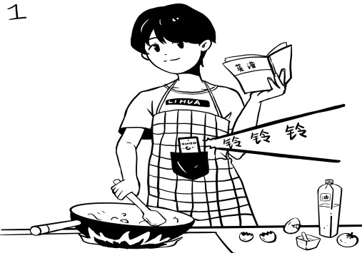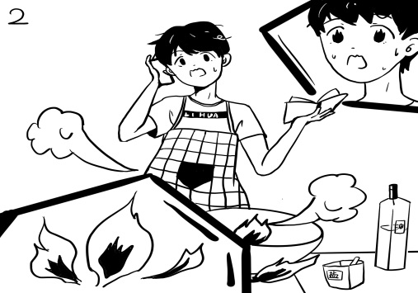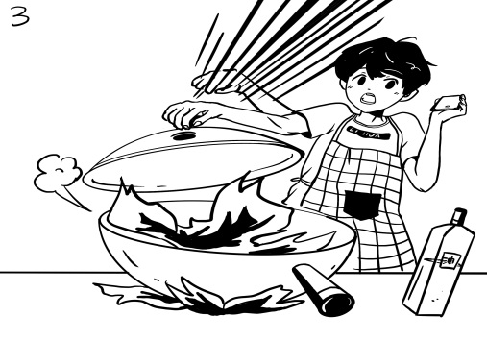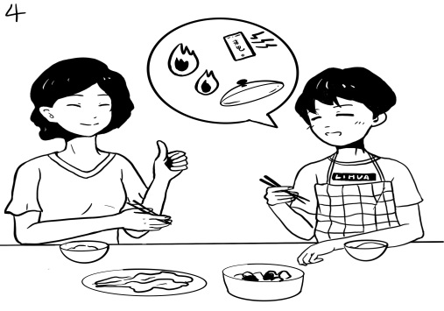

四月份测试题（B卷）

高三年级英语学科参考答案 2020. 4
第一部分：知识运用（共两节，45分）
第一节 语法填空（共10小题；每小题1.5分，共15分）
1．to make 2．belongs 3．families 4．are kept
5．for 6．called 7．walking 8．when
9．who/that 10．why

第二节 完形填空（共20小题；每小题1.5分，共30分）
11．B 12．B 13．A 14．D 15．C
16．A 17．C 18．B 19．D 20．A
21．C 22．B 23．A 24．D 25．D
26．C 27．D 28．B 29．C 30．A

第二部分：阅读理解（共两节，40分）
第一节（共15小题；每小题2分，共30分）
31．D 32．B 33．D 34．A 35．A
36．B 37．B 38．D 39．D 40．D
41．D 42．A 43．B 44．B 45．C

第二节（共5小题；每小题2分，共10分）
46．A 47．C 48．B 49．E 50．D

作文（略）

