2020届湘赣皖·十五校高三联考第一次考试
英语模拟试卷
时量：120分钟 总分：150分
第一部分 听力（共两节，满分30分）
做题时，先将答案标在试卷上。录音内容结束后，你将有两分钟的时间将试卷上的答案
转涂到答题卡上。
第一节（共5小题：每小题1.5分，满分7.5分）
听下面5段对话。每段对话后有一个小题，从每题所给的A、B、C三个选项中选出最
佳选项，并标在试卷的相应位置。听完每段对话后，你都有10秒钟的时间来回答有关小题
和阅读下一小题。每段对话仅读一遍。
1. What was the man planning to do next month?
A. Go skiing. B. Go on vacation. C.Take part in a football game.
2. What does the man find in the closet?
A. An umbrella. B . A raincoat. C . Rain boots
3. How many cups of soy sauce does the woman suggest?
A. 1 B．2 C 3
4. What is the probable relationship between the speakers?
A. Sister and brother B. Friends C. Co-workers
5 . Why did the student fail the test?
A. He got too many answers wrong
B. He didn't finish the test
C. He left the answer sheet blank
第二节（共15小题：每小题1.5分，满分22.5分）
听下面5段对话或独白。每段对话或独白后有几个小题，从每题所给的A、B、C三个
选项中选出最佳选项，并标在试卷的相应位置。听每段对话或独白前，你将有时间阅读各个
小题，每小题5秒钟；听完后，各小题将给出5秒钟的作答时间。每段对话或独白读两遍。
听第6段材料，回答第6和第7两个小题。
6. Who will watch the show with the speakers?
A. Jimmy. B. Marlon. C. Jack.
7. How does the man probably feel now?
A. Annoyed B. Confused. C. Excited
听第7段材料，回答第8至第10三个小题。
8. What day is it today?
A. Monday. B. Tuesday C. Wednesday
9. Which character does the man like most?
A. The mad scientist B. The Jedi C. Spiderman
10. What does the woman think of Spiderman?
A. Brave B. Shy C. Funny
听第8段材料，回答第11至第13三个小题。
11 .What's making the man feel sad?
A. He isn't allowed to make his own decisions
B . His parents often quarrel
C . His parents misunderstand him.
12. What major does the man want to study now?
A. Art history B. Philosophy C. Accounting
13. What can we know about the man?
A. He is worried about his future
B. He isn't good at math
C. He wants a well-paid job after graduation
听第9段材料，回答第14至第16三个小题。
14. What was the woman's job in the past?
A. Babysitter B. Nurse C . Nutritionist
15. What does the woman like to do?
A. Change diapers B. Make meals C. Wash clothes
16. What has led to fewer stay-at-home parents, according to the woman?
A. The neighborhood atmosphere
B . Boring housework
C . Financial pressure
听第10段材料，回答第17至第20四个小题。
17. How many Britons can speak at least one foreign language?
A．18% B．3 8% C．62%
18. When do British children usually start to learn a foreign language at school now?
A. At the age of5 B. At the age of 11 C. At the age of 14
19. Why do many young people quit learning a foreign language in the UK?
A. They find it too hard. B. It's too easy for them. C. It's not interesting
20. What does the British government plan to do to improve language learning?
A. Train language teachers
B . Offer more foreign language choices
C . Encourage students to learn two foreign languages

第二部分阅读理解（共两节，满分40分）
第一节（共15小题：每小题2分，满分30分）
阅读下列短文，从每题所给的四个选项（A、B、C和D）中，选出最佳选项。
A

Musicals in Washington's Historic National Theatre in 2020
The Last Ship
Friday, March 27-Sunday, April 5
$49-$154

THE LAST SHIP, inspired by Sting's 1991 album "The Soul Cages" and his own
childhood experiences, tells the story of a community in Tyne and Wear.Sting will star and
perform the role at every performance. It features an original score with music and lyrics by
Sting as well as a few of his best-loved songs: "Island of Souls"“A1l This Time" and "When
We Dance". Learn more atTheLastShipMusical.com
Recommended for ages 13 and up
Run time: Approximately 2 hours, 30 minutes
The King 's Speech

Tuesday, Feb. 11-Sunday, Feb. 16
$54-$104
THE KING'S SPEECH is based on the true story of King George VI's struggle with a
speech problem and the friendship he formed with his doctor, Lionel Logue. With the Nazi
threat coming and civil unrest at home, royal secrets explode around the King as he appeared
onto the world stage
Recommended for ages 13 and up
Run time: Approximately 2 hours, 50 minutes
Blue Man Group
Friday, May 8-Sunday, May 17
$64-$124
At BLUE MAN GROUP, you'II rock, laugh, and party! As three blue men explore our
world, together we'II discover music, comedy and surprises at every turn. It is perfect for
audiences of all ages and cultural backgrounds, and retums to D.C. with new music, fresh
stories, custom mstruments like never before

Recommended for ages 4 and up
Run time: Approximately l hour, 30 minutes
Summer: The Donna Summer Musical
Wednesday, July 22-Sunday, Aug. 2
$54 - $114
Donna Summer was a girl from Boston with a voice from heaven. With a score featuring
more than 20 0f Summer's classic hits including "Love to Love You Baby" "Bad Girls" and
"Hot Stuff', this electric experience is a moving tribute to the voice of a generation
Recommended for ages 13 and up
Run time: Approximately I hour, 40 minutes
21 .In which musical can you enjoy the song "AII This Time"?
A. The King′s Speech B .The Last Ship
C．Blue Man Group D. Surmmer: The Donna Summer Musical
22. When is the musical "The King's Speech" scheduled to open?
A. Tuesday, Feb. 11 B . Friday, March 27.
C. Sunday, May 17. D. Wednesday, July 22
23 . What is the ticket price of ;'Summer: The Donna Summer Musical"?
A. $49-$154range B. $64-$124.
C. $54-$104. D. $54-$114

B
It is with mixed emotions that I went to the young criminal center every few months to
give vaccinations(按种疫苗). On the one hand, I feel lucky to be able to provide a service
that may have a positive health effect on the residents. But, on the other hand, I feel a sense
of sadness and disappointment as I see the prisoners being escorted（押送）by guards to the
nursing unit.
My last visit was very memorable. For some reason, there was a lightness in the air.
More than ever before, I felt a lightness as I spoke with each person. We shared stories and
smiles and fears. Even the toughest prisoners seemed to be surrounded by light. As a mother,
I saw them as not only youth, being punished for crimes, but also as children who have the
potential to change for the better. Most of them wanted to talk longer! They were reaching
out to us! It felt right.
There was one more prisoner. He was limited to a different unit in a lonely cell. We were
asked if we were okay going down there. We said that we were. Two guards escorted us down
and when we entered the area, instant tears welled up in my eyes. The area was sad. These
guards didn't smile. We entered the cell and had to make do with what was there
We were done but I didn't want to leave. I gave the 17 year old a gentle touch and smile
as I explained what to do regarding the side effects. At first there was no response, so I just
looked down at his bare feet and then to my supplies. I thought that I had better pack up
Suddenly, he looked up at me and smiled before he said "Thanks" and then he gave me a
thumbs-up. I smiled back and said, "You're welcome. Take care of yourself."
It was wonderful to receive a kind response from someone who was in such a harsh
place. As we walked back to the main entrance, we didn't speak. Where there can be a smile,
there is hope. Sometimes smiles can be very powerful
24. What can we know about the young in the young criminal center
A. They received regular medical service.
B .They were treated unfairly
C.They stayed in bad conditions
D . They were forced to take treatment
25 .What was special about the center the last time the author went there?
A. She was asked to share stories B . Every prisoner was kind to her
C. The young people talked freely D. She sensed a relaxing atmosphere
26. What did the young man think of the author?
A. He disliked her for her sympathy
B . He really appreciated her kindness
C. He thought she would change his life
D. He thought she was just an ordinary doctor
27. What impressed the author most in this story?
A. The young man's smile.
B .The medical care for prisoners.
C. The punishment to the prisoners.
D. The difference between the young man and others.
C
In 1992, Teen Talk Barbie was released with the controversial voice fragment, "Mathclass is hard." While the toy's release met with strong public reaction, this underlying assumption persists, spreading the myth that women do not thrive in science, technology,engineering and mathematic (STEM) fields due to biological inadequacies in math aptitude.
However, in 2019 Jessica Cantlon at Carnegie Mellon University led a research team that comprehensively examined the brain development of young boys and girls and found no gender difference in brain function or math ability.
Cantlon and her team conducted the first neuroimaging study to evaluate biological gender differences in math aptitude of young children. Her team used functional MRI【核磁共振）to measure the brain activity in 104 young children (3-to-lO-year-old; 55 girls) while watching an educational video covering early math topics, like counting and addition. The researchers compared scans from the boys and girls to evaluate brain similarity. In addition,the team examined brain maturity by comparing the children's scans to those taken from a group of adults (63 adults; 25 women) who watched the same math videos.After numerous statistical comparisons, Cantlon and her team found no difference in the brain development of girls and boys. In addition, the researchers found no difference in how boys and girls processed math skills and were equally engaged while watching the educational videos. Finally, boys' and girls' brain maturity were statistically equivalent when compared to either men or women in the adult group. Cantlon said she thinks society and culture are likely steering girls and young women away from math and STEM fields, as previous studies show that families spend more time with young boys in play that involves spatial cognition (空间认知)．"Typical socialization can make worse small differences between boys and girls that can snowball into how we treat them in science and math," Cantlon said. "We need to be aware of these origins to ensure we aren′t the ones causing the gender inequities." However, this project is focused on early childhood development using a limited set of math tasks. Cantlon wants to continue this work using a broader scope of math skills, such asspatial processing and memory, and follow the children over many years
28. What can we infer about the toy's release?
A. It has raised a storm of applause
B . Girls perform no worse than boys in math
C. Math is a subject difficuit to every one ofus
D .Women are born with insufficient math abilities
29.What can we learn from the study conducted by Cantlon?
A.Boys process math skills more quickly than girls
B .Boys and girls have similar brain in math abilities
C.Boys and girls have similar interest in math
D . Adults have better brain than children in math
30. What will Cantlon most likely agree with?
A. Parents should lengthen the time spent with girls.
B . Society is causing a greater gender difference in math abilities.
C . Culture plays a leading role in children's brain development.
D. We should cultivate boys' and girls' math abilities equally.
31 . How will Cantlon further her research?
A. By using a wider range of math skills.
B . By involving a broader scope of subj ects.
C. By increasing the complexity of math tasks.
D . By following the children until their adulthood.
D
Dutch designer Daan Roosegaarde has spent much of his time seeking artistic solutions (解决方案) to solve our environmental problems. His past projects include "Bioluminescent (生物发光) Trees" to light streets, a "Smog-Free Tower" to clean Beijing's polluted air, and"Gates of Light". which uses the headlamps of passing cars to light up the 60 floodgates of the Afsluitdijk, a major dam in the Netherlands. Now, he is hoping to use his skills to solve a pressing global problem-space junk!Scientists guess that there are over 500,000 bits of large rubbish. To deal with the problem, Roosegaarde intends to achieve his goal by educating the public about the need of the situation and coming up with possible solutions. The plan, called the Space Waste Lab,started in October 2018 with a laser(激光) show in the Netherlands. The unique outdoor artwork of LEDs used real-time tracking information to point at pieces of space junk floating at altitudes of 200 to 20,000 kilometers. The experience was designed to make the public
know more about how much space junk there are To find a solution, the designer has been thinking with experts. One of the proj ects being considered is "Shooting Stars", which attempts to reintroduce the trash to the atmosphere in a controlled way. Upon reentry, the waste would burn in the atmosphere like a shooting star Roosegaarde envisageS that if successful, buming space trash could someday replace fireworks at large public events In September 2018, the RemoveDEBRIS satellite successfully sent a net to catch a target while orbiting at an altitude of about 300 kilometers (190 miles) . Sometime this year,the capsule will set free a harpoon that has been designed to remove space trash. At the end of its task, RemoveDEBRIS will let go a sail to bring the satellite itself, and, hopefully some trash, back into the atmosphere, where it will burn up
32. What can we infer about Daan Roosegaarde?
A. He is too aggressive to put forward good plans
B . He is creative in solving environmental problems
C.He is fond of spending all of his time seeking art skills
D.He is sensitive to art reflected in environmental projects
33.Why was a laser show held in October 2018?
A.To confirm real-time information about space trash.
B. To show the great beauty of LEDs to common people.
C. To raise public awareness of the amount of space trash.
D. To inspire people to consider the solution to space trash.
34. What does the underlined word "envisage" in paragraph 3 probably mean?
A. Suspect. B. Demand. C. Advise D. Imagine
35. Whatis the function ofa sail?
A. Bringing the satellite to atmosphere to burn.
B Keeping trash traveling along its own orbit.
C. Taking the satellite away from atmosphere.
D. Removing space trash out of the capsule.
第二节（共5小题：每小题2分，满分10分）
根据短文内容，从短文后的选项中选出能填入空白处的最佳选项，选项中有两项为多余
选项。
Live Every Day Like It's A Holiday
We feel great on holiday because we let go of everyday stresses and strains36 So whether or not you're going away this summer, there's plenty you can do to make sure you benefit from that holiday feeling
Sleep like a holidaymaker
Sleep like a baby when you're on your holidays but stay awake when you're in yourusual routine? 37To reset your sleep pattern, avoid bringing problems to bed. That includes your phone, TV or laptop. Make sure the room is dark and cool. Aim for at least seven hours' ZZZs-just as you would on holiday Get moving 38 Given that exercise is cheap, healthy and reduces stress, it makes absolute sense to build it into your day. A walk will release happy hormones, and eases anxiety and mild depression.39 Part of the joy of going away is lingenng over delicious food with families. Take up the holiday habit of sitting down as a family for at least one meal a day. Families who eat together experience less anxiety, less depression and less obesity, research has found
Be a tourist in your own city Part of toe thrill of a holiday is the novelty of discovering a new place and doing new things 40 At weekends, check out a new music venue, visit a different museum or have a drink in that interesting-looking pub you're always walking past. It will get you out of routine and make you feel alive.A bit like a holiday, really.
A. Make your meals a celebration.
B. Carve out some dedicated quiet time.
C. lf so, you might need to examine your sleep habits.
D. Just make sure you schedule it into your day or week.
E. But it's also easy to be a holidaymaker in the place you live.
F. Research has even shown that vacations help health and well-being.
G. When you're travelling, you walk around new cities without a second thought.
第三部分语言知识运用（共两节，满分45分）
第一节（共20小题：每小题1.5分，满分30分）
阅读下面短文，从短文后各题所给的A. B.C和D四个选项中，选出可以填入空白处
的最佳选项。
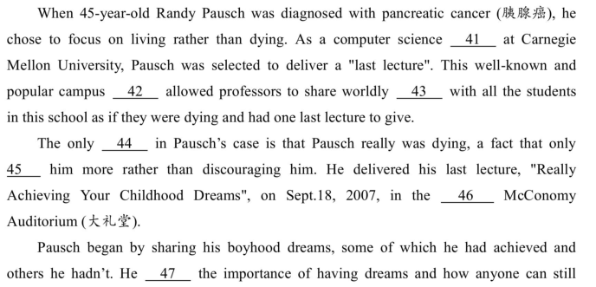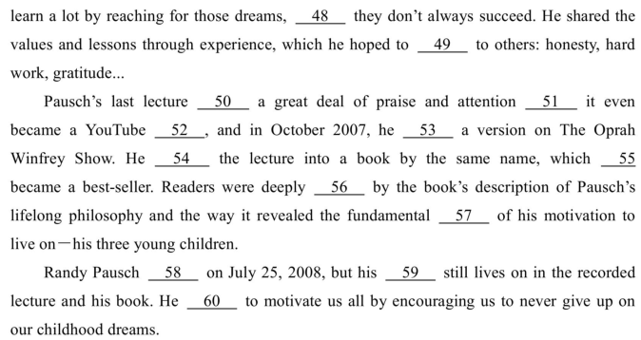
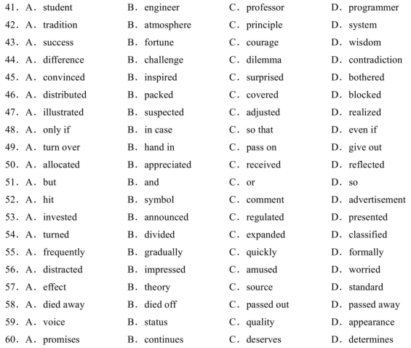
笫二节（共10小题：每小题1.5分，满分15分）
阅读下面材料，在空白处填入适当的内容（1个单词）或括号内单词的正确形式。
Since 61 first fully artificial plastic was invented in 1907, humans 62 (find)innumerable uses for the material. It has found 63 (it) and even our bodies. In a new study in 64 (environment) way into our tools, our clothesscience and technology,researchers estimate the average American eats more than 50,000 pieces of microplastic particles, 50,000. Although 65 (small) than 5 millimeters in length every year and breathes in another the health 66 (effect) of consuming these tiny bits of plastic are unclear, researchers stress the real volume that people are 67 (casual) swallowing is alarming. The largest contributor came 68 drinking bottled water, in 69 the bottle
itself added more than 32 times more plastic to a diet 70(compare) with tap water, The Guardian reports.
第四部分 写作（共两节，满分35分）
第一节 短文改错（共10小题：每小题1分，满分10分）
71.假定英语课上老师要求同桌之间交换修改作文，请你修改你同桌写的以下作文。文中共
有10处语言错误，每句中最多有两处。每句错误仅涉及一个单词的增加、删除或修改。
增加：在该词处加一个漏字符号（八），并在其下面写出该加的词。
删除：把多余的词用斜线(＼)划掉。
修改：在错的词下画一横线，并在该词下面写出修改后的词。
注意：1．每处错误及其修改均仅限一词；
2．只允许修改10处，多者（从第11处起）不计分。
Millions of people traveled to Italy every year. It's the third mostly popular country in Europe for foreign visitors. Why do people travel to Italy? They love its fashion, food, art, buildings or history. There are a lot things to see in Italy and Rome is a must during you visit. First, you can see the treasures in its wonderful museums. Before that, plan to visit the Trevi Fountain. Remembering to throw a coin in the fountain and make two wishes. The first one can be anything. The second is to return back to the city one day. Then buy anlce cream make in a special way from one of the nearby shop. It's delicious!
第二节 书面表达（满分25分）
72.假定你是李华，你收到外国朋友Peter的邮件，他想了解你校在新冠疫情(COVID-
19epidemic)期间线上教学的情况。请你给他回复邮件，内容包括：
1．课程与时间；
2．你的学习状态；
3．你的期待。
注意：
1．词数100左右；
2．可适当增加细节，以使行文连贯。

