2020届高三模拟考试试卷
英 语2020.4
本试卷分第Ⅰ卷(选择题)和第Ⅱ卷(非选择题)两部分。满分120分，考试时间120分钟。
第Ⅰ卷(选择题 共85分)
第一部分：听力(共两节，满分20分)
第一节(共5小题；每小题1分，满分5分)
听下面5段对话。每段对话后有一个小题，从题中所给的A、B、C三个选项中选出最佳选项，并标在试卷的相应位置。听完每段对话后，你都有10秒钟的时间来回答有关小题和阅读下一小题。每段对话仅读一遍。
( )1. How will the speakers go to the movies?
A. By taxi. B. By underground. C. By bus.
( )2. How much should the woman pay?
A. $10. B. $15. C. $25.
( )3. Who is in charge of the project?
A. Dan. B. Gary. C. Mary.
( )4. What does the man say about the restaurant?
A. The waiters were noisy. B. The food was not his thing.
C. The atmosphere was friendly.
( )5. What are the speakers talking about?
A. An adventure. B. A book. C. A vacation plan.
第二节(共15小题；每小题1分，满分15分)
听下面5段对话或独白。每段对话或独白后有几个小题，从题中所给的A、B、C三个选项中选出最佳选项，并标在试卷的相应位置。听每段对话或独白前，你将有时间阅读各个小题，每小题5秒钟；听完后，各小题将给出5秒钟的作答时间。每段对话或独白读两遍。
听第6段材料，回答第6、7题。
( )6. What will the speakers have to do?
A. Send figures to Mr. Jones. B. Draw up the budget for next year.
C. Organize an advertising campaign on Thursday.
( )7. What does the woman ask the man to do?
A．Wait for her in his office. B. Go to Mr. Jones' workplace.
C. Make a phone call to Mr. Jones.
听第7段材料，回答第8至10题。
( )8. What is the woman?
A. A hostess. B. A producer. C. An environmentalist.
( )9. Why is the interview held?
A. To present a study. B. To fill the thirtyminute opening.
C. To raise public awareness of environmental protection.
( )10. When does the conversation take place?
A. Before the interview. B. During the interview. C. After the interview.
听第8段材料，回答第11至13题。
( )11. What is always nice according to the man?
A. He lives by the sea. B. Animals can get more food.
C. Green can he seen all year round.
( )12. What does the man have near his house?
A. Trees. B. Vegetables. C. Grass.
( )13. What are the speakers discussing?
A. The man's house. B. The effects of global warming.
C. The vegetables on the man's farm.
听第9段材料，回答第14至16题。
( )14. Where does the man most probably work?
A. At an airport. B. At a hotel. C. At a travel agency.
( )15. Which airport is the best choice for the woman?
A. Reagan National. B. Dulles.
C. BaltimoreWashington Airport.
( )16. Why is the woman going to Washington DC?
A. To stay in a friend's house. B. To meet the man. C. To visit the White House.
听第10段材料，回答第17至20题。
( )17. What is the show about?
A. Experiments done by audience. B. Young enthusiastic experimenters.
C. Explanations for some mysteries.
( )18. What subject is the speaker most looking forward to?
A. How to live a good life. B. How to meet the perfect partner.
C. How to eat chocolate without gaining weight.
( )19. What does the speaker think of the show?
A. It's boring. B. It's timewasting. C. It's beneficial.
( )20. When will the show start this week?
A. At 9：30. B. At 9：00. C. At 8：30.
第二部分：英语基础知识运用(共两节，满分35分)
第一节：单项填空(共15小题；每小题1分，满分15分)
请认真阅读下面各题，从题中所给的A、B、C、D四个选项中，选出最佳选项。
( )21. Though he has made a big fortune, he is ________ a happy man.

A. nothing but B. anything but C. more than D. other than
( )22. Chinese medical teams have made tremendous ________ to contain the spread of Covid19.
A. appointments B. headlines C. sacrifices D. compromises
( )23. —Have you accepted the job, Aaron?
—Yes. But my ________ reaction was to decline the offer.
A. fierce B. initial C. rigid D. allergic
( )24. John accompanied me to the airport so that he could ________ the driving when I felt tired.
A. take over B. run over C. turn over D. rule over
( )25. Most students set their alarm clocks to ensure they can attend online classes ________．
A. on purpose B. on occasion C. on average D. on schedule
( )26. The tourism industry, as the core of our local economy, is supposed ________ in the months to come.
A. to recover B. to have recovered
C. to be recovering D. to have been recovering
( )27. ________ to the students at home, the textbooks enabled them to study more efficiently.
A. Distributing B. Having distributed
C. Being distributed D. Distributed
( )28. The Yangtze River Delta regional development plan, ________ Nantong has long expected, is under way.
A. that B. where C. which D. when
( )29. China's efforts to give timely treatment to those infected with the virus are being ________ by the rest of the world.
A. applauded B. clarified C. postponed D. transferred
( )30. My neighbour Saria is always sheltering her child too much, and that's ________ we differ.
A. when B. what C. how D. where
( )31. I will try my best to get to the station ahead of time, ________ I have to walk all the way there.
A. so that B. as though C. even if D. in case
( )32. It's really exciting to imagine my future when I ________ a new life at university.
A. would experience B. have experienced
C. will be experiencing D. experienced
( )33. If you ________ here half an hour ago, you would have known what we were talking about.
A. arrived B. had arrived C. should arrive D. would arrive
( )34. Regular exercise along with proper diets ________ our health in the long term.
A. benefits B. has benefited C. benefit D. have benefited
( )35. —Thank you so much for your kind help, Lucy.
—________．
A. That's right B. All right C. With pleasure D. My pleasure
第二节： 完形填空(共20小题；每小题1分，满分20分)
请认真阅读下面短文，从短文后各题所给的A、B、C、D四个选项中，选出最佳选项。
About six years ago I started having panic attacks(恐慌症). I began my journey to __36__ them with traditional tools, all of which were a great help.__37__， a year later treatment was no longer needed.
Frustratingly, about a year after that, I started to develop __38__ and began to have panic attacks once again. I tried what I knew best and went back to my previous __39__， but I was still __40__ and far from feeling well again __41__ I got some new advice.
I loved to sing when I was young. My childhood had been __42__ with creativity, yet for most of my adult life it was __43__. A therapist told me that mental health issues are common among the __44__ minds of the world when creativity is suppressed(压制). To regain it, I decided to get back into __45__. Then I joined a group called Sound, a pop choir. Much better. I found the __46__ to audition(试音). I was amazed that I managed to __47__ such a risky situation and not have a panic attack. The audition itself was a __48__ for me, never mind how I did.
I have now been a __49__ of the choir for three years. I love the community and the performances. It __50__ me of who I was at school. My path back then was always “do what you love”. My entire __51__ was filled with fond memories because of that, and I was starting to build that back into my __52__ life.
Now, I am feeling a lot better. When I am __53__， distraction(分散注意力) is key and singing does __54__. It sends me into a state in which my body works with pure passion and joy. More importantly，I will have exercised my creativity and __55__ my anxiety.
( )36. A. ignore B. solve C. interpret D. stress
( )37. A. Casually B. Ridiculously C. Controversially D. Thankfully
( )38. A. passion B. depression C. adaptation D. relation
( )39. A. tutors B. conditions C. values D. tools
( )40. A. doubting B. hesitating C. struggling D. improving
( )41. A. though B. until C. since D. after
( )42. A. charged B. burdened C. mixed D. filled
( )43. A. neglected B. maintained C. sharpened D. exploited
( )44. A. open B. absent C. creative D. narrow
( )45. A. painting B. acting C. reading D. singing
( )46. A. turn B. pressure C. courage D. privilege
( )47. A. set off B. get through C. shrink from D. figure out
( )48. A. win B. failure C. pain D. barrier
( )49. A. sponsor B. director C. trainer D. member
( )50. A. suspects B. reminds C. cures D. warns
( )51. A. education B. competition C. career D. existence
( )52. A. holiday B. school C. adult D. adolescent
( )53. A. absorbed B. thrilled C. ambitious D. anxious
( )54. A. last B. help C. exist D. fade
( )55. A. relieved B. shared C. felt D. caused
第三部分： 阅读理解(共15小题；每小题2分，满分30分)
请认真阅读下列短文，从短文后各题所给的A、B、C、D四个选项中，选出最佳选项。
A
A NEW STORY AWAITS...
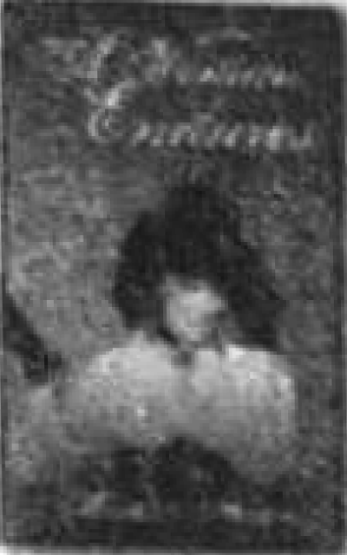  A Woman Endures  Marilyn Hering  www.iuniverse.com  Paperback | Ebook  $10.95 | $3.99  Following the loss of her baby and marriage, Eleanor decides to move to South Carolina to run an inherited tea plantation. There she will learn to grow tea, and possibly something more: love. | 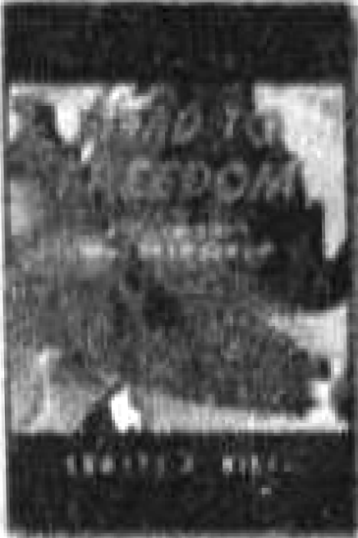  Road to Freedom  —My Life and Journey from a 3rd World Country  Edward A. Nieto  www.__xlibris.com  Hardback | Paperback | Ebook  $29.99 | $19.99 | $3.99  This memoir details Edward's life and journey. It also includes his struggles with violence, corruption, and the politics of living in a third world country.
  Saving Nia  G．B. Jones  www.__authorhouse.com  Hardback | Paperback | Ebook  $28.99 | $19.95 | $3.99  Snatched from her happy home and placed with drugaddicted, abusive relatives, Nia sinks into depression and attempts to set herself on fire. The love of another abused child gets into her darkness, but can it bring her out？ | 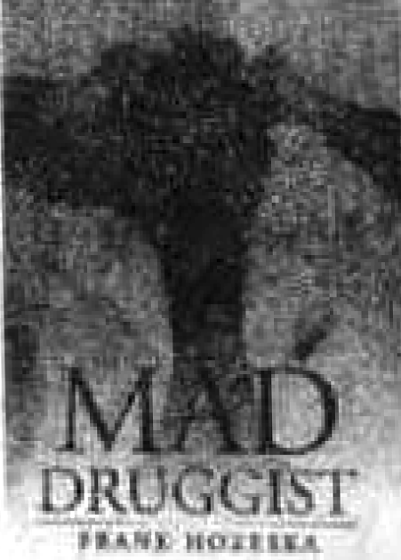  Mad Druggist  Frank Hozeska  www.__xlibris.com  Hardback | Paperback | Ebook  $29.99 | $19.99 | $3.99  Louie gets fired from every drugstore job. He ends up a washedup(unsuccessful) druggist, and he's ready to give up his fight, until something crazy happens in the final round.
( )56. A young man failing in his business may find encouragement in ________．
A. Saving Nia B. Mad Druggist
C. Road to Freedom D. A Woman Endures
( )57. From the passage we can know that ________．
A. Eleanor may find her love in a tea plantation
B. Edward enjoys his life in a third world country
C. Nia may inspire another child with her passion
D. Louie becomes unsuccessful in the final round
B
Be careful of those solid gold pieces of advice. The friend who advises you to, say, stay in your relationship or leave your job may well be looking out for you; but she's inescapably looking out for herself, too, whether she realizes it or not.
Moreover, research suggests that people will generally advise you to act more cautiously than they would act themselves in a similar situation—perhaps because they don't want to feel guilty if you take a daring leap and fall flat on your face.
There's a happy side to this, though, for parents, teachers, managers and anyone else who finds themselves in the position of needing to motivate others: far better than giving them advice is to give them the opportunity to give advice. A new study found that American middleschool pupils were much more enthusiastic about doing their homework after giving advice on the topic to younger children, as compared with after receiving advice from teachers. This motivational effect lasted weeks, and was also observed among adults who were attempting to lose weight, save money, control their temper or find a job. This result isn't all that surprising, I suppose, when you consider how happy it feels to be invited to give advice. Faced with a challenge, we tend to assume we need to seek advice in order to obtain more knowledge about how to give advice; yet the truth, very often, is that we know exactly what we need to do—we just lack the confidence to do it.
This, by the way, is another good reason to keep a journal: you can use it to advise yourself. Your friends may have limited patience with your habit of lecturing them on their lives in order to feel better about your own, but a leathereffect notebook never complains.
Finally, this is a reminder that there are few bigger compliments(恭维) you can pay another person than to ask for their advice. Benjamin Franklin famously observed that to flatter(奉承) someone, it's better to ask for a favour than to perform one: the favourdoer will come to think of you as the likable sort for whom they do favours.
( )58. Why should you be careful of those solid gold pieces of advice?
A. They may be practical. B. They may be rewarding.
C. They may be demanding. D. They may be conservative.
( )59. The examples in Paragraph 3 suggest that people giving advice ________．
A. become more motivated to act B. should turn to others for advice
C. are superior to the professionals D. usually lack relevant knowledge
( )60. What does the author want to convey by mentioning Benjamin Franklin?
A. Keeping a journal is a good habit.
B. You should be polite to the favourdoers.
C. You should be patient with your listeners.
D. Asking for a favour pleases the favourdoers.
C
The voice of an ancient Egyptian priest has been heard for the first time in more than 3，000 years, thanks to a detailed reconstruction of his vocal tract(声带) from his mummified remains.
A team of scientists in England used medical scans of the famous mummy of Nesyamun to create a digital, 3D model of the insides of the individual's throat and mouth, which were reproduced on a 3D printer. Then the researchers created an artificial larynx(喉头) with a loudspeaker using an electronic waveform. The sound was then played through the speaker into the 3D printed vocal tract to produce a short bust of Nesyamun's voice—a sound not heard since the 11th century B．C.
Previous efforts to reproduce ancient voices could only approximate them, by animating facial reconstructions with software. In comparison, the sound of Nesyamun's voice is based on “an extant(现存的) vocal tract preserved over 3，000 years，” the researchers wrote.
Nesyamun lived around 1100 B．C. He is thought to have died in his late 50s from a severe allergic reaction. Almost 3，000 years later, his mummy was discovered at Karnak and transported to the Leeds City Museum in 1823. His remains and ornate coffin(棺材) have since become some of the world's best researched relics of ancient Egypt.
“Nesyamun's mummy was a good choice for studying the sound of an ancient voice，” said David Howard, the lead author of the new research, “It was particularly suited，given its age and preservation of its soft tissues, which is unusual.”
He said he hopes the scientific understanding of how human voices are created can be combined with knowledge of the ancient Egyptian language to reconstruct longer passages of Nesyamun's speech.
Before examining the mummy, the researchers had to deal with ethical(道德的) concerns related to examining a person without their consent. They used nondestructive research methods, and took into account words on his coffin, relating that Nesyamun hoped again “to address the gods as he had in his working life.”
The researchers interpreted that to indicate his desire to speak again after death. “We are in a way fulfilling his declared wishes，” Howard said.
Howard and Schofield said they hope a reconstruction of Nesyamun's speech, perhaps reciting an ancient Egyptian prayer, can be featured at the Karnak temple in Egypt for modern tourists.
“When visitors encounter the past, it is usually a visual encounter，” said Schofield. “With this voice, we can change that.”
( )61. The voice of Nesyamun was recreated by ________．
A. repairing his vocal tract B. bringing Nesyamun back to life
C. using some advanced technologies D. combining it with facial movements
( )62. Why was Nesyamun's mummy suitable for research?
A. He often gave long speeches. B. His vocal tract is well preserved.
C. A severe disease resulted in his death. D. His remains are displayed in the museum.
( )63. What does the underlined word “that” in Paragraph 8 refer to?
A. The researchers took into account words on his coffin.
B. Nesyamun's mummy was examined without his consent.
C. The researchers hope to reconstruct longer passages of his speech.
D. Nesyamun hoped to address the gods as he had in his working life.
( )64. What would be the best title for the passage?
A. A 3，000yearold mummy speaks again
B. The voice of a mummy excites visitors
C. A 3Dprinted vocal tract has been created
D. The dream of Nesyamun has been achieved
D
Curtis Whitson knew the water fall was coming. He'd rafted down the Arroyo Seco, a river in central California, before. He figured he would hop out of his raft into the shallow water, rappel(绕绳下降) down the rocks on either side of the falls, and continue on his way, as he had on a previous trip.
But this year was different. Heavy snow and spring rains had turned the usually manageable falls into something fierce. And this year, instead of his friends, Whitson's companions were his wife, Krystal Ramirez, and his 13yearold son, Hunter. As the three of them approached the falls late in the afternoon of the third day of their camping trip, Whitson could tell from the increasing roar of water in the narrow canyon(峡谷) that they were in serious trouble. There was no way they'd be able to rappel down the rocks as planned.
As he considered what to do, Whitson hit on a bit of luck—he heard voices coming from the other side of the falls. He yelled, but the sound of the rushing water drowned him out.
We have to get these people a message, Whitson thought.
He grabbed a stick and pulled out his pocketknife to carve “Help” in it. Then he tied a rope to it so the people would know it wasn't just any stick. He tried throwing it over the falls, but it floated away in the wrong direction.
Then he spotted his green Nalgene water bottle. Whitson grabbed it and carved “Help！” on it. Ramirez also reminded him that he had a pen and paper, which she'd brought to play games with, in his backpack.
Whitson knew it__was__a__long__shot. But he scrawled(草草地写) “We are stuck here at the waterfall. Get help please! ” and pushed the note into the bottle.
This time, his throw over the waterfall was perfect.
“All right, that's all we can do，” Whitson told Hunter.
It took 30 minutes to navigate back upstream to the beach where they'd had lunch. They made a fire and laid out a tarp(油布). As the evening wore on, they placed a headlamp with a flashing light on a ledge(岩石突出部). By about 10：30 p．m.，they decided they probably weren't going to get rescued that night, so they pulled out their sleeping bags. Before turning in, Ramirez added more wood to the fire to keep the mountain lions away.
Then, just after midnight, they heard a helicopter hovering above them. Whitson turned to his son and started shaking him.
“They're here！” he said.
Whitson ran over to the headlamp and started flashing it at the helicopter. He, Ramirez, and Hunter were waving and hollering when they heard the magic words：“This is Search and Rescue. You have been found.”
The helicopter circled as the pilot looked for a good place to land. Finding none, the crew announced to the campers over the PA system that they would not be rescued until morning and told them to conserve their firewood.
The next morning, the helicopter returned and it was a moment of pure happiness as the three chatted with the officers who had rescued them. Together, they marveled(惊叹) at the unlikelihood of it all.
When the officers dropped them back at the Arroyo Seco Campground, the family learned more about the long shot events that had saved them: Two men had seen the water bottle in the water. When they picked it up, they noticed the writing on it—“Help！”. Then they realized there was a note inside. After they read it, they hightailed it to the campground, turned the bottle in, and took off without leaving their names.
A few days after news of the rescue broke, one of the hikers contacted Whitson. That's when he learned the rest of the story. There were actually two little girls hiking with the men that day. It was the girls who first spotted the bottle and swam to get it. Whitson is planning on having a big barbecue to meet the hikers—and thank them.
“I imagine it's going to be one of the greatest moments of my life，” he says.
( )65. How was Whitson's thisyear trip different from his previous trip?
A. It involved more people. B. It presented more threats.
C. It included more activities. D. It progressed more steadily.
( )66. Which of Whitson's attempted approaches worked?
A. Throwing a stick tied with a rope.
B. Yelling to the people across the fall.
C. Using an SOS bottle to send messages.
D. Bringing a pen and paper to play games.
( )67. What does the underlined part in Paragraph 7 mean?
A. It was a wild attempt. B. It was a great danger.
C. It was a fantastic idea. D. It was a real inspiration.
( )68. Why did Whitson place a headlamp with a flashing light on a ledge?
A. To enable his family to fall fast asleep.
B. To frighten the mountain animals away.
C. To increase the chance of being rescued.
D. To keep warm at night in the deep mountain.
( )69. Why did the crew delay rescuing till the next morning?
A. They were running out of oil. B. They conserved little firewood.
C. They found no place to land safe. D. They were caught in a snowstorm.
( )70. Who picked up the bottle from the water?
A. Two little girls. B. Two men hikers.
C. A helicopter pilot. D. The officers on duty.
第Ⅱ卷(非选择题 共35分)
第四部分：任务型阅读(共10小题；每小题1分，满分10分)
请认真阅读下面短文，并根据所读内容在文章后表格中的空格里填入一个最恰当的单词。注意：每个空格只填1个单词。
Everyone knows bullying(霸凌) is a huge problem, and we all need to work to stop it. But how? The science is unclear. While school districts across the country spend millions of dollars each year to stop bullying, not all antibullying programs work equally—and common approaches, it turns out, don't work very well at all.
Many schools simply handle bullying by hosting an antibullying assembly. While that might be a good start, experts agree that an annual address does little. “We can't teach math overnight，” Catherine Bradshaw said, “It is not a skill you can learn in an hour. That is the whole issue with social emotional learning.”
When schools only host an assembly it sends the message to students that bullying isn't important. That might mean students don't seek help when they are being bullied or see a classmate being bullied. Bullying is a complex phenomenon. There are many reasons why children bully, why kids may be targeted. An approach needs to be comprehensive and touch all the risk factors and really can't be seen as a shortterm solution.
Another common strategy is to encourage the bully and victim to talk through the problem and promise to be nice to each other. While it sounds lovely, in theory, the result normally contradicts the original intention.
A bullying prevention that's integrated(融合) throughout the curriculum makes a difference. Heather Wellman, a seventh grade English language teacher, in Pueblo, Colorado, has used novels to explore social and emotional learning concepts around bullying. When her seventh grade students read Animal Farm they looked at whether Squealer was a good friend, which ties in with the antibullying and mental health program Sources of Strength that her school uses. Using fictional characters helps students better identify negative characteristics that might lead to bullying, while better understanding the books.
Sources of Strength encourages students to use positive things in their lives, such as helpful adult mentors(导师) or healthy activities, to address bullying. For example, the program helps children identify those strong people in their lives so they know where to turn if they do face problems.
Another strategy proven lo reduce bullying: teaching socialemotional learning. This helps students better learn how to wrestle with their feelings in a positive way instead of taking it out on others. “They know what to do when they are bullied and develop skills with social and emotional learning so they can regulate their own emotions，” Bradshaw said.
Experts agree that any antibullying program is only as strong as a school's commitment to it. To get results, you have to put in the time.

Passage outline | Supporting details
A tough problem | Bullying in school is hard to deal with, and not all antibullying programs are (71)________.
(72)________  approaches | ●Hosting an antibullying assembly might be a good start, which, however, will (73)________ students from seeking help in the bullying. So the shortterm approach makes little (74)________．  ●Encouraging the bully and victim to understand the problem and promise to reach a(n) (75)________ sounds reasonable, but may have a(n) (76)________ effect.
Integrated approaches | ●By better understanding novels students can (77)________ negative features which may be the (78)________ of bullying.  ●A school program makes students clear about what or who they can (79)________ on to address bullying.  ●Teaching socialemotional learning helps reduce bullying.
Summary | Antibullying programs and schools' (80)________ of time and energy can jointly produce ideal results.
第五部分：书面表达(满分25分)
请阅读下面文字及图表，并按照要求用英语写一篇150词左右的文章。
Mandarin(普通话) is the common language in China, but each region has its own dialect(方言). For travelers, a familiar accent can refresh the memory of their hometown.
According to an official video by the Chinese Education Ministry's Language Commission, among the more than 130 languages spoken in China, 68 of them are spoken by less than 10，000 people; and 25 by under 1，000.
Hu Shuning, a dialect preservationist, said, “I think it is natural with a society's development that a dominant language appears, but from a cultural aspect I think dialects are still important, because they reflect cultural diversity.”
“Mandarin can take you further, but your dialect tells you where you come from，” said Wang Han, a wellknown TV host.
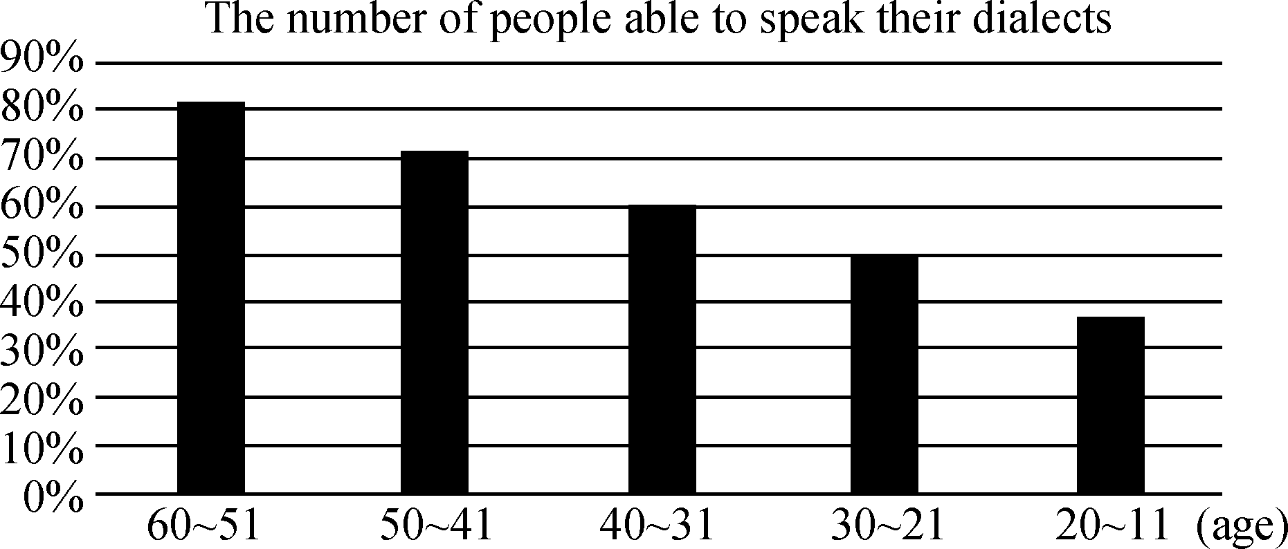
【写作内容】 1. 用约30个单词概述上述信息的主要内容；2. 结合上述信息，简要分析保护我国地方方言的重要性；3. 根据你的分析，谈谈保护地方方言的途径和方法。
【写作要求】 1. 写作过程中不能直接引用原文语句；2. 作文中不能出现真实姓名和学校名称；3. 不必写标题。
【评分标准】 内容完整，语言规范，语篇连贯，词数适当。

2020届高三模拟考试试卷(七市联考)
英语参考答案及听力材料

听力
1～5 BCCAB 6～10 BCACA 11～15 AABBA 16～20 CCBCA
单项填空
21～25 BCBAD 26～30 ADCAD 31～35 CCBAD
完形填空
36～40 BDBDC 41～45 BDACD 46～50 CBADB 51～55 ACDBA
阅读理解
56～57 BA 58～60 DAD 61～64 CBDA 65～70 BCACCA
任务型阅读
71. effective 72. Common/Ineffective 73. discourage/block/prevent/stop/keep
74. difference/sense 75. accommodation/compromise/agreement 76. opposite/contradictory
77. identify/discover/see 78. cause(s)/source(s) 79. depend/rely/count/calculate
80. commitment/devotion/ dedication
书面表达
One possible version：
In the face of the growing influence of mandarin, dialects are losing ground gradually. A survey reveals that younger people are more likely to be incapable of speaking their dialects.
Mandarin is crucial for China's development in politics, economy and culture, but the significance of local dialects is undeniable. Actually, not only are dialects communication tools, but they also play a very important role in cultural heritage. Besides, it is dialects that contribute to the diversity of cultures in different regions.
Therefore, it is high time that dialects preserving intangible should be protected so that they can be heard for the generations to come. Cultural activities can be organized in schools and neighborhoods to enhance people's awareness of dialect protection. Live tutorials and salons on how to speak the language can also be given online. What's more, local people are encouraged to write history books and compile textbooks and dictionaries in dialects.
听力材料
Text 1
M: We should discuss our plans for the movie. Since it starts so soon after work, getting there might be a problem.
W: I'm not really familiar with the underground. Why don't we take a taxi or bus?
M: No, we might be late if we run into traffic. Don't worry. I know well about the underground.
Text 2
W: Hello, I want to order two large pizzas. I'd like them for delivery. My address is 14 Walnut Drive.
M: The pizza is 10 dollars each and you need to pay 5 dollars for delivery. It should take about fortyfive minutes to get to your place.
Text 3
M: I heard you were going to attend the meeting on Wednesday, Mary. I didn't know you would go.
W: Yes，Gary. I am responsible for the project now. I took Dan's place since he had to be on sick leave.
Text 4
W: Are you satisfied with the restaurant?
M: Well, I have to say it's not my thing. The food was fine, but the restaurant was too crowded and the waiters kept shouting all the time. I thought they should be working in a quieter and friendlier way.
Text 5
W: Have you read this new bestseller by Mike Brooklyn?
M: No, I haven't. I don't really enjoy fiction.
W: I think you'd like this one—it's a very fast paced adventure, and Brooklyn has a really wild imagination.
M: Really? Maybe I'll try to read it when I'm on vacation.
Text 6
W: Has Mr. Jones sent you the figures for next year's advertising campaign yet?
M: No, I haven't received anything from him. If we don't get those figures by tomorrow morning, we won't be able to draw up next year's budget on time.
W: We have to set the budget until Thursday, so maybe you should call him and find out what happened.
M: I think I will. If I don't hear from him by four, I'll try calling his office.
Text 7
W: Thank you for meeting me, Dr. Freeman.
M: It's my pleasure. I'm glad to be here.
W: Sorry for the short notice, but we're hoping to air this story on tonight's evening news. The producer already briefed you about our interview, right?
M: Yes, she told me we're going to discuss the research results of our study.
W: Yes, hopefully the results will encourage more people to recycle and care for the environment. The interview should take about thirty minutes. Are you ready to begin?
M: Sure, let's start.
W: Good evening. Today with me is Dr. Freeman. And you know he is…
Text 8
W: So, Eric, how is life in Greenland these days?
M: Oh, you know. Winters are long. I live on the coast, though, so I get to see the ocean every day. That's always nice.
W: I heard that winters in Greenland are somewhat shorter than they used to be—global warming, I guess?
M: Yes, that's true. They're calling it “the greening of Greenland”．
W: The “greening”？ What does that mean?
M: Well, the average temperature in Greenland is rising twice as fast as in other places. So, now I have a few trees near my house. Trees didn't use to exist in Greenland, you know! And we, um, people are growing some vegetables now—cabbage, potatoes, and things like that. And farmers can grow more grass for their animals.
Text 9
W: Hello, this is Tina. I haven't booked my flight to DC yet, but I was wondering if you have any advice on how to best get to you from the airport?
M: Yes, well, if you're flying, Reagan National is the closest. You can take the underground right in from there. Dulles is further away and a taxi is probably the easiest. And then BaltimoreWashington Airport connects to a train that you can take right into the main train station in town.
W: OK, cool, I think Reagan should be the best. And do you pretty centrally lie in DC? Like, next to all the sights and everything? My friend asked me to stay in her house, but I don't think it would be very convenient.
M: Yep. We're in the Dupont Circle area, pretty central to DC. You can walk down to the White House. The underground is right around the corner.
W: Do you include breakfast?
M: Yes, madam, and we also offer dinner if you like.
W: OK. That sounds good. Thank you. I'm going to think about it and once I've got everything booked, I'll give you a call.
M: OK. Have a good day.
Text 10
W: I've just discovered a fantastic new show called How Do They Do That？. The idea is simple. Take a topic—like travel, for example and then think of lots of little mysteries that could be explained. How do planes take off and land? That sort of thing. Then get two young, enthusiastic hosts in a lab to do lots of exciting experiments. Add some pictures to explain the process to the audience and that's the show. Get the idea?
Each edition looks at a different subject. As well as travel, topics that have already been covered include education, the body, things around the house and magic—my favorite so far. Still to come are personal finances, the natural world, sports, and life and how to live it. The one I'm personally looking forward to the most is how to meet the perfect partner. But some of my friends would like to know how to eat chocolate without putting on weight.
What I like most about the show is that it's fun and you learn something at the same time, so you don't feel so guilty about spending 60 minutes in front of the TV each week. So if you aren't already watching How Do They Do That？， I strongly recommend that you make the time. You'll never think it boring. It's on every Tuesday at 9 p．m. but this week's edition won't be shown until half an hour later because of the live international soccer game. Get watching and start learning!

