2017年高考试题及模拟题分项解析之 专题2

动词的时态和语态及情态动词
动词的时态与语态
1． —________that company to see how they think of our product yesterday?
—Yes. They are happy with it.
A．Did you call B．Have you called
C．Will you call D．Were you calling
2． In the 1950s in the USA, most families had just one phone at home, and wireless phones ________ yet.
A．haven't invented B．haven't been invented
C．hadn't invented D．hadn't been invented
D 考查动词的时态和语态。 首先无线电话是被发明的， 所以排除 A和 C, 另外通过时间状语in the 1950s, 可知时态为过去完成时，故答案为D。句意：20世纪50年代的美国，大多数家庭只有一部电话，无线电话那时还没有被发明出来。
3． People ________ better access to health care than they used to, and they're living longer as a result.
A．will have B．have
C．had D．had had
B 考查动词的时态。句子是在描述现在的医疗便捷，表达的是现在的状态，所以应该用一般现在时，故答案选 B。句意：人们现在有权使用比过去更好的医疗服务，所以人们更长寿了。
4． He hurried home，never once looking back to see if he ________．
A．was being followed B． was following
C．had been followed D．followed
A 考查动词的时态和语态。根据题意可知，此处应该是他“被跟踪”，动词follow与主语he之间构成被动关系，又因为hurried是过去式，故用过去进行时的被动语态，故选A项。句意：他匆忙赶回家，从来没有回过头去看看他是否被跟踪。
5． He's been informed that he ________ for the scholarship because of his academic background.
A．hasn't qualified B．hadn't qualified
C．doesn't qualify D．wasn't qualifying
C 考查动词的时态。根据has been informed及句意可排除B项和D项；“没有资格”属于客观事实，所以应用一般现在时。故选C项。句意：他被告知，由于他的学术背景，他没有资格获得奖学金。
6． I ________down to London when I suddenly found that I was on the wrong road.
A．was driving B．have driven
C．would drive D．drove
A 考查动词时态。be doing…when…是固定句式，表示“正在做……这时突然……”。句意：我正开车去伦敦，这时我突然发现自己走错路了。
数词与主谓一致
7． The publication of Great Expectations, which ________ both widely reviewed and highly praised，strengthened Dickens' status as a leading novelist.
A．is B．are
C．was D．were
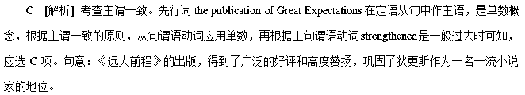8． Nowadays, cycling, along with jogging and swimming, ________ as one of the best allround forms of exercise.
A．regard B．is regarded
C．are regarded D．regards
B 考查主谓一致和语态。along with连接前后两个主语时，谓语动词应和前面的那个主语(cycling)保持一致，故排除A、C两项；cycling与regard是被动关系，应用被动语态，排除D项，故选B项。句意：如今，骑行与慢跑、游泳一起被认为是最全面的运动方式之一。
情态动词与虚拟语气
9． Samuel, the tallest boy in our class, ________ easily reach the books on the top shelf.
A．must B．should
C． can D．need
C 考查情态动词。can表示能力，意为“能够” 。故答案为C。句意：塞缪尔——我们班个子最高的男孩——能够轻松地够到架子顶层上的书。
10． If the new safety system ________ to use, the accident would never have happened.
A．had been put B．were put
C．should be put D．would be put
A 考查虚拟语气。根据句意可知是对过去情况的虚拟，从句用had done形式， 故答案选 A。句意：如果新的安全系统已投入使用的话， 这次事故就不会发生了。
11． ________not for the support of the teachers，the student could not overcome her difficulty.
A．It were B．Were it
C．It was D．Was it
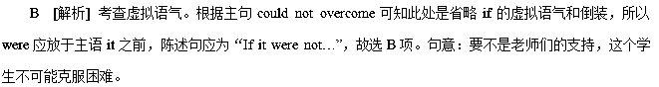12． My room is a mess, but I ________clean it before I go out tonight. I can do it in the morning.
A．daren't B．shouldn't
C．needn't D．mustn't
C 考查情态动词。根据“I can do it in the morning.”可知现在没必要打扫房间。故选C项。needn't不必；daren't不敢；shouldn't不应该；mustn't不准，禁止。句意：我的房间很乱，不过今晚在我出去之前，我没必要打扫它。我可以在(明天)早晨打扫。
13． —Do you have Betty's phone number?
—Yes. Otherwise, I ________ able to reach her yesterday.
A．hadn't been B．wouldn't have been
C．weren't D．wouldn't be
B 考查虚拟语气。由空前的otherwise可知应用虚拟语气，再结合句意可知此处表示与过去事实相反，谓语动词用would have done，故选B项。句意：“你有贝蒂的电话号码吗？”“有。不然的话，我昨天就不会联系上她了。”
14. .
— I wonder what makes you a good salesperson.
— I ________ as a waiter for three years, which contributes a lot to my today’s work.
A. serve | B. served
C. have served | D. had served
【答案】B
15.
— Why did you miss the interview yesterday?
— Terribly sorry. My pet dog got seriously injured and I ________ it all the day.
A. attend | B. was attending
C. had attended | D. have attended
【答案】B
【解析】考查时态。根据后面的时间状语all the day可知，这件事情是在过去持续进行的，应用过去进行时。故选B。
16.
— Helen, are you going Io the airport to pick up Jack the day after tomorrow?
— ________ tomorrow night. I would go.
A. Were he to come back | B. If he was about to come back
C. Had he come back | D. If he would come back
【答案】A
【解析】考查虚拟语气的倒装形式。此句是虚拟语气if sb. were ··, sb. would do sth.的变形，当if引导的虚拟状语从句中如有were/had/should，if省略后，从句要部分倒装。故选A。
17.
Now the world’s attention ________ the stocking markets, as they have great influence on the world’s economy.
A. is fixing on | B. is being fixed on
C. has fixed on | D. had been fixed on
【答案】B
【解析】考查时态语态。句意：现在世界关注的焦点都在股票市场上，因为它们对世界经济已经产生了很大的影响。 attention与focus之间为被动关系，Now提示用现在进行时。
18.
— What happened to the young trees we planted last week?
— The trees __________ well, but I didn’t water them.
A. might grow | B. would have grown
C. needn’t have grown | D. would grow
【答案】B
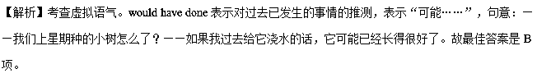【名师点睛】
虚拟语气
在表示假想的、虚假的、与事实相反的或难以实现的情况时用虚拟语气，
此题是与过去事实相反的虚拟，主句应该用would have done。would have done 是对过去事情的虚拟，本可以做却没做，第二空根据后面使用了转折but 来看，表示事实上没有浇水，是过去的事实，用一般过去式。
19. 【江苏省苏州市2017届高三上学期期中调研】----Why are you standing the street in such hot weather?
----I just can’t help it. I am appointed to interview people______ to learn about the customers’ feedback on our products.
A. at random B. at hand C. at best D. at intervals
【答案】A
【解析】
试题分析：考查介词短语 句意上：--为什么这么热的天你还站在街上？--我也是不得已。我被安排采访路人以了解对我们产品的反馈。A项表示“随意地”；B项是“在手头，即将到来”；C项表示“充其量”；D项是“不时地”，依照语境A项适合。
考点：考查介词短语
20. 【江苏省苏州市2017届高三上学期期中调研】Mr. Green is always devoted to his work and has a sense of responsibility. That’s why he was asked to _______the company when manager’s health was declining.
A. take over B. hand over C. turn over D. trip over
【答案】A
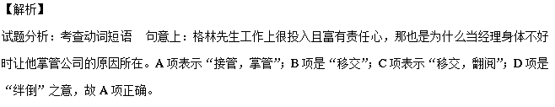考点：考查动词短语
21. 【江苏省苏州市2017届高三上学期期中调研】To be an artist is not easy, but sometimes dreams can be a rich source of______-for an artist.
A. occasion B. identification C. inspiration D. occupation
【答案】C
【解析】
试题分析：考查名词 句意上：成为一名艺术家不容易，但是有时候对一名艺术家来说梦想是灵感的丰富源泉。A项表示“场合”；B项是“识别”；C项表示“灵感”而D项表示“占据，职业”之意。依据语境C项适合。
考点：考查名词
22. 【江苏省苏州市2017届高三上学期期中调研】_____the danger of traveling on the lonely island, they would not be trapped now.
A. Have they been informed of B. Were they informed of
C. Should they be informed of D. Had they been informed of
【答案】D
【解析】
试题分析：考查虚拟语气 句意上：如果他们被告知了在孤岛上旅行的危险的话他们现在就不会被困了。此题考查的是混合虚拟语气且考查了虚拟语气与倒装省略的结合。If条件句中表示的是与过去事实相反应该是“If they had been informed of the danger of traveling on the lonely island”，主句是与现在事实相反可以通过时间状语“now”判断出。依照if遇到的虚拟语气与倒装省略的结合用法可以用成“Had they been informed of the danger of traveling on the lonely island”故D项正确。
考点：考查虚拟语气
23. 【江苏省苏州市2017届高三上学期期中调研】----It was such a difficult examination that a lot of students were unable to finish it on time.
----That’s the case. It’s hard to accept the fact that over90%of my classmates_______.
A. should fail B. should have failed C. will fail D. may fail
【答案】B
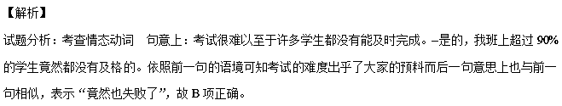考点：考查情态动词
24. 【江苏省苏州市2017届高三上学期期中调研】Housing prices_______ since the end of the last year. Therefore, it’s time the central government______ some effective measures to bring them under control.
A. have increased; would take B. have increased; will take
C. have been increasing; take D. have been increasing; took
【答案】D
【解析】
试题分析：考查时态和虚拟语气 句意上：房价自从去年的以来一直在上涨，所以中央政府该采取措施加以控制了。第一空依据since一词应该使用现在完成时，且进行时态更能体现出目前的状况，故使用现在完成进行时最好；第二空是虚拟语气中“it’s time that +did/ should do”的句式使用，且在使用过程中should一词不能省略，故D项最佳。
考点：考查时态和虚拟语气
25. Were Fidel Castro, the Cuban Communist leader, still alive now, he _______ seven American presidents.
A. would see B. would have seen C. will see D. will have seen
【答案】B
【解析】考查虚拟语气 句意：要是古巴领导人卡斯特罗还活着的话，他就能见证美国七位总统了。此题考查的混合虚拟语气的使用，前一句可以还原为：If Fidel Castro, the Cuban Communist leader, were still alive now, 表示的是与现在事实相反；后面的主句表示的是“他见证七位美国总统”，应该是过去发生的事情，故要使用“would have seen”，所以B项正确。
【考点】考查虚拟语气

