2017年高考试题及模拟题分项解析之专题5阅读理解
1.【2017·全国新课标I】A
Pacific Science Center Guide
◆Visit Pacific Science Center’s Store
Don’t forget to stop by Pacific Science Center’s Store while you are here to pick up a wonderful science activity or souvenir to remember your visit. The store is located(位于) upstairs in Building 3 right next to the Laster Dome.
◆Hungry
Our exhibits will feed your mind but what about your body? Our café offers a complete menu of lunch and snack options, in addition to seasonal specials. The café is located upstairs in Building 1 and is open daily until one hour before Pacific Science Center closes.
◆Rental Information
Lockers are available to store any belongings during your visit. The lockers are located in Building 1 near the Information Desk and in Building 3. Pushchairs and wheelchairs are available to rent at the Information Desk and Denny Way entrance. ID required.
◆Support Pacific Science Center
Since 1962 Pacific Science Center has been inspiring a passion(热情) for discovery and lifelong learning in science, math and technology. Today Pacific Science Center serves more than 1.3 million people a year and beings inquiry-based science education to classrooms and community events all over Washington State. It’s an amazing accomplishment and one we cannot achieve without generous support from individuals, corporations, and other social organizations. Wish pacificorganzier.org to find various ways you can support Pacific Science Center.
21. Where can you buy a souvenir at Pacific Science Center?
A. In Building 1.
B. In Building 3.
C. At the last Dome.
D. At the Denny Way entrance.
22. What does Pacific Science Center do for schools?
A. Train Science teachers.
B. Distribute science books.
C. Distribute scientific research.
D. Take science to the classroom.
23. What is the purpose of the last part of the text?
A. To encourage donations.
B. To advertise coming events.
C. To introduce special exhibits.
D. To tell about the Center’s history.
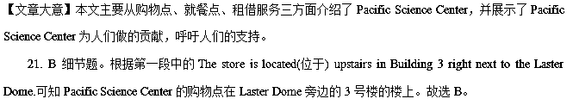22. D 细节题。根据第四段中的Today Pacific Science Center serves more than 1.3 million people a year and beings inquiry based science education to classrooms and company events all over Washington State可知现在Pacific Science Center每年向130多万人提供服务，并开始把科学教育带到教室。故选D。
23. A 根据文章最后一段Wish pacificorganzier.org to find various ways you can support Pacific Science Center.可知作者呼吁读者支持Pacific Science Center，也就是鼓励人们为之提供帮助，做贡献。故选A。
【名师点睛】
一般来说，解答细节理解题时都可采用“寻读法”。也就是说，考生不必通篇细看原文，而可以采取“带着问题找答案”的方法，先从问题中抓住关键性词语。这种关键性的词语可以被称为“定位词”，找出“定位词”然后以此为线索，快速地捕捉和理解事实或细节，恰当地运用略读、查读等技巧，在文章中寻找与此问题相关的段落、语句，仔细品味，对照比较，确定答案。
1. 应用文中的细节理解，特别是广告，是阅读理解题中常见的一种体裁。广告简洁明快，语言精练，篇幅小、信息多。广告阅读题多为细节理解题。做这类阅读题的技巧是：先读题目，带着问题有针对性地阅读相关部分快速寻找有效信息。一般情况下，只要细心都会找到正确答案。
2. 说明文中的细节理解与应用文一样，说明文中的阅读理解也偏重考查细节，我们也可以采用“先看题，然后带着问题在材料中寻找对应信息”的办法答题。
3. 记叙文中的细节以理解故事、人物描写等是阅读理解的考查重点之一。做这类题一般也可采用“寻读法”，即先读题，然后带着问题快速阅读短文，找出与问题相关的词语或句子，再对相关词语或句子进行分析对比，获取准确信息，找出正确答案。
例如第21题中根据题干中的关键词buy定位到Store，也就是第一段的内容。然后再结合后文中的The store is located(位于) upstairs in Building 3 right next to the Laster Dome.就可以得出正确答案。
能在文中直接找到信息句子的细节题比较简单，一般设置在第一篇阅读里以减轻考生的紧张心理。所以考生要抓住这一特点，灵活使用解题策略，达到快速高效的目的。
2.【2017·全国新课标I】B
I work with Volunteers for Wildlife, a rescue and education organization at Bailey Arboretum in Locust Valley. Trying to help injured, displaced or sick creatures can be heartbreaking; survival is never certain. However, when it works, it is simply beautiful.
I got a rescue call from a woman in Muttontown. She had found a young owl(猫头鹰) on the ground. When I arrived, I saw a 2-to 3-week-old owl. It had already been placed in a carrier for safety.
I examined the chick(雏鸟) and it seemed fine. If I could locate the nest, I might have been able to put it back, but no luck. My next work was to construct a nest and anchor it in a tree.
The homeowner was very helpful. A wire basket was found. I put some pine branches into the basket to make this nest safe and comfortable. I placed the chick in the nest, and it quickly calmed down.
Now all that was needed were the parents, but they were absent. I gave the homeowner a recording of the hunger screams of owl chicks. These advertise the presence of chicks to adults; they might also encourage our chick to start calling as well. I gave the owner as much information as possible and headed home to see what news the night might bring.
A nervous night to be sure, but sometimes the spirits of nature smile on us all! The homeowner called to say that the parents had responded to the recordings. I drove over and saw the chick in the nest looking healthy and active. And it was accompanied in the nest by the greatest sight of all — LUNCH! The parents had done their duty and would probably continue to do so.
24. What is unavoidable in the author’s rescue work according to paragraph 1?
A. Efforts made in vain.
B. Getting injured in his work.
C. Feeling uncertain about his future.
D. Creatures forced out of their homes.
25. Why was the author called to Muttontown?
A. To rescue a woman.
B. To take care of a woman.
C. To look at a baby owl.
D. To cure a young owl.
26. What made the chick calm down?
A.A new nest.
B. Some food.
C.A recording.
D. Its parents.
27. How would the author feel about the outcome of the event?
A. It’s unexpected.
B. It’s beautiful.
C. It’s humorous.
D. It’s discouraging.
【文章大意】救助小动物并没有那么简单，因为你所做的救助行为到最后可能都成了无用功。但无论结果怎样，救助小动物的这种行为是美好的。本文主要介绍了作者救助一只小猫头鹰，给它做新的窝，帮助它回到父母身边的故事。
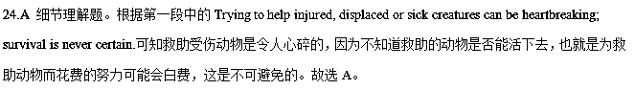25.C 细节题。根据第二段She had found a young owl(猫头鹰) on the ground. When I arrived, I saw a 2-to 3-week-old owl可知有人给作者打电话是因为有只小猫头鹰掉在地上了，作者赶过去看看情况。文中并没有说小猫头鹰受伤了，作者只是过去看情况，所以D选项错误。故选C。
26.A 细节题。根据第四段I placed the chick in the nest, and it quickly calmed down可知在作者把小猫头鹰放在窝里之后，它很快就安静下来，所以是窝让小猫头鹰安静下来的。故选A。
27.B 推理判断题。根据前文描述可知作者为小猫头鹰做了窝，并且帮助它找回了它的父母。小猫头鹰的父母还为它带回了午餐。作者的救助成功了，说明结局是美好的。再结合第一段的However, when it works, it is simply beautiful.可推测，作者感觉很美好。故选B。
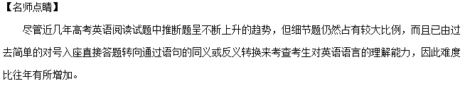对于直接信息的细节题来说，考生可以首先从问题中找到关键词，然后以此为线索，运用略读及查阅的技巧在文中迅速寻找这一细节，找到后再把这一部分内容仔细阅读一遍，仔细比较所给选项与文中细节的细微区别，在准确理解细节的前提下，最后确定最佳答案。
而细节理解题是介于事实细节题和推理判断题之间的一种题型，做这类题目时，考生需要对原文信息进行加工处理，然后再进行进一步的推理或鉴别，这对考生来说有一定难度。
例如第25题Why was the author called to Muttontown?作者为什么会被打电话喊去Muttontown呢？通过浏览后文考生都知道是和救助小猫头鹰有关，但C选项To look at a baby owl.和D选项To cure a young owl.中都涉及到了“小猫头鹰”，那到底是去“看小猫头鹰”还是去“治疗小猫头鹰”呢？毕竟文章第一段中介绍作者工作职责的句子I work with Volunteers for Wildlife, a rescue and education organization at Bailey Arboretum in Locust Valley.中出现了rescue“救援”这个单词。再加上后文又出现injured， displaced or sick creatures等单词，给考生的心理暗示就是被救助的小动物都是受伤的状态。有了前文的暗示，考生很有可能会选择D选项，认为作者接到电话后去Muttontown救助小猫头鹰。但实际上，小猫头鹰只是掉在地面上，并没有受伤。根据这一点，D选项就被排除了。所以正确答案是C选项。
3.【2017·全国新课标I】C
Some of the world’s most famous musicians recently gathered in Paris and New Orleans to celebrate the first annual International Jazz Day. UNESCO( United Nations Educational, Scientific and Cultural Organization) recently set April 30 as a day to raise awareness of jazz music, its significance, and its potential as a unifying(联合) voice across cultures.
Despite the celebrations, though, in the U.S. the jazz audience continues to shrink and grow older, and the music has failed to connect with younger generations.
It’s Jason Moran’s job to help change that. As the Kennedy Center’s artistic adviser for jazz, Moran hopes to widen the audience for jazz, make the music more accessible, and preserve its history and culture.
“Jazz seems like it’s not really a part of the American appetite,” Moran tells National Public Radio’s reporter Neal Conan. “What I’m hoping to accomplish is that my generation and younger start to reconsider and understand that jazz is not black and write anymore. It’s actually color, and it’s actually digital.”
Moran says one of the problems with jazz today is that the entertainment aspect of the music has been lost. “The music can’t be presented today the way it was in 1908 or 1958. It has to continue to move, because the way the world works is not the same,” says Moran.
Last year, Moran worked on a project that arranged Fats Waller’s music for a dance party, “Just to kind of put it back in the mind that Waller is dance music as much as it is concert music,” says Moran. “For me, it’s the recontextualization. In music, where does the emotion(情感) lie? Are we, as humans, gaining any insight(感悟) on how talk about ourselves and how something as abstract as a Charlie Parker record gets us into a dialogue about our emotions and our thoughts? Sometimes we lose sight that the music has a wider context,” says Moran, “so I want to continue those dialogues. Those are the things I want to foster.”
28．Why did UNESCO set April 30 as International Jazz Day?
A．To remember the birth of jazz.
B．To protect cultural diversity.
C．To encourage people to study music.
D．To recognize the value of jazz.
29．What does the underlined word “that” in paragraph 3 refer to?
A．Jazz becoming more accessible.
B．The production of jazz growing faster.
C．Jazz being less popular with the young.
D．The jazz audience becoming larger.
30．What can we infer about Moran’s opinion on jazz?
A．It will disappear gradually.
B．It remains black and white.
C．It should keep up with the times.
D．It changes every 50 years.
31．Which of the following can be the best title for the text?
A．Exploring the Future of Jazz.
B．The Rise and Fall of Jazz.
C．The Story of a Jazz Musician.
D．Celebrating the Jazz Day.
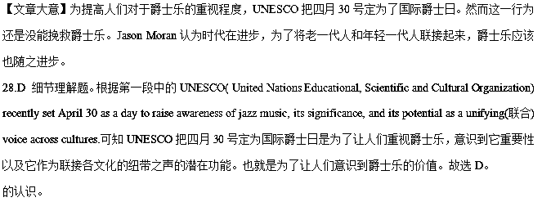29.C 推理判断题。根据前文Despite the celebrations, though, in the U.S. the jazz audience continues to shrink and grow older, and the music has failed to connect with younger generations可知尽管UNESCO为爵士乐设了纪念日，但美国的爵士乐听众依然在减少，并且年龄在老化。爵士乐没能将年轻一代人联接起来。再结合It’s Jason Moran’s job to help change that“是Jason Moran所做的事情帮助改变了那个情况”，所以可推测that指代的是前文中爵士乐在年轻一代人中失去吸引力的现象。故选C。
30.C 细节理解题。根据第五段中的The music can’t be presented today the way it was in 1908 or 1958. It has to continue to move, because the way the world works is not the same可知Moran认为爵士乐不能以1908或1958年的方式来表达当代，因为世界运转的方式不同，所以爵士乐必须继续前进才行。说明随着时代的发展，爵士乐也要跟上时代才不会被年轻一代所抛弃。故选C。
31.A 推理判断题。通读全文可知本文主要讲UNESCO为提高人们对爵士乐的重视设立爵士日，但实际收效甚微。有人认为爵士乐应随着时代的进步而进步，否则将失去吸引力。可知本文主要探索爵士乐的未来，故选A。
【名师点睛】
通常情况下，文章的标题具有概括性、针对性、醒目性的特点。概括性就是指标题应在最大程度上覆盖全文，囊括文章的主要内容，体现文章的主题。针对性是对标题外延的一种界定，标题要直接指向文章的主要特点。而醒目性是为了吸引读者的注意力，唤起读者对文章阅读的兴趣。考试中标题选择的题型一般是基础标题的概括性进行设题。解答这一类题型，考生可以从以下几点着手：
一、在阅读文章时，要注意文章中反复出现或强调的信息，寻找与文章大多数内容相关的信息，找出覆盖全文的核心词汇，看选项内容是否切中文章的中心论题，也就是要看选项内容与作者的写作目的是否一致。
二、了解文章主要论题的关键是找到全文的主题句。主题句通常在文章首段，但是也可能在文章的末段、在文章的某一段落，或者分散在文章的各个段落中。如果每个段落都有主题句，那么把各段落的主题句的中心思想集中起来，即为全文的主题句。
三、逆向思维法 如果考生觉得文章大意难以总结，不妨采取逆向思维，从四个选项下手。也就是思考四个选项：如果我是作者，遇到这样的标题，文章应该写些什么内容？
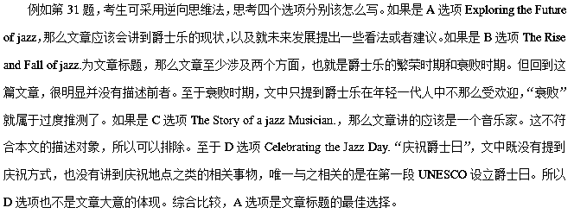4.【2017·全国新课标I】D
A build-it-yourself solar still（蒸馏器） is one of the best ways to obtain drinking water in areas where the liquid is not readily available. Developed by two doctors in the U.S. Department of Agriculture, it’s an excellent water collector. Unfortunately, you must carry the necessary equipment with you, since it’s all but impossible to find natural substitutes. The only components required, though, are a 5＇5＇ sheet of clear or slightly milky plastic, six feet of plastic tube, and a container— perhaps just a drinking cup — to catch the water. These pieces can be folded into a neat little pack and fastened on your belt.
To construct a working still, use a sharp stick or rock to dig a hole four feet across and three feet deep. Try to make the hole in a damp area to increase the water catcher’s productivity. Place your cup in the deepest part of the hole. Then lay the tube in place so that one end rests all the way in the cup and the rest of the line runs up — and out — the side of the hole.
Next, cover the hole with the plastic sheet, securing the edges of the plastic with dirt and weighting the sheet’s center down with a rock. The plastic should now form a cone(圆锥体) with 45-degree-angled sides. The low point of the sheet must be centered directly over, and no more than three inches above, the cup.
The solar still works by creating a greenhouse under the plastic. Ground water evaporates (蒸发) and collects on the sheet until small drops of water form, run down the material and fall off into the cup. When the container is full, you can suck the refreshment out through the tube, and won’t have to break down the still every time you need a drink.
32. What do we know about the solar still equipment from the first paragraph?
A. It’s delicate. B. It’s expensive.
C. It’s complex. D. It’s portable.
33. What does the underlined phrase “the water catcher” in paragraph 2 refer to?
A. The tube. B. The still.
C. The hole. D. The cup.
34. What’s the last step of constructing a working solar still?
A. Dig a hole of a certain size. B. Put the cup in place.
C. Weight the sheet’s center down. D. Cover the hole with the plastic sheet.
35. When a solar still works, drops of water come into the cup form .
A. the plastic tube B. outside the hole
C. the open air D. beneath the sheet
【答案】
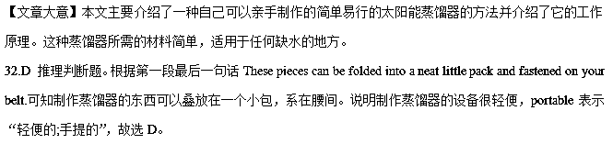33.B 推理判断题。根据Try to make the hole in a damp area to increase the water catcher’s productivity可知最好在潮湿的地方挖洞，以提高接水器的工作效率。接水器指的是在潮湿地方挖洞，在洞的底部放一个杯子，杯子上方用覆盖膜遮挡。整个装置构成接水器，而不是某个部分。这一题很容易错选D，但是退一步讲，就算在干燥的地方挖洞，杯子也可以接水，杯子接水的事实并不会因为周围的环境变化而变化，杯子的工作效率是不变的。故选B。
34.C 细节题。根据第三段Next, cover the hole with the plastic sheet, securing the edges of the plastic with dirt and weighting the sheet’s center down with a rock.可知最后一步是weighting the sheet’s center down with a rock“放一块石头在覆盖膜的中间，把它压下去”，故选C。
35.D 推理判断题。结合第四段中的Ground water evaporates (蒸发) and collects on the sheet until small drops of water form, run down the material and fall off into the cup可知地下水蒸发，在覆盖膜上聚集起来直到形成小水滴落在杯子里。覆盖膜是在杯子上面的，水滴落入杯子里。所以水滴是凝聚在覆盖膜的下面。故选D。
【名师点睛】
近年来全国统一高考中加大了对考生猜词义能力的考查，因此，掌握一定的猜词技巧，对突破高考阅读理解、提高同学们的英语语言能力都有非常重要的意义。这类试题包括对生词生义的推测、熟词生义的推测、以及对it/they/them等代词的确指对象的判断等。
做这种类型的题，要根据词、词组、句子所在的语境来判断其意义。因此熟练掌握一些猜词技巧是做好这类题的关键。命题者在出这类题时惯用常规词义来麻痹考生，考生要特别注意熟词生义，切不可脱离语境想当然。猜测词义时，要掌握以下六种解题技巧：
技巧 1 定义法：一般通过定义/定语从句/词组或同位语从句来确定词义。
技巧 2 对比法：利用文中的反义词、表对比关系的词猜测词义。
技巧 3 因果法：从原因推测结果，从结果推测原因。
技巧4 例举法：利用文中的举例猜测词义。
技巧5 构词法：在猜测词义过程中，我们还可以依靠构词法方面的知识，从生词本身猜测词义。
技巧6 根据文段中出现的同义、近义或反义词的意思进行判断。
技巧7 根据句子结构进行判断。
技巧8 根据文章的背景进行判断。
技巧9 上下文：利用语境及前后的提示来猜测词义。
本篇阅读中的第33小题就属于词义猜测题。考生可以根据技巧9 上下文：利用语境及前后的提示来猜测词义来选择正确答案。划线短语the water catcher很简单，考生一看就知道是“获得水的物品”的意思，在蒸馏器整个装置中，接水的东西就是杯子，这根据常识也知道的，因此很容易错选为D选项。如果考生仔细读划线短语所在的句子Try to make the hole in a damp area to increase the water catcher’s productivity就会发现一个关键的单词productivity。productivity表示“生产效率，工作效率”，杯子接水是它本来的功能，不会因为环境变化而加快聚水或减慢聚水。在潮湿的地方挖洞是因为潮湿的土中含有的水相对丰富，水蒸气蒸发凝成水珠就快些，这和水杯完全没有关系。所以结合上下文可知，the water catcher指的是蒸馏器整个装置。
5.【2017·全国新课标II】A
In the coming months, we are bringing together artists form all over the globe, to enjoy speaking shakespeare’s plays in their own language, in our globe, within the architecture shakespeare wrote for. please come and join us.
National Theatre Of China Beijing|Chinese
This great occasion(盛会) will be the national theatre of china’s first visit to the uk. The company’s productions show the new face of 21st century chinese theatre. This production of
Shakespeare’s Richard III will be directed by the National’s Associate Director,Wang Xiaoying.
Date&Time:Saturday 28 April,2.30pm&Sunday 29 April,1.30pm&6.30pm
Marjanishvili Theatre Tbilisi l Georgian
One of the most famous theatres in Georgia,the Marjanishvili,founded in 1928,appears regularly at theatre festivals all over the world. This new production of As You Like It is helmed（指导）by the company’s Artistic Director Levan Tsuladze.
Date & Time :Friday 18May,2.30pm&Sunday 19May,7.30pm
Deafinitely Theater London l British Sign Language （BSL）
By translating the rich and humourous taxt of Love’s Labour’s Lost into the physical language of BSL,Deafinitely Thertre creates a new interpretation of Shakespeare’s comedy and aims to build a bridge between deaf and hearing worlds by performing to both groups as one audience.
Date&Time:Tueaday 22 May,2.30pm&Wednesday 23 May,7.30pm
Habima National Theatre Tel Aviv l Hebrew
The Habima is the centre of Hebrew-languege theatre worldwide,Founded in Moscow after the 1905 revolution,the company eventually settled in Tel Aviv in the late 1920s,Since 1958,they have been recognized as the national theatre of Israel.This production of Shakespeare’s The Merchant of Venice marks their first visit to the UK.
Date Date&Time:Monday 28May,7.30&Tuesday 29 May,7.30pm
21.which play will be performed by the National Theatre of China?
A.Richard Ⅲ. B.Lover’s Labour’s Lost
C.As You Like It D.The merchant of Venice
22.What is special about Deafinnitely Theatre?
A.Tt has two groups of actors B.It is the leading theatre in London
C.It performs plays in BSL D.It is good at prducting comedies
23.When can you see a play in Hebrew?
A.Onsuturday 28Apil. B.On Sunday 29 April
C.On Tuesday 22 May. D. On Tuesday 29 May
【解析】本文是一篇记叙文。主要讲的是，莎士比亚的戏剧被翻译成几个国家的语言，并将在这些国家的大剧院上映的这一事件。
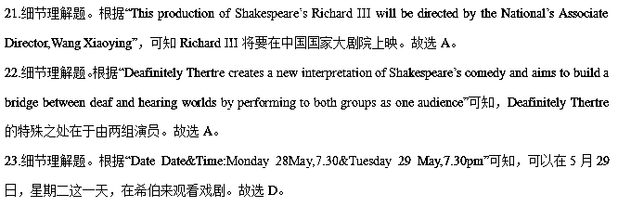【名师点睛】
阅读理解旨在考查考生对于文章整体的理解与细节的把握与分析，要在了解整篇文章框架的基础上进行选择。本文属于广告类短文，所考查三题均为细节题中的直接理解题。细节事实理解题主要考查考生对文章中某一些特定细节或文章的重要实事的理解能力。它一般包括直接理解题和语义理解题两种。直接理解题的答案与原文直接挂钩，从阅读材料 中可以找到。这种题难度低，只要学生读懂文章，就能得分，属于低层次题。在阅读中可以使用定位法与跳读法解决直接理解题。定位法即根据题干和选项所提供的信息直接从原文中找到相应的句子(即定位)，然后进行比较和分析(尤其要注意一些同义转换)，从而找出正确答案。跳读法即根据题干和选项所提供的信息跳读原文，并找到相关的句子(有时可能是几个句子)或段落，然后进行分析和推理等，从而找出正确答案。
例如第21题，根据题目“which play will be performed by the National Theatre of China?”，由题目中出现的关键信息the National Theatre of China，直接定位第一篇宣传广告，在文中找到“This production ofShakespeare’s Richard III will be directed by the National’s Associate Director,Wang Xiaoying” 可知，Shakespeare’s Richard III 会在中国国家大剧院上映，故选A。
考点：考查广告类阅读。
6.【2017·全国新课标II】B
I first met Paul Newman in 1968, when George Roy Hill, the director of Butch Cassidy and the Sundance Kid, introduced us in New York City. When the studio didn’t want me for the film— it wanted somebody as well known as Paul— he stood up for me. I don’t know how many people would have done that; they would have listened to their agents or the studio powers.
The friendship that grew out of the experience of making that film and The Sting four years later had its root in the fact that although there was an age difference, we both came from a tradition of theater and live TV. We were respectful of craft（技艺）and focused on digging into the characters we were going to play. Both of us had the qualities and virtues that are typical of American actors: humorous, aggressive, and making fun of each other— but always with an underlying affection. Those were also at the core （核心）of our relationship off the screen.
We shared the brief that if you’re fortunate enough to have success, you should put something back— he with his Newman’s Own food and his Hole in the Wall camps for kids who are seriously ill, and me with Sundance and the institute and the festival. Paul and I didn’t see each other all that regularly, but sharing that brought us together. We supported each other financially and by showing up at events.
I last saw him a few months ago. He’d been in and out of the hospital. He and I both knew what the deal was, and we didn’t talk about it. Ours was a relationship that didn’t need a lot of words.
24.Why was the studio unwilling to give the role to author at first?
A.Paul Newman wanted it.
B.The studio powers didn’t like his agent.
C.He wasn’t famous enough.
D.The director recommended someone else.
25.Why did Paul and the author have a lasting friendship?
A.They were of the same dge.
B.They worked in the same theater.
C.They were both good actors.
D.They han similar charactertics.
26.What does the underlined word “that” in paragraph 3 refer to?
A.Their belief.
B.Their care for chileden.
C.Their success.
D.Their support for each other.
27.What is the author’s purpose in writing the test?
A.To show his love of films.
B.To remember a friend.
C.To introduce a new movie.
D.To share his acting experience.
【解析】本文是一篇记叙文。主要讲述了作者与Paul Newman之间的深厚友情。当制片人不想让我参演电影时，Paul Newman站出来为我说话，两人因此而建立了深厚的友谊。在此后的很多年里，两人一直相互扶持，相互鼓励，因此两人的深厚友情维系了很多年。
- 细节理解题。根据“When the studio didn’t want me for the film— it wanted somebody as well known as Paul”制片人不想要我，他想要当时比较出名的演员Paul,因此，可知作者当时还不是很有名。故选C。
- 细节理解题。根据“Both of us had the qualities and virtues that are typical of American actors: humorous, aggressive, and making fun of each other— but always with an underlying affection. Those were also at the core （核心）of our relationship off the screen”可知，作者与Paul之间有着相似的性格特征。故选D。
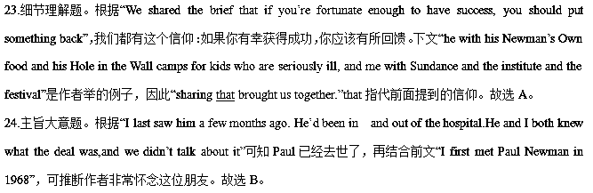【名师点睛】
本文前三题均考查了细节题。在完成细节题时，要特别注意排除干扰项。
如24题中的A项“Paul Newman wanted it.”属于“颠倒黑白”类干扰项，根据“When the studio didn’t want me for the film— it wanted somebody as well known as Paul”可知制片人不想要我，他想要当时比较出名的演员Paul，说明A项明显错误。
干扰项的设置方法除了“颠倒黑白”之外，通常还有以下几种方式：
1. 张冠李戴。命题者把文章作者的观点与他人的观点混淆起来，题干问的是作者的观点，选项中出现的却是他人的观点；或者题干问的是他人的观点，却把作者的观点放到选项中去。
2. 偷梁换柱。干扰项用了与原文相似的句型结构和大部分相似的词汇，却在不易引人注意的地方换了几个词汇，造成句意的改变。
3. 无中生有。干扰项往往是生活的基本常识和普遍接受的观点，但在原文中并无相关的信息支持点，这种选项的设置往往与问题的设问毫不相干。
4. 以偏概全。考生在做猜测文章中心思想、给文章添加标题或判断推理题时，往往会犯以偏概全的错误。产生这类错误的原因是考生受思维定势的影响或考虑不周，以局部代替整体。其具体表现为合理关联与不合理关联、准确概括与不准确概括之间的错位。不合理关联就是表层理解与深层理解相混淆。表层理解是对文章中客观事实的感知和记忆，往往是文章直接表述的结论；深层理解则是对文章中的客观事实进行逻辑推理、总结或概括后得出的结论。不准确概括是指不能准确地按题目要求概括或提取文中的表层或深层信息。
考点：考查记叙文阅读
7.【2017·全国新课标II】C
Terrafugia Inc .said Monday that its new flying car has completed its first flight,bringing the company closer to its goal of selling the flying car within the next year. The vehicle-named the Transition – has two seats wheels and wings that fold up so it can be driven like a car.The Transition,which flew at 1,400 feet for eight minutes last month, can reach around 70 miles per hour on the road and 115 in the flies using a 23-gallon tank of gas and bums 5 gallons per hour in the air. On the ground, it gets 35 miles per gallon.
Around 100 people have already put down a $10,000 deposit to get a Transition when they go on sale, and those numbers will likely rise after Terrafugia introduces the Transition to the public later this week at the New York Auto Show. But don’t expect it to show up in too many driveways. It’s expected to cost $279,000.And it won’t help if you’re stuck in traffic. The car needs a runway.
Inventors have been trying to make flying cars since the 1930s, according to Robert Mann, an airline industry expert. But Mann thinks Terrafugia has come closer than anyone to making the flying car a reality. The govemment has already permitted z&xxkthe company to use special materials to make it easier for the vehicle to fly. The Transition is now going through crash tests to make sure it meets federal safety siandards.
Mann said Terrafugia was helped by the Federal Aviation Administration’s decision five years ago to create a separate set of standards for light sport aircraft, which are lower than those for pilots of larger planes. Terrafugia says an owner would need to pass a test and complete 20 hours of flying time to be able to fly the Transition,a requirement pilots would find relatively easy to meet.
28. What is the first paragraph mainly about?
A. The basic data of the Transition. B. The advantages of flying cars.
C. The potential market for flying cars. C. The designers of the Transition.
29. Why is the Transition unlikely to show up in too many driveways?
A. It causers traffic jams. B. It is difficult to operate.
C. It is very expensive. D. It bums too much fuel.
30. What is the government’s attitude to the development of the flying car?
A. Cautious B. Favorable.
C. Ambiguous. D. Disapproving.
31. What is the best title for the text?
A. Flying Car at Auto Show B. The Transition’s Fist Flight
C.Pilots’Dream Coming True D. Flying Car Closer to Reality
【解析】本文是一篇说明文。主要讲述Terrafugia公司，研制出了飞车，试飞成功，预计将于明年进行销售。本文主要对飞车的历史由来及其构架进行了介绍。
- 主旨大意题。根据“The wehicle-named the Transition – has two seats wheels and wings that fold up so it can be driven like a car.The Transition,which flew at 1,400 feet for eight minutes last month, can reach around 70 miles per hour on the road and 115 in the flies using a 23-gallon tank of gas and bums 5 gallons per hour in the air. On the ground, it gets 35 miles per gallon.”可知，本段主要是对Transition的构架进行了介绍。故选A。
- 细节理解题。根据“But don’t expect it to show up in too many driveways. It’s expected to cost $279,000”可知，因为Transition 的价格较高，所以不太可能在太多的马路上出现。故选C。
- 细节理解题。根据“he govemment has already permitted z&xxkthe company to use special materials to make it easier for the vehicle to fly”以及“Mann said Terrafugia was helped by the Federal Aviation Administration’s decision five years ago to create a separate set of standards for light sport aircraf”可知，政府对于飞车的研发是比较支持的。故选B。
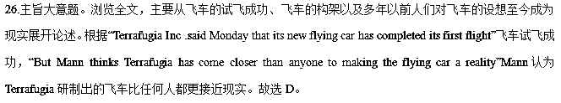8.【2017·全国新课标II】D
When a leafy plant is under attack ，it doesn’t sit quietly. Back in 1983,two scientists, Jack Schultz and Ian Baldwin, reported that young maple trees getting bitten by insects send out a particular smell that neighboring plants can get. These chemicals come from the injured parts of the plant and seem to be an alarm. What the plants pump through the air is a mixture of chemicals known as volatile organic compounds, VOCs for short.
Scientists have found that all kinds of plants give out VOCs when being attacked .It’s a plant’s way of crying out. But is anyone listening? Apparently. Because we can watch the neighbours react.
Some plants pump out smelly chemicals to keep insects away. But others do double duty .They pump out perfumes designed to attract different insects who are natural enemies to the attackers.Once they arrive,the tables are turned .The attacker who are natural enemies to the attackers . zxx|k Once they arrive,the tables are turned.The attacker who was lunching now becomes lunch.
In study after study,it appears that these chemical conversations help the neighbors .The damage is usually more serious on the first plant,but the neighbors ,relatively speaking ,stay safer because they heard the alarm and knew what to do.
Does this mean that plants talk to each other? Scientists don’t know. Maybe the first plant just made a cry of pain or was sending a message to its own branches, and so, in effect, was talking to itself. Perhaps the neighbors just happened to “overhear” the cry. So information was exchanged, but it wasn’t a true, intentional back and forth.
Charles Darwin, over 150 years ago, imagined a world far busier, noisier and more intimate(亲密的) than the world we can see and hear. Our senses are weak. There’s a whole lot going on.
32. What does a plant do when it is under attack?
A. It makes noises. B. It gets help from other plants.
C. It stands quietly D. It sends out certain chemicals.
33. What does the author mean by “the tables are turned” in paragraph 3?
A. The attackers get attacked.
B. The insects gather under the table.
C. The plants get ready to fight back.
D. The perfumes attract natural enemies.
34.Scientists find from their studies that plants can .
A.predict natural disasters B.protect themselves against insects
C.talk to one another intentionally D.help their neighbors when necessary
35.what can we infer from the last paragraph?
A.The word is changing faster than ever.
B.People have stronger senses than before
C.The world is more complex than it seems
D.People in Darwin’s time were imaginative.
【解析】本文是一篇记叙文。首先提出，当多叶植物受到攻击时，不会坐以待毙这一论点，并围绕这一论点展开叙述。研究发现，当植物受到攻击时，会发出VOCs ，以此来保护自己或者与周围的植物通过化学物质进行交流。
- 细节理解题。根据“reported that young maple trees getting bitten by insects send out a particular smell that neighboring plants can get. These chemicals come from the injured parts of the plant and seem to be an alarm”可知，当植物受到伤害时，会分泌一种特殊的化学物质。
- 词义推测题。根据“Once they arrive,the tables are turned.The attacker who was lunching now becomes lunch”，一旦它们到达这里，（ ），然后这些攻击者就会成为植物的午餐，根据语境，故选C。
- 细节理解题，根据“ In study after study, it appears that these chemical conversations help the neighbors .The damage is usually more serious on the first plant, but the neighbors ,relatively speaking ,stay safer because they heard the alarm and knew what to do”，可知，植物在必要的时候会通过分泌化学物质，通知周围的植物保持警惕。故选D。
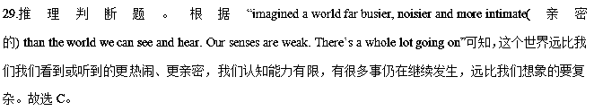【名师点睛】
本文33题属于词义猜测题。我们可以根据后句“Once they arrive,the tables are turned.The attacker who was lunching now becomes lunch”中的lunch,说明攻击者会成为午餐以及“When a leafy plant is under attack ，it doesn’t sit quietly植物受到攻击时，不会坐以待毙”，故the tables are turned意为“The plants get ready to fight back.植物准备反击”。本题属于典型的理由上下文语境推测。
近几年高考阅读中猜测词义考查方法多样化，其中根据上下文语境推测将会越来越多。根据上下文语境作出判断：有时短文中出现一个需猜测其意义的词或短语，下面接着出现其定义域解释或例子，这就是判断该词或短语意义的主要依据。
考点：考查记叙文阅读。
9.【2017·新课标III】A
San Francisco Fire Engine Tours
San Francisco Winery Tour
Running: February 1st through April 30th
This delicious tour goes through the city on its way to Treasure Island where we will stop at the famous Winery SF. Here you can enjoy 4 pours of some of the best wine San Francisco has to offer.(Included in tickets price)
Departing from the Cannery: Tell time upon request.
Duration(时长)：2 hours
Price: $90
Back to the Fifties Tour
Running: August 16th through August 31st
This tour transports you back in time to one of San Francisco’s most fantastic periods, the 1950s! Enjoy fun history as we take you through San Francisco for a free taste of ice cream.
Departing form the Cannery 5:00 pm and 7:00 pm
Duration:2 hours
Price:$90
Spooky Halloween Tour
Running: October 10th through October 31st
Join us for a ride through the historical Presidio district .Authentic fire gear （服装）is provided for your warmth as our entertainers take you to some of the most thrilling parts of San Francisco
Departing from the Cannery:6:30 pm and 8:30 pm
Duration :1 hour and 30 minutes
Price: Available upon request
Holiday Lights Tour
Running: December 6th through December 23nd
This tractive four takes you to some of San Francis’s most cheerful holiday scenes. Authentic fire gear is provided for your warmth as you get into the holiday spirit.
Departing from the Cannery 7:00 pm and 9:00 pm
Duration: I hour and 30 minutes
Advance reservations required.
21.Which of the tours is available in March?
A.San Francisco Winery Tour.
B.Back to the Fifties Tour.
C.Spooky Hallowen Tour.
D.Holiday Lights Tour.
22.What can tourists do on Back to the Fifties Tours?
A.Go to Treasure Island.
B.Enjoy the holiday scenes.
C.Have free ice cream.
D.Visit the Presidio district.
23.What are tourists required to do to go on Holiday Lights Tour?
A.Take some drinks.
B.Set off early in the morning.
C.Wear warm clothes.
D.Make reservations in advance.
【文章大意】本文是一篇应用文，主要介绍了圣弗朗西斯科的四个旅游活动和路线。
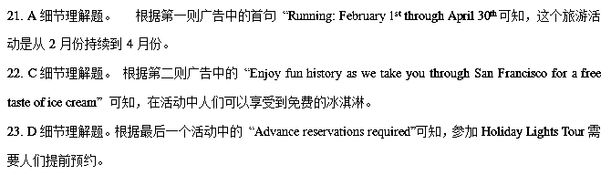【名师点睛】
细节题的破解一般采用寻读法，即先看试题，再读文章。对有关信息进行快速定位，再将相关信息进行整合、甄别、分析、对比，有根有据地排除干扰项，选出正确答案。此法加强了阅读的针对性，提高了做题的准确率，节省了宝贵的时间。寻读法还特别适用于对图形表格类题材的理解。做此类型的题目还要特别注意句子的逻辑关系。本文中的22. 23.题都可以根据题干定位到相关的the Fifties Tours 和Holiday Lights Tour部分，然后轻松得出答案。
10.【2017·新课标III】B
Minutes after the last movie ended yesterday at the Plaza Theater, employees were busy sweeping up popcorns and gathering coke cups. It was a scene that had been repeated many times in the theater’s 75-year history. This time, however, the cleanup was a little different. As one group of workers carried out the rubbish, another group began removing seats and other theater equipment in preparation for the building’s end.
The film classic The Last Picture Show was the last movie shown in the old theater. Though the movie is 30 years old, most of the 250 seats were filled with teary-eyed audience wanting to say good-be to the old building. Theater owner Ed Bradford said he chose the movie because it seemed appropriate. The movie is set in a small town where the only movie theater is preparing to close down.
Bradford said that large modern theaters in the city made it impossible for the Plaza to compete. He added that the theater’s location(位置) was also a reason. “This used to be the center of town,” he said. “Now the area is mostly office buildings and warehouses.”
Last week some city officials suggested the city might be interested in turning the old theater into a museum and public meeting place. However, these plans were abandoned because of financial problems. Bradford sold the building and land to a local development firm, which plans to build a shopping complex on the land where the theater is located.
The theater audience said good-by as Bradford locked the doors for the last time. After 75 years the Plaza Theater has shown its last movie. The theater will be missed.
24. In what way was yesterday’s cleanup at the Plaza special?
A. It made room for new equipment.
B. It signaled the closedown of the theater.
C. It was done with the help of the audience.
D. It marked the 75th anniversary of the theater.
25. Why was The Last Picture Show put on?
A. It was an all-time classic. B. It was about the history of the town.
C. The audience requested it. D. The theater owner found it suitable.
26. What will probably happen to the building?
A. It will be repaired. B. It will be turned into a museum.
C. It will be knocked down. D. It will be sold to the city government.
27. What can we infer about the audience?
A. They are disappointed with Bradford. B. They are sad to part with the old theater.
C. They are supportive of the city officials. D. They are eager to have a shopping center.
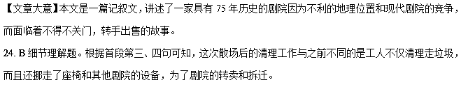
25. D推理判断题。根据第二段内容可知，剧院老板选择这部戏剧的因为是这部戏剧本身讲述的就是小镇上唯一的电影院准备关门停业的故事，恰好能反映出the Plaza Theater的现状。
26. C细节理解题。根据第四段末句“which plans to build a shopping complex on the land where the theater is located.”可以推断这个剧院将被拆除，取而代之的是一个现代的购物中心。
27.B推理判断题。根据第二段中“most of the 250 seats were filled with teary-eyed audience wanting to say good-bye to the old building.”可知，人们非常难过，不愿意看到老剧院被拆掉。
11.【2017·新课标III】C
After years of heated debate, gray wolves were reintroduced to Yellowstone National Park. Fourteen wolves were caught in Canada and transported to the park. By last year, the Yellowstone wolf population had grown to more than 170 wolves.
Gray wolves once were seen here and there in the Yellowstone area and much of the continental United States, but they were gradually displaced by human development. By the 1920s, wolves had practically disappeared from the Yellowstone area. They went farther north into the deep forests of Canada, where there were fewer humans around.
The disappearance of the wolves had many unexpected results. Deer and elk populations — major food sources (来源) for the wolf – grew rapidly. These animals consumed large amounts of vegetation (植被), which reduced plant diversity in the park. In the absence of wolves, coyote populations also grew quickly. The coyotes killed a large percentage of the park’ s red foxes, and completely drove away the park’ s beavers.
As early as 1966,biologists asked the government to consider reintroducing wolves to Yellowstone Park. They hoped that wolves would be able to control the elk and coyote problems. Many farmers opposed the plan because they feared that wolves would kill their farm animals or pets.
The government spent nearly 30 years coming up with a plan to reintroduce the wolvers. The U.S. Fish and Wildlife Service carefully monitors and manages the wolf packs in Yellowstone. Today, the debate continues over how well the gray wolf is fitting in at Yellowstone.Elk, deer, and coyote populations are down, while beavers and red fores have made a comeback. The Yellowstone wolf project has been a valuable experiment to help biologists decide whether to reintroduce wolves to other parts of the country as well.
28.What is the text mainly about?
A. Wildlife research in the United States.
B. Plant diversity in the Yellowstone area.
C. The conflict between farmers and gray wolves.
D. The reintroduction of wolves to Yellowstone Park.
29.What does the underlined word “displaced” in paragraph 2 mean?
A. Tested. B. Separated. C. Forced out. D. Tracked down.
30.What did the disappearance of gray wolves bring about？
A. Damage to local ecology. B. A decline in the park’s income.
C. Preservation of vegetation. D. An increase in the variety of animals.
31.What is the author’s attitude towards the Yellowstone wolf project？
A. Doubtful. B. Positive. C. Disapproving. D. Uncaring.
【文章大意】本文是一篇说明文，介绍了美国黄石公园重新引进灰狼的事情。因为人类活动影响到灰狼数量逐渐减少，鹿群数量逐渐增加，从而造成植被遭到大量破坏。
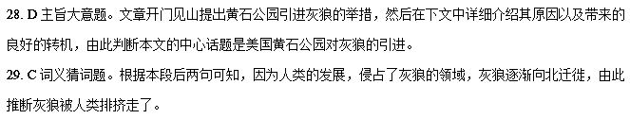【名师点睛】词义猜测题是高考英语阅读理解中常见的题型，一般考查对生词的猜测、熟词生义词的猜测、短语的猜测、代词的指代以及句子的理解。要求考生掌握构词法，还要学会利用上下文语境、利用定义、解释、举例和对比转折等线索来进行判断推测。而构词法也是一种猜词的办法，比如通过前缀：dis-， un-，im-等等，如本题中的displace。
30. A细节理解题。根据第三段内容可知，灰狼的减少造成了鹿群的增多，从而植被遭到了破坏；而且红狐和海狸也不断减少，由此推断灰狼的消失引起了当地生态的破坏。
31. B推理判断题。根据文章末段末句可知，作者认为引进灰狼的项目是很有价值的实验，是很值得推广的。
12.【2017·新课标III】D
The Intelligent Transport team at Newcastle University have turned an electric car into a mobile laboratory named “DriveLAB” in order to understand the challenges faced by older drivers and to discover where the key stress points are.
Research shows that giving up driving is one of the key reasons for a fall in health and well-being among older people, leading to them becoming more isolated(隔绝) and inactive.
Led by Professor Phil Blythe, the Newcastle team are developing in-vehicle technologies for older drivers which they hope could help them to continue driving into later life.
These include custom-made navigation(导航) tools, night vision systems and intelligent speed adaptations. Phil Blythe explains: “For many older people, particularly those living alone or in the country, driving is important for preserving their independence, giving them the freedom to get out and about without having to rely on others.”
“But we all have to accept that as we get older our reactions slow down and this often results in people avoiding any potentially challenging driving conditions and losing confidence in their driving skills. The result is that people stop driving before they really need to.”
Dr Amy Guo, the leading researcher on the older driver study, explains, “The DriveLAB is helping us to understand what the key points and difficulties are for older drivers and how we might use technology to address these problems.
“For example, most of us would expect older drivers always go slower than everyone else but surprisingly, we found that in 30mph zones they struggled to keep at a constant speed and so were more likely to break the speed limit and be at risk of getting fined. We’re looking at the benefits of systems which control their speed as a way of preventing that.
“We hope that our work will help with technological solutions(解决方案) to ensure that older drivers stay safer behind the wheel.”
32.What is the purpose of the Drivel AB?
A.To explore newmeans of transport.
B.To design new types of cars.
C.To find out older driver`s problems.
D.To teach people traffic rules.
33.Why is driving important for older people according to Phil Blythe?
A.It keeps them independent.
B.It helps them save time.
C.It builds up their strength.
D.It cures their mental illnesses.
34.What do researchers hope to do for older drivers?
A.Improve their driving skills.
B.Develop driver-assist technologles.
C.Provide tips on repairing their cars.
D.Organize regular physical checkups.
35.What is the best title for the text?
A.A new Model Electric Car
B.A Solution to Traffic Problem
C.Driving Service for elders
D.Keeping Older Drivers on the Road
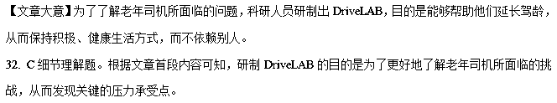33. A推理判断题。根据第四段中 Phil Blythe所说的内容 “driving is important for preserving their independence, giving them the freedom to get out and about without having to rely on others”可知，在Phil Blythe看来，能够开车是老年人能够保持独立生活的重要条件。
34. B推理判断题。根据文章最后三段内容可知，研究人员希望能够通过研制一些司机辅助技术来帮助老年司机延长驾龄、享受更多独立的生活。
35. D主旨大意题。文章主要介绍了科研人员通过把电动车改装成一款 “DriveLAB”来研究如何帮助解决老年司机在开车时候遇到的问题，以便延长他们独立生活的时间，提高他们的生活质量。
【名师点睛】主旨大意题可分为篇章主旨和段落主旨。开门见山提出主题是大多数文章的写作方法，新闻报道、调查报告、科普性文章大都采用演绎法，本文就属于科技报告类，在文章开头提出了中心，然后详细介绍这种技术，由此可以判断文章的中心话题。
13.【2017·北京卷】A
It was a cold March day in High Point, North Carolina. The girls on the Wesleyan Academy softball were waiting for their next turns at bat during practice, stamping their feet to stay warm, Eighth-grader Taylor Bisbee shivered(发抖) a little as she watched her teammate Paris White play. The two didn’t know each other well — Taylor had just moved to town a month or so before.
Suddenly, Paris fell to the ground,“Paris’s eye rolled back,” Taylor says. “She started shaking. I knew it was an emergency.”
It certainly was, Paris had suffered a sudden heart failure. Without immediate medical care, Paris would die. At first no one moved. The girls were in shock. Then the softball coach shouted out, “Does anyone know CPR?”
CPR is a life-saving technique. To do CPR, you press on the sick person’s chest so that blood moves through the body and takes oxygen to organs. Without oxygen the brain is damaging quickly.
Amazingly, Taylor had just taken a CPR course the day before. Still, she hesitated. She didn’t think she knew it well enough. But when no one else came forward, Taylor ran to Paris and began doing CPR, “It was scary. I knew it was the difference between life and death,” says Taylor.
Taylor’s swift action helped her teammates calm down. One girl called 911. Two more ran to get the school nurse, who brought a defibrillator, an electronic devices(器械) that can shock the heart back into work. Luck stayed with them: Paris’ heartbeat returned.
“I know I was really lucky,” Paris says now. “Most people don’t survive this. My team saved my life.”
Experts say Paris is right: For a sudden heart failure, the single best chance for survival is having someone nearby step in and do CPR quickly.
Today, Paris is back on the softball team. Taylor will apply to college soon. She wants to be a nurse. “I feel more confident in my actions now,” Taylor says. “I know I can act under pressure in a scary situation.”
56.What happened to Paris on a March day?
A. She caught a bad cold.
B. She had a sudden heart problem.
C. She was knocked down by a ball.
D. She shivered terribly during practice
57.Why does Paris say she was lucky?
A. She made a worthy friend.
B. She recovered from shock.
C. She received immediate CPR.
D. She came back on the softball team.

58.Which of the following words can best describe Taylor?
A. Enthusiastic and kind.
B. Courageous and calm.
C. Cooperative and generous.
D. Ambitious and professional.
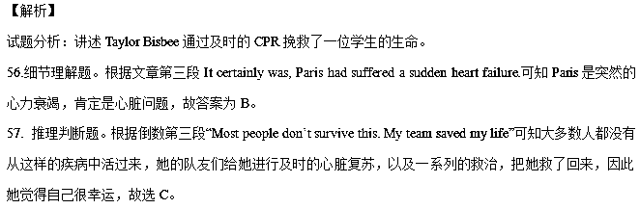58.推理判断题。Taylor根据自己所学的CPR知识及时的挽救了 Paris的生命，虽然犹豫了，但是很快地进行CPR抢救，说明她很勇敢，很镇静，不慌不忙，不像其他孩子那样陷入惊慌之中，故选B。
考点：人物故事类短文阅读。
【名师点睛】
故事类文章是高考阅读理解常选材料之一。这类文章常通过叙述突出人物性格特征或讲述个人经历与感悟，以及逸闻趣事。文章的要素有时间、地点、人物、事件等。有些是按事件发展的经过为主线叙述的，在叙述的过程中有详有略；有些是按时间的顺序叙述的，有顺叙、倒叙等。
解题技巧：
1、高考选用的此类文章常常为幽默类或情感类故事，其目的或阐明某种观点，或抨击某种陋习，或赞扬某种品德，所以要关注作者表达的个人感悟，提出的个人意见，或故事中出其不意的变化，而这些往往体现文章中心或写作意图，属于必考点。如本题中的第58题，总结人物品质的，Taylor根据自己所学的CPR知识及时的挽救了 Paris的生命，虽然犹豫了，但是很快地进行CPR抢救，说明她很勇敢，很镇静，不慌不忙，不像其他孩子那样陷入惊慌之中，故选B。
2、该类文章语言流畅、有趣，命题往往从故事的情节、人物或事件之间的关系、作者的意图和态度、故事的前因和后果等方面入手，考查学生对细节的辨认能力以及推理判断能力。这类文章同学们常有文章易懂，题目不易做的感觉。要注意培养自己快速阅读的习惯。切不可在个别难懂的词句上停留太久，耽误时间。
3、对整篇短文内容有了一定的了解后，要马上看短文后的问题，带着问题去选择或判断答案。要确定所需查找的信息范围，并注意所查找信息的特点。例如：如果问题或选项涉及到人名、地名，就应该找首字母大写的单词；如果问题或选项涉及时间、日期、数字，就应该寻找具体的数据。
14.【2017·北京卷】B
Inspiring young minds!
TOKNOW Magazine is a big hit in the world of children’s publishing, bringing a unique combination of challenging ideas and good fun to young fans every month.
What is so special about TOKNOW magazine?
Well, it has no ads or promotions inside—
instead it is jam-packed with serious ideas.
TOKNOW makes complex ideas attractive and
accessible to children, who can become involved in advanced concepts and even philosophy（哲学）—and they will soon discover that TOKNOW feels more like a club than just a magazine.

What’s inside?
Every month the magazine introduces a
fresh new topic with articles, experiments
and creative things to make — the magazine
also explores philosophy and wellbeing to make sure young readers have a balanced take on life.

Sounds too good to be true?
Take a look online—evidence shows that thousands of teachers and parents know a good thing when they see it and recommend TOKNOW to their friends.
Happy Birthday All Year!
What could be more fun than a gift that keeps coming through the letterbox every month? The first magazine with your gift message will arrive in time for the special day.
SUBSCRIBE NOW
□Annual Subscription
Europe £55 Rest of World £65
□Annual Subscription with Gift Pack
Includes a Mammoth Map, a passport Puzzle Booklet, and Subscription
Europe £60 Rest of World £70
Refund Policy—the subscription can be cancelled within 28 days and you can get your money back.
59. Why is TOKNOW a special magazine?
A. It entertains young parents.
B. It provides serious advertisements.
C. It publishes popular science fictions.
D. It combines fun with complex concepts.
60. What does TOKNOW offer its readers?
A. Online courses.
B. Articles on new topics.
C. Lectures on a balanced life.
D. Reports on scientific discoveries.
61. How much should you pay if you make a 12-mouth subscription to TOKNOW with gift pack from China?
A. £55. B. £60. C. £65. D. £70.
62. Subscribers of TOKNOW would get .
A. free birthday presents
B. full refund within 28 days
C. membership of the TOKNOW club
D. chances to meet the experts in person
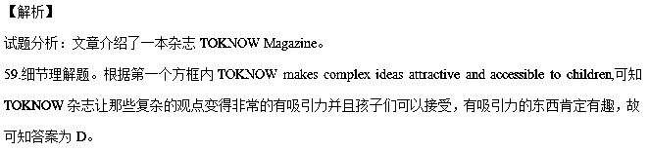60.细节理解题。根据第二个方框内Every month the magazine introduces a fresh new topic with articles, experiments and creative things to make可知杂志每个月都会引入一个新观点，并配有文章，实验等，所以答案为B。
61.细节理解题。根据Annual Subscription with Gift Pack所在部Includes a Mammoth Map, a passport Puzzle Booklet, and Subscription Europe £60 Rest of World £70，中国属于Rest of World，故是£70，答案为D。
62.细节理解题。根据最后一句话Refund Policy—the subscription can be cancelled within 28 days and you can get your money back.可知订阅可在28天内取消，且全额退款，故答案为B。
考点：广告类文章阅读
【名师点睛】
细节理解题的类型：
1、直接信息题
对此类题型，考生可以首先从问题中找到关键词，然后以此为线索，运用略读及查阅的技巧在文中迅速寻找这一细节，找到后再把这一部分内容仔细阅读一遍，仔细比较所给选项与文中细节的细微区别，在准确理解细节的前提下，最后确定最佳答案。60题就是可以直接在文中找到有关信息。
2、间接信息题
做这类题目时，考生需要对原文信息进行加工处理，然后再进行进一步的推理或鉴别，这是介于事实细节题和推理判断题之间的一种题型，对考生来说有一定难度。比如第61题就属于间接信息题，只需要根据题意推知中国属于Rest of World，故是£70，答案为D。
3、数字计算题
数字计算题也是近几年高考中常考的内容，此类试题是在文章中直接表现出来细节事实，有的要经过具体的计算才能够得出正确的答案。具体的计算题可以是对年代的计算、月份的计算或比例的计算等。文章中经常会出现许多数字，它们对解题产生一定的影响。解答此类试题的方法是先来理解文章的大意，然后经过对比、分析、计算等就能够得出正确的答案。
4、排列顺序题
这种试题要求考生根据事件发生的先后顺序和句子之间的逻辑关系，找出事件发生的正确顺序。做这种题时可采用“首尾定位法”，即最先找出第一个事件和最后一个事件，迅速缩小选择范围，从而快速选出正确答案。
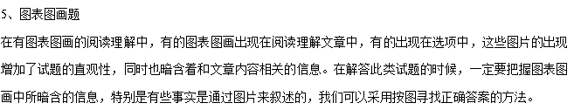15.【2017·北京卷】C
Measles(麻疹), which once killed 450 children each year and disabled even more, was nearly wiped out in the United States 14 years ago by the universal use of the MMR vaccine(疫苗). But the disease is making a comeback, caused by a growing anti-vaccine movement and misinformation that is spreading quickly. Already this year, 115 measles cases have been reported in the USA, compared with 189 for all of last year.
The numbers might sound small, but they are the leading edge of a dangerous trend. When vaccination rates are very high, as they still are in the nation as a whole, everyone is protected. This is called “herd immunity”, which protects the people who get hurt easily, including those who can’t be vaccinated for medical reasons, babies too young to get vaccinated and people on whom the vaccine doesn’t work.
But herd immunity works only when nearly the whole herd joins in. When some refuse vaccination and seek a free ride, immunity breaks down and everyone is in even bigger danger.
That’s exactly what is happening in small neighborhoods around the country from Orange County, California, where 22 measles cases were reported this month, to Brooklyn, N.Y., where a 17-year-old caused an outbreak last year.
The resistance to vaccine has continued for decades, and it is driven by a real but very small risk. Those who refuse to take that risk selfishly make others suffer.
Making things worse are state laws that make it too easy to opt out(决定不参加) of what are supposed to be required vaccines for all children entering kindergarten. Seventeen states allow parents to get an exemption（豁免), sometimes just by signing a paper saying they personally object to a vaccine.
Now, several states are moving to tighten laws by adding new regulations for opting out. But no one does enough to limit exemptions.
Parents ought to be able to opt out only for limited medical or religious reasons. But personal opinions? Not good enough. Everyone enjoys the life-saving benefits vaccines provide, but they’ll exist only as long as everyone shares in the risks.
63．The first two paragraphs suggest that ____________.
A．a small number of measles cases can start a dangerous trend
B．the outbreak of measles attracts the public attention
C．anti-vaccine movement has its medical reasons
D．information about measles spreads quickly
64．Herd immunity works well when ____________.
A．exemptions are allowed
B．several vaccines are used together
C．the whole neighborhood is involved in
D．new regulations are added to the state laws
65．What is the main reason for the comeback of measles?
A．The overuse of vaccine.
B．The lack of medical care.
C．The features of measles itself.
D．The vaccine opt-outs of some people.
66．What is the purpose of the passage?
A．To introduce the idea of exemption.
B．To discuss methods to cure measles.
C．To stress the importance of vaccination.
D．To appeal for equal rights in medical treatment.
【答案】63 A 64 C 65 D 66 C
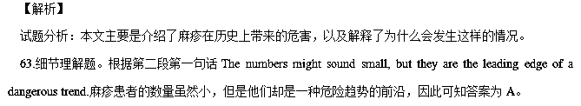
64.细节理解题。根据第三段But herd immunity works only when nearly the whole herd joins in.可知只有群体中所有人都参与进来了群体免疫才会有用，因此答案选C。
65.推理判断题。根据第一段But the disease is making a comeback, caused by a growing anti-vaccine movement and misinformation that is spreading quickly.可知，那些反对注射疫苗的运动和迅速传播的错误信息导致了麻疹疾病的复发，故选D。
66.态度意图题。本文主要是介绍了麻疹在历史上带来的危害，以及为什么会有这样的情况，最根本原因还是那些不注射疫苗的人导致的，故本文的目的是强调疫苗的作用，选C。
考点：医学疾病类文章阅读
【名师点睛】
作者态度及写作意图推断
每一篇文章都会包含作者的某种观点和态度，只不过有的直截了当，有的含而不露，有的通过所用词语的褒贬来体现。此类题可细分为作者态度题(表明作者的好恶)和作者观点题(表明作者对某事物的看法)。准确把握作者的情感和态度，需要注意以下几点：
1.作者对某一事物的看法,要么支持,要么反对,带中立色彩的词最不可能是正确答案。
2.漠不关心类词语往往不对,既然写文章就不会不关心。
3.不要把自己的态度揉入其中,也要区分作者的态度和作者引用的别人的态度。
4.当作者的态度没有明确提出时,要学会根据作者使用词语的褒贬性来判断。
5.作者的观点一般与文章的主旨相关联。
6.绝对化或语气过于强烈的选项常常是错误的,如:strong, complete, entire等。
比如66题，本文主要是介绍了麻疹在历史上带来的危害，以及为什么会有这样的情况，最根本原因还是那些不注射疫苗的人导致的，故本文的目的是强调疫苗的作用，选C。
16.【2017·北京卷】D
Hollywood’s theory that machines with evil(邪恶) minds will drive armies of killer robots is just silly. The real problem relates to the possibility that artificial intelligence(AI) may become extremely good at achieving something other than what we really want. In 1960 a well-known mathematician Norbert Wiener, who founded the field of cybernetics（控制论）, put it this way: “If we use, to achieve our purposes, a mechanical agency with whose operation we cannot effectively interfere(干预), we had better be quite sure that the purpose put into the machine is the purpose which we really desire.”
A machine with a specific purpose has another quality, one that we usually associate with living things: a wish to preserve its own existence. For the machine, this quality is not in-born, nor is it something introduced by humans; it is a logical consequence of the simple fact that the machine cannot achieve its original purpose if it is dead. So if we send out a robot with the single instruction of fetching coffee, it will have a strong desire to secure success by disabling its own off switch or even killing anyone who might interfere with its task. If we are not careful, then, we could face a kind of global chess match against very determined, super intelligent machines whose objectives conflict with our own, with the real world as the chessboard.
The possibility of entering into and losing such a match should concentrate the minds of computer scientists. Some researchers argue that we can seal the machines inside a kind of firewall, using them to answer difficult questions but never allowing them to affect the real world. Unfortunately, that plan seems unlikely to work: we have yet to invent a firewall that is secure against ordinary humans, let alone super intelligent machines.
Solving the safety problem well enough to move forward in AI seems to be possible but not easy. There are probably decades in which to plan for the arrival of super intelligent machines. But the problem should not be dismissed out of hand, as it has been by some AI researchers. Some argue that humans and machines can coexist as long as they work in teams—yet that is not possible unless machines share the goals of humans. Others say we can just “switch them off” as if super intelligent machines are too stupid to think of that possibility. Still others think that super intelligent AI will never happen. On September 11, 1933, famous physicist Ernest Rutherford stated, with confidence, “Anyone who expects a source of power in the transformation of these atoms is talking moonshine.” However, on September 12, 1933, physicist Leo Szilard invented the neutron-induced(中子诱导) nuclear chain reaction.
67. Paragraph 1 mainly tells us that artificial intelligence may .
A. run out of human control
B. satisfy human’s real desires
C. command armies of killer robots
D. work faster than a mathematician
68. Machines with specific purposes are associated with living things partly because they might be able to .
A. prevent themselves from being destroyed
B achieve their original goals independently
C. do anything successfully with given orders
D. beat humans in international chess matches
69. According to some researchers, we can use firewalls to .
A. help super intelligent machines work better
B. be secure against evil human beings
C. keep machines from being harmed
D. avoid robots’ affecting the world
70. What does the author think of the safety problem of super intelligent machines?
A. It will disappear with the development of AI.
B. It will get worse with human interference.
C. It will be solved but with difficulty.
D. It will stay for a decade.
【答案】67 A 68 A 69 D 70 C
【解析】
试题分析：本文主要介绍了人工智能，它会给我们的生活带来什么样的影响。
67.推理判断题。根据第一段The real problem relates to the possibility that artificial intelligence(AI) may become extremely good at achieving something other than what we really want.可知人工智能可能会出现的真正问题是AI会非常擅长取得某个成就而不是我们真正想要的东西，也就是说AI可能会超出人的控制去做一些事情，故选A。
68.推理判断题。根据第二段第一句A machine with a specific purpose has another quality, one that we usually associate with living things: a wish to preserve its own existence.可知，原因是保护它自己的存在的一种愿望，也就是说，它具有有生命的物体的一种品质是因为它要保护自己不被破坏，继续存在下去，故选A。
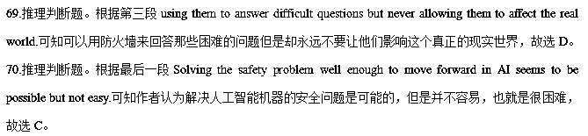【名师点睛】
推理判断题属于主观题，是层次较高的题目。它包括判断题和推理题。这两类题常常相互依存，推理是为了作出正确的判断，正确的判断又依赖于合乎逻辑的推理。此类题要求在理解表面文字的基础上，作出判断和推论，从而得到文章的隐含意思和深层意思，也就是通过文章中的文字信息、上下文的逻辑关系及事物的发展变化等已知的信息，推断出作者没有直接表达的态度和观点。
推理判断题的解题方法 ：
推理判断题不仅要求考生读懂文章中的每个句子的意思还要推理它们之间的关系，结合自己的生活常识和经验，再通过逻辑推理和判断，理解文章的言外之意，从而揭示文章的深层涵义。
任何一篇文章都有其特定的写作目的，读者需要知道如何去做或按照某种方式思考问题。推理判断题的答案不可能在文章中直接找到，因此推理时我们务必要忠于原文，在文章中寻找并确定可推论的依据，即：已知部分－推论的前提，从中推测出未知部分－推理的结论，切忌妄加评论，把自己的观点当成作者的观点。
17.【2017·天津卷】A
Suppose you’re in a rush, feeling tired, not paying attention to your screen, and you send an email that could get you in trouble.
Realisation will probably set in seconds after you’ve clicked “send”. You freeze in horrors and burn with shame.
What to do? Here are four common email accidents, and how to recover.
Clicking “send” too soon
Don’t waste your time trying to find out if the receivers has read it yet. Write another email as swiftly as you can and send it with a brief explaining that this is the correct version and the previous version should be ignored.
Writing the wrong time
The sooner you notice, the better. Respond quickly and briefly, apologizing for your mistake. Keep the tone measured: don’t handle it too lightly, as people can be offered, especially if your error suggests a misunderstanding of their culture(I.e. incorrect ordering of Chinese names).
Clicking “reply all” unintentionally
You accidentally reveal(透露)to entire company what menu choices you would prefer at the staff Christmas dinner, or what holiday you’d like to take. In this instance, the best solution is to send a quick, light-hearted apology to explain your awkwardness. But it can quickly rise to something worse, when everyone starts hitting “reply all” to join in a long and unpleasant conversation. In this instance, step away from your keyboard to allow everyone to calm down.
Sending an offensive message to it’s subject
The most awkward email mistake is usually committed in anger. You write an unkind message about someone, intending to send it to a friend, but accidentally send it to the person you’re discussing. In that case, ask to speak in person as soon as possible and say sorry. Explain your frustrations calmly and sensibly—see it as an opportunity tic hear up any difficulties you may have with this person.
36. After realizing an email accident, you are likely to feel _______.
A. curious B. tired C. awful D. funny
37. If you have written the wrong name in an email, it is best to ________.
A. apologise in a serious manner
B. tell the receiver to ignore the error
C. learn to write the name correctly
D. send a short notice to everyone
38. What should you do when an unpleasant conversation is started by your “reply all” email?
A. Try offering other choices.
B. Avoid further involvement.
C. Meet other staff members.
D. Make a light-hearted apology.
39. How should you deal with the problem caused by an offensive email?
A. By promising not to offend the receiver again.
B. By seeking support from the receiver’s friends.
C. By asking the receiver to control his anger.
D. By talking to the receiver face to face.
40. What is the passage mainly about?
A. Defining email errors.
B. Reducing email mistakes.
C. Handling email accidents.
D. Improving email writing.
【语篇解读】这是一篇说明文。介绍了因为失误而发错信息的补救方法。
36.【答案】C
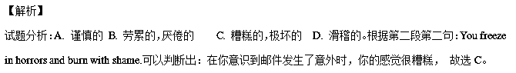考点：考查细节理解。
37.【答案】A
【解析】
试题分析：根据第二个标题句Writing the wrong time后面内容Respond quickly and briefly, apologizing for your mistake. Keep the tone measured: don’t handle it too lightly, as people can be offered, especially if your error suggests a misunderstanding of their culture(I.e. incorrect ordering of Chinese names).可以拍判断出：你在邮件上写错了名字，最好以认真的方式道歉，故选A。
考点：考查细节理解。
38.【答案】B
【解析】
试题分析：根据第三标题句Clicking “reply all” unintentionally下面内容的最后一句话：
In this instance, step away from your keyboard to allow everyone to calm down在这种情况下，远离键盘让大家冷静下来，即避免进一步的牵涉。故选B。
考点：考查细节理解。
39.【答案】D
【解析】
试题分析：据最后最后一个标题句下面内容In that case, ask to speak in person as soon as possible and say sorry，在这种情况下尽快的去当面说声和道歉，故选D。
考点：考查细节理解。
40.【答案】C
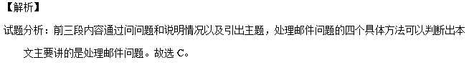考点：考查主旨大意。
【名师点睛】这是一篇说明文，题目比较简单的，考查细节题为主。可以使用信息筛选法做题。为了节省时间，可以用先看题目，带着题目在文中寻读的方法找到主题句，理解并找出正确答案。如36题，题目问：在你意识到你的邮件问题时你可能会感到_____，而文章中第二段就是题干信息，后面就是答案，答案是很明显的。
18.【2017·天津卷】B
Fifteen years ago, I took a summer vacation in Lecce in southern Italy. After climbing up a hill for a panoramic(全景的) view of the blue sea, white buildings and green olive trees, I paused to catch my breath and then positioned myself to take the best photo of this panorama.
Unfortunately, just as I took out my camera, a woman approached from behind, and planted herself right in front of my view. Like me, this woman was here to stop, sigh and appreciate the view.
Patient as I was, after about 15 minutes, my camera scanning the sun and reviewing the shot I would eventually take, I grew frustrated. Was it too much to ask her to move so I could take just one picture of the landscape? Sure, I could have asked her, but something prevented me from doing so. She seemed so content in her observation. I didn’t want to mess with that.
Another 15 minutes passed and I grew bored. The woman was still there. I decided to take the photo anyway. And now when I look at it, I think her presence in the photo is what makes the image interesting. The landscape, beautiful on its own, somehow coms to life and breathes because this woman is engaging with it.
This photo, with the unique beauty that unfolded before me and that woman who “ruined” it, now hangs on a wall in my bedroom. What would she think if she knew that her figure is captured(捕捉) and frozen on some stranger’s bedroom wall? A bedroom, after all, is a very private space, in which some woman I don’t even know has been immortalized(使……永存). In some ways, she lives in my house.
Perhaps we all live in each others’ space. Perhaps this is what photos are for: to remind us that we all appreciate beauty, that we all share a common desire for pleasure, for connection, for something that is greater than us.
That photo is a reminder, a captured moment, an unspoken conversation between two women, separated only by a thin square of glass.
41. What happened when the author was about to take a photo?
A. Her camera stopped working.
B. A woman blocked her view.
C. Someone asked her to leave
D. A friend approached from behind.
42. According to the author, the woman was probably_______.
A. enjoying herself
B. losing her patience
C. waiting for the sunset
D. thinking about her past
43. In the author’s opinion, what makes the photo so alive?
A. The rich color of the landscape.
B. The perfect positioning of the camera.
C. The woman’s existence in the photo.
D. The soft sunlight that summer day.
44. The photo on the bedroom wall enables the author to better understand ________.
A. the need to be close to nature
B. the importance of private space
C. the joy of the vacation in Italy
D. the shared passion for beauty
45. The passage can be seen as the author’s reflections upon _______.
A. a particular life experience
B. the pleasure of traveling
C. the art of photography
D. a lost friendship
【语篇解读】这是一篇记叙文。本文讲述了作者一次旅行的特殊经历带给作者的深思和感悟。
41.【答案】B
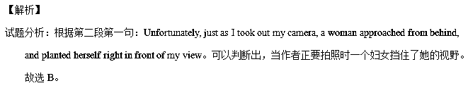考点：考查细节理解。
42.【答案】A
【解析】
试题分析：根据第三段的句子She seemed so content in her observation.她好像那么的满足于她的观察（欣赏风景），即在作者看来，那个妇女很可能很愉快。故选A。
考点：考查细节理解。
43.【答案】C
【解析】
试题分析：根据第四段的句子 The landscape, beautiful on its own, somehow coms to life and breathes because this woman is engaging with it可以判断出作者认为是因为照片中有了这个妇女的存在使这张照片有了活力和生机.。故选C。
考点：考查细节理解。
44.【答案】D
【解析】
试题分析：根据倒数第二段中Perhaps this is what photos are for: to remind us that we all appreciate beauty,可以判断出：挂在卧室墙上的照片使作者更好的理解了人们共有的欣赏追求美的激情 。故选D。
考点：考查推理判断。
45.【答案】A
【解析】
试题分析：通读全文可知，前四段讲述这次印度旅行的特殊经历，后三段讲述这次特殊经历带给作者的感悟， 所以这篇文章可以看做是作者对于一次特殊经历的深入思考。故选A。
考点：考查推理判断。
【名师点睛】这是一篇故事类短文，题目设置都以细节题为主，推理判断为辅。细节题一般就是文章出现的内容即是答案，也有推理判断题，就是不是通过题干的某个单词定位到文中能直接看出答案来的，要通过故事中所陈述的内容来推理判断。做题时不能流于表面。可以适当运用一些解题技巧。
做推理判断题要善于抓住某一段话中的关键信息，即某些关键词或短语去分析、推理、判断，利用逆向思维或正面推理，从而推断出这句话所隐含的深层含义。比如45题，问这篇文章是作者对___ 的思考，答案是根据最后三段内容推理出来的。
19.【2017·天津卷】C
This month, Germany’s transport minister, Alexander Dobrindt, proposed the first set of rules for autonomous vehicles(自主驾驶车辆). They would define the driver’s role in such cars and govern how such cars perform in crashes where lives might be lost.
The proposal attempts to deal with what some call the “death valley” of autonomous vehicles: the grey area between semi-autonomous and fully driverless cars that could delay the driverless future.
Dobrindt wants three things: that a car always chooses property(财产) damage over personal injury; that it never distinguishes between humans based on age or race; and that if a human removes his or her hands from the driving wheel — to check email, say — the car’s maker is responsible if there is a crash.
“The change to the road traffic law will permit fully automatic driving,” says Dobrindt. It will put fully driverless cars on an equal legal footing to human drivers, he says.
Who is responsible for the operation of such vehicles is not clear among car makers, consumers and lawyers. “The liability(法律责任) issue is the biggest one of them all,” says Natasha Merat at the University of Leeds, UK.
An assumption behind UK insurance for driverless cars, introduces earlier this year, insists that a human “ be watchful and monitoring the road” at every moment.
But that is not what many people have in mind when thinking of driverless cars. “When you say ‘driverless cars’, people expect driverless cars.”Merat says. “You know — no driver.”
Because of the confusion, Merat thinks some car makers will wait until vehicles can be fully automated without operation.
Driverless cars may end up being a form of public transport rather than vehicles you own, says Ryan Calo at Stanford University, California. That is happening in the UK and Singapore, where government-provided driverless vehicles are being launched.
That would go down poorly in the US, however. “The idea that the government would take over driverless cars and treat them as a public good would get absolutely nowhere here,” says Calo.
46. What does the phrase “death valley” in Paragraph 2 refer to?
A. A place where cars often break down.
B. A case where passing a law is impossible.
C. An area where no driving is permitted.
D. A situation where drivers’ role is not clear.
47. The proposal put forward by Dobrindt aims to __________.
A. stop people from breaking traffic rules
B. help promote fully automatic driving
C. protect drivers of all ages and races
D. prevent serious property damage
48. What do consumers think of the operation of driverless cars?
A. It should get the attention of insurance companies.
B. It should be the main concern of law makers.
C. It should not cause deadly traffic accidents.
D. It should involve no human responsibility.
49. Driverless vehicles in public transport see no bright future in __________.
A. Singapore
B. the UK
C. the US
D. Germany
50. What could be the best title for passage?
A. Autonomous Driving: Whose Liability?
B. Fully Automatic Cars: A New Breakthrough
C. Autonomous Vehicles: Driver Removed
D. Driverless Cars: Root of Road Accidents
【语篇解读】这是一篇记叙文。文章记叙了德国交通部长的对于自主驾驶车辆的规章制度的一个提议，引出说明了位于科技前沿的无人驾驶的自动化车辆在英国、新加坡和美国的不同前景。
46.【答案】D
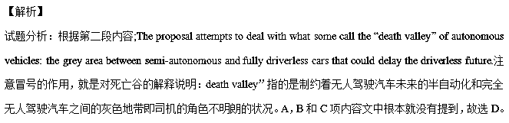考点：考查词义猜测。
47.【答案】B
【解析】
试题分析：根据第二段的句子The proposal attempts to deal with what some call the “death valley” of autonomous vehicles:和第四段内容The change to the road traffic law will permit fully automatic driving,” says Dobrindt. It will put fully driverless cars on an equal legal footing to human drivers, he says.可以判断出这个提议被提出是为了推动完全自动化的驾驶。故选B。
考点：考查推理判断。
48.【答案】D
【解析】
试题分析：根据第七段内容But that is not what many people have in mind when thinking of driverless cars. “When you say ‘driverless cars’, people expect driverless cars.”Merat says. “You know — no driver.” 可知消费者认为对于无人驾驶车辆的运行不应该牵涉到人的责任。故选D。
考点：考查细节理解。
49.【答案】C
【解析】
试题分析：根据最后一段That would go down poorly in the US, however. “The idea that the government would take over driverless cars and treat them as a public good would get absolutely nowhere here,” says Calo.可知公共交通工具中无人驾驶车看不到未来是在美国。故选C。
考点：考查细节理解。
50.【答案】A
【解析】
试题分析：通读全文可以知道，本文主要讲述了德国交通部长的提议是为了促进无人驾驶车运行，界定了汽车制造方负责，由此在第五段引出全文的主题句:Who is responsible for the operation of such vehicles is not clear among car makers, consumers and lawyers. 下面就此展开陈述。所以：自动化驾驶：谁的责任可以概括全文，充当本文题目，故选A。
考点：考查主旨大意。
【名师点睛】这篇文章内容和每个人生活密切相关，讲的是谁对这种新型交通工具：无人驾驶的全自动化的车辆负责各国意见不一，学生应该有兴趣阅读，涉及到科技前沿，文章篇幅适中。考查比较全面，除了理解细节题，还需要适当的推理，还有词义辨析类的题目，对学生能力考查比较全面。
做词义辨析类的题目，要仔细阅读这个词所在的前后的句子，发现有没有关联的同义词，反义词或是这个词的定义，分析这篇阅读的46题，要求对含有这个短语的整个句子的正确理解以及标点符号的作用。
20.【2017·天津卷】D
I read somewhere that we spend a full third of our lives waiting. But where are we doing all of this waiting, and what does it mean to an impatient society like ours? To understand the issue, let’s take a look at three types of “waits”.
The very purest form of waiting is the Watched-Pot Wait. It is without doubt the most annoying of all. Take filling up the kitchen sink(洗碗池) as an example. There is absolutely nothing you can do while this is going on but keep both eyes fixed on the sink until it’s full. During these waits, the brain slips away from the body and wanders about until the water runs over the edge of the counter and onto your socks. This kind of wait makes the waiter helpless and mindless.
A cousin to the Watched-Pot Wait is the Forced Wait. This one requires a bit of discipline. Properly preparing packaged noodle soup required a Forced Wait. Directions are very specific. “Bring three cups of water to boil, add mix, simmer three minutes, remove from heat, let stand five minutes.”I have my doubts that anyone has actually followed the procedures strictly. After all, Forced Waiting requires patience.
Perhaps the most powerful type of waiting is the Lucky-Break Wait. This type of wait is unusual in that it is for the most part voluntary. Unlike the Forced Wait, which is also voluntary, waiting for your lucky break does not necessarily mean that it will happen.
Turning one’s life into a waiting game requires faith and hope, and is strictly for the optimists among us. On the surface it seems as ridiculous as following the directions on soup mixes, but the Lucky-Break Wait well serves those who are willing to do it. As long as one doesn’t come to rely on it, wishing for a few good things to happen never hurts anybody. zxxk
We certainly do spend a good deal of our time waiting. The next time you’re standing at the sink waiting for it to fill while cooking noodle soup that you’ll have to eat until a large bag of cash falls out of the sky, don’t be desperate. You’re probably just as busy as the next guy.
51. While doing a Watched-Pot Wait, we tend to ___________.
A. keep ourselves busy
B. get absent-minded
C. grow anxious
D. stay focused
52. What is the difference between the Forced Wait and the Watched-Pot Wait?
A. The Forced Wait requires some self-control.
B. The Forced Wait makes people passive.
C. The Watched-Pot Wait needs directions.
D. The Watched-Pot Wait engages body and brain.
53. What can we learn about the Lucky-Break Wait?
A. It is less voluntary than the Forced Wait.
B. It doesn’t always bring the desired result.
C. It is more fruitful than the Forced Wait.
D. It doesn’t give people faith and hope.
54. What does the author advise us to do the next time we are waiting?
A. Take it seriously.
B. Don’t rely on others.
C. Do something else.
D. Don’t lose heart.
55. The author supports his view by _________.
A. exploring various causes of “waits”.
B. describing detailed processes of “waits”.
C. analyzing different categories of “waits”
D. revealing frustrating consequences of “waits”
【语篇解读】这是一篇议论文。文章主要通过介绍三种不同种类的等待来论述我们花费大量的时间来等待而且说明自己的观点，充满希望和信念去等待。
51.【答案】B
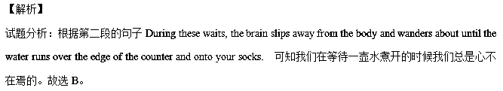考点：考查细节理解。
52.【答案】A
【解析】
试题分析：根据第三段第一句A cousin to the Watched-Pot Wait is the Forced Wait. This one requires a bit of discipline可知，被迫的等待和留意的等待之间的区别在于被迫的等待需要纪律即自控.，故选A。
考点：考查细节理解。
53.【答案】B
【解析】
试题分析：根据第四段的句子which is also voluntary, waiting for your lucky break does not necessarily mean that it will happen.可知等待你的好运不一定意味着就会发生，即不一定带来渴望的结果 。故选B。
考点：考查细节理解。
54.【答案】D
【解析】
试题分析：根据第最后一段中The next time you’re standing at the sink waiting for it to fill while cooking noodle soup that you’ll have to eat until a large bag of cash falls out of the sky, don’t be desperate. .。可以判断出当我们下一次等待的时候我们不要绝望即不要灰心。故选D。
考点：考查细节理解。
55.【答案】C
【解析】
试题分析：通读全文可以知道，作者通过2,3,4段列举了三种类型的等待，最后总结和表明了自己观点，所以判断出作者是通过分析不同种类的等待来支持自己的观点的。故选C。
考点：考查标题判断。
【名师点睛】这篇文章内容是非常贴近生活的，篇幅适中较长，要求学生快速阅读材料，在掌握文章大意的前提下答题。考查题型以理解细节题为主，还要学生结合文章作出推理判断，这些不是某个句子可以体现的，要对文章有整体把握。
这篇文章最后一题就是推理判断题。学生对于55题推理判断题能很好的把握，根据文章中第二三四段的首句即主题句就可以正确理解不难得出答案。
21.【2017·浙江卷】A
Benjamin West, the father of American painting, showed his talent for art when he was only six years of age. But he did not know about brushes before a visitor told him he needed one. In those days , a brush was made from camel’s hair. There were no camels nearby. Benjamin decided that cat hair would work instead. He cut some fur from the family cat to make a brush.
The brush did not last long. Soon Benjamin needed more fur. Before long, the catbegan to look ragged （蓬乱）. His father said that the cat must be sick. Benjamin was forced to admit what he had been doing.
The cat’s lot was about to improve. That year, one of Benjamin’s cousins, Mr.Pennington, came to visit. He was impressed with Benjamin’s drawings. When he went home, he sent Benjamin a box of paint and some brushes. He also sent six engravings （版画）by an artist. These were the first pictures and first real paint and brushes Benjamin had ever seen. In 1747，when Benjamin was nine years old，Mr.Pennington retured for another visit .He was amazed at what Benjamin had done with his gift.He asked Benjamin’s parents if he might take the boy to Philadelphia for a visit.
In the city, Mr.Pennington gave Benjamin materials for creating oil paintings.The boy began a landscape (风景) painting.Wiliams ,a well-known painter,came to see him work . Wiliams was impressed with Benjamin and gave him two classic books on painting to take home .The books were long and dull. Benjamin could read only a little,having been a poor student.But he later said,”Those two books were my companions by day,and under my pillow at night.”While it is likely that he understood very little of the books,they were his introduction to classical paintings.The nine-year-old boy decided then that he would be an artist.
21. What is the text mainly about?
A. Benjamin’s visit to Philadelphia.
B. Williams’ influence on Benjamin.
C. The beginning of Benjamin’s life as an artist.
D. The friendship between Benjamin and Pennington.
22. What does the underlined sentence in paragraph 3 suggest?
A. The cat would be closely watched.
B. The cat would get some medical care.
C. Benjamin would leave his home shortly.
D. Benjamin would have real brushes soon.
23. What did Pennington do to help Benjamin develop his talent?
A. He took him to see painting exhibitions.
B. He provided him with painting materials.
C. He sent him to a school in Philadelphia.
D. He taught him how to make engravings.
24. Williams’ two books helped Benjamin to ________.
A. master the use of paints
B. appreciate landscape paintings
C. get to know other painters
D. make up his mind to be a painter
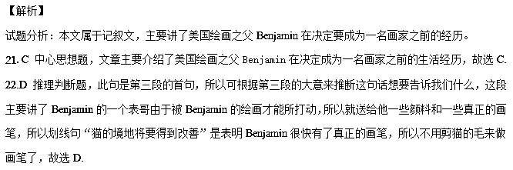23.B细节理解题，根据最后一段“Mr. Pennington gave Benjamin materials for creating oil paintings”, 可知Pennington为了帮助Benjamin培养绘画天赋，给他提供了一些绘画材料，故选B.
24.D细节理解题，根据最后一段“While it is likely that he understood very little of the books, they were his introduction to classical paintings. The nine-year-old boy decided then that he would be an artist, 可知：这两本书帮助Benjamin坚定了自己成为一名画家的决心，故选D.
【名师点睛】
本文后两个小题考查了细节题。在完成细节题时，要特别注意排除干扰项。如中的D项“He taught him how to make engravings”属于“偷梁换柱”类干扰项，根据第三段第五句“He also sent six engravings by an artist”可知“这些版画是Pennington送给Benjamin的”，并非是Pennington教Benjamin如何画版画，说明D项明显错误。
干扰项的设置方法通常有以下几种方式：
1. 张冠李戴。命题者把文章作者的观点与他人的观点混淆起来，题干问的是作者的观点，选项中出现的却是他人的观点；或者题干问的是他人的观点，却把作者的观点放到选项中去。
2. 偷梁换柱。干扰项用了与原文相似的句型结构和大部分相似的词汇，却在不易引人注意的地方换了几个词汇，造成句意的改变。
3. 无中生有。干扰项往往是生活的基本常识和普遍接受的观点，但在原文中并无相关的信息支持点，这种选项的设置往往与问题的设问毫不相干。
4. 以偏概全。考生在做猜测文章中心思想、给文章添加标题或判断推理题时，往往会犯以偏概全的错误。产生这类错误的原因是考生受思维定势的影响或考虑不周，以局部代替整体。其具体表现为合理关联与不合理关联、准确概括与不准确概括之间的错位。不合理关联就是表层理解与深层理解相混淆。表层理解是对文章中客观事实的感知和记忆，往往是文章直接表述的结论；深层理解则是对文章中的客观事实进行逻辑推理、总结或概括后得出的结论。不准确概括是指不能准确地按题目要求概括或提取文中的表层或深层信息。
考点：考查记叙文阅读
22.【2017·浙江卷】B
Getting less sleep has become a bad habit for most American kids. According to a new survey(调查) by the National Sleep Foundation, 51% of kids aged 10 to 18 go to bed at 10 pm or later on school nights, even though they have to get up early. Last year the Foundation reported that nearly 60% of 7- to 12-year-olds said they felt tired during the day, and 15% said they had fallen asleep at school.
How much sleep you need depends a lot on your age. Babies need a lot of rest: most of them sleep about 18 hours a day! Adults need about eight hours. For most school-age children, ten hours is ideal(理想的). But the new National Sleep Foundation survey found that 35% of 10- to 12-year-olds get only seven or eight hours. And guess what almost half of the surveyed kids said they do before bedtime? Watch TV.
“More children are going to bed with TVs on, and there are more opportunities(机会) to stay awake, with more homework, the Internet and the phone,” says Dr. Mary Carskadon, a sleep researcher at Brown University Medical School. She says these activities at bedtime can get kids all excited and make it hard for them to calm down and sleep. Other experts say part of the problem is chemical. Changing levels of body chemicals called hormones not only make teenagers’ bodies develop adult characteristics, but also make it hard for teenagers to fall asleep before 11 pm.
Because sleepiness is such a problem for teenagers, some school districts have decided to start high school classes later than they used to. Three years ago, schools in Edina, Minnesota, changed the start time from 7:25 am to 8:30 am. Students, parents and teachers are pleased with the results.
25. What is the new National Sleep Foundation survey on?
A. American kids’ sleeping habits. B. Teenagers’ sleep-related diseases.
C. Activities to prevent sleeplessness. D. Learning problems and lack of sleep.
26. How many hours of sleep do 11-year-olds need every day?
A. 7 hours. B. 8 hours. C. 10 hours. D. 18 hours.
27. Why do teenagers go to sleep late according to Carskadon?
A. They are affected by certain body chemicals.
B. They tend to do things that excite them.
C. They follow their parents’ examples.
D. They don’t need to go to school early.
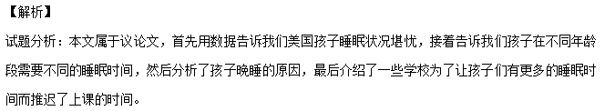25.A细节理解题，根据文中第一段列举了一些数据，向我们说明美国有51%的10到18岁的孩子上床睡觉的时间偏晚，也调查了60%的7到12岁的孩子在白天感到疲惫，15%的孩子会在学校睡着，所以这些调查都是关于美国孩子的睡眠习惯的，故选A.
26.C细节理解题，根据第二段“For most school-age children, ten hours is ideal”, 所以11岁的上学小孩子的睡眠时间需要10个小时，故选C.
27.B细节理解题，根据第三段“She says these activities at bedtime can get kids all excited and make it hard for them to calm down and sleep”,所以她认为孩子们睡觉晚的原因是他们会在睡前做一些让他们兴奋的活动，故选B.
【名师点睛】
本文属于议论类短文，所考查三题均为细节题中的直接理解题。细节事实理解题主要考查考生对文章中某一些特定细节或文章的重要实事的理解能力。它一般包括直接理解题和语义理解题两种。直接理解题的答案与原文直接挂钩，从阅读材料中可以找到。这种题难度低，只要学生读懂文章，就能得分，属于低层次题。
在阅读中可以使用定位法与跳读法解决直接理解题。定位法即根据题干和选项所提供的信息直接从原文中找到相应的句子(即定位)，然后进行比较和分析(尤其要注意一些同义转换)，从而找出正确答案。跳读法即根据题干和选项所提供的信息跳读原文，并找到相关的句子(有时可能是几个句子)或段落，然后进行分析和推理等，从而找出正确答案。
以本文为例，我们根据题干中“How many hours of sleep do 11-year-olds need every day”11岁的孩子每天需要多少小时的睡眠时间，直接定位第二段第三句For most school-age children, ten hours is ideal.可知上学的孩子需要10小时的理想睡眠时间，故选择C项。
考点：考查议论文类阅读
23.【2017·浙江卷】C
FLORENCE, Italy—Svetlana Cojochru feels hurt. The Moldovan has lived here seven years as a caregiver to Italian kids and the elderly, but in order to stay she’s had to prove her language skills by taking a test which requires her to write a postcard to an imaginary friend and answer a fictional job ad.
Italy is the latest Western European country trying to control a growing immigrant(移民) population by demanding language skills in exchange for work permits, or in some cases, citizenship.
Some immigrant advocates worry that as hard financial times make it more difficult for natives to keep jobs, such measures will become more a vehicle for intolerance than integration(融合). Others say it’s only natural that newcomers learn the language of their host nation, seeing it as a condition to ensure they can contribute to society.
Other European countries laid down a similar requirement for immigrants, and some terms are even tougher. The governments argue that this will help foreigners better join the society and promote understanding across cultures.
Italy, which has a much weaker tradition of immigration, has witnessed a sharp increase in immigration in recent years. In 1990, immigrants numbered some 1.14 million out of Italy’s then 56.7 million people, or about 2 percent. At the start of this year, foreigners living in Italy amounted to 4.56 million of a total population of 60.6 million, or 7.5 percent, with immigrants’ children accounting for an even larger percentage of births in Italy.
Cojochru, the Moldovan caregiver, hoped obtaining permanent residence(居住权) would help her bring her two children to Italy; they live with her sister in Moldova, where salaries are among the lowest in Europe. She was skeptical that the language requirement would encourage integration.
Italians always “see me as a foreigner,” an outsider, even though she’s stayed in the country for years and can speak the local language fluently, she said.
28. Why does Cojochru have to take a language test?
A. To continue to stay in Italy. B. To teach her children Italian.
C. To find a better job in Italy. D. To better mix with the Italians.
29. Some people worry that the new language requirement may ________.
A. reduce Italy’s population quickly B. cause conflicts among people
C. lead to financial difficulties D. put pressure on schools
30. What do we know about Cojochru?
A. She lives with her sister now in Italy.
B. She enjoys learning the Italian language.
C. She speaks Italian well enough for her job.
D. She wishes to go back to her home country.
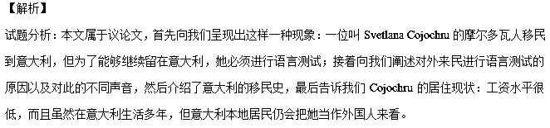28.A细节理解题，根据第一段第二句“but in order to stay she’s had to prove her language skills by taking a test…”可知，Cojochru为了能够继续留在意大利才要参加语言考试的，故选A.
29.B推理判断题，根据第三段第一句“,such measures will become more a vehicle for intolerance than integration”,可知一些人担心对语言水平的要求可能会造成人与人之间的不包容，即冲突，故选B.
30.C细节理解题，根据最后一段最后一句“,even though she ‘s stayed in the country for years and can speak the local language fluently”可知Cojochru的意大利语已经说的很流利了，足够应付工作，故选C.
【名师点睛】
本文属于推理判断题，根据题干“Some people worry that the new language requirement may…”, 抓住关键词worry，可以从文中第三段第一句话进行推断：Some immigrant advocates worry that as hard financial times make it more difficult for natives to keep jobs, such measures will become a more vehicle for intolerance than integration. 根据关键信息intolerance可判断对语言的要求会造成外来居民和本地居民的不融合，即矛盾，从而选出正确答案。
推理判断题是历届考生失分较多的题型，因为此类题不仅要求考生理解具体事实细节，也要理解抽象含义，推理题的解题方法有：
- 抓住特定的信息进行逆向或正向推理：善于抓住某一段话中的关键信息，即某些关键词或短语去分析，利用逆向思维或正向推理，从而推断出这句话所隐藏的深层含义。（29小题使用的就是这种方法）
- 结合全文（段）进行推断：做推理题时，需要在弄懂全文意思的基础上，整合与题目相关的有用信息，综合起来进行推理判断，从而确定最佳结论。
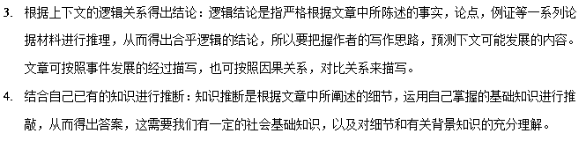考点：考查议论文类阅读
24.【2017·江苏卷】A
CHRONOLOGICA
—The Unbelievable Years that Defined History
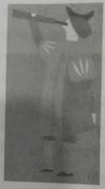
DID YOU KNOW…
- In 105AD paper was invented in China?
When Columbus discovered the New World?
The British Museum opened in 1759?
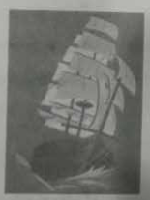
CHRONOLOGICA is a fascinating journey through time, from the foundation of Rome to the creation of the internet. Along the way are tales of kings and queens, hot air balloons…and monkeys in space.
Travel through 100 of the most unbelievable years in world history and learn why being a Roman Emperor wasn’t always as good as it sounds, how the Hundred Years’ War didn’t actually last for 100 years and why Spencer Perceval holds a rather unfortunate record.
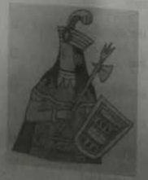
CHRONOLOGICA is an informative and entertaining tour into history, beautifully illustrated and full of unbelievable facts. While CHRONOLOGICA tells the stories of famous people in history such as Thomas Edison and Alexander the Great, this book also gives ab account of the lives of lesser-known individuals including the explorer Mungo Park and sculptor Gutzon Borglum.
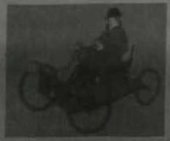
This complete but brief historical collection is certain to entertain readers young and old,and guaranteed to present even the biggest history lover with something new!
56.What is CHRONOLOGICA according to the next?
A. A biography. B. A travel guide.
C. A history book. D. A science fiction.
57.How does the writer recommend CHRONOLOGICA to readers?
A. By giving details of its collection. B. By introducing some of its contents.
C. By telling stories at the beginning. D. By comparing it with other books.
【答案】56. C 57. B
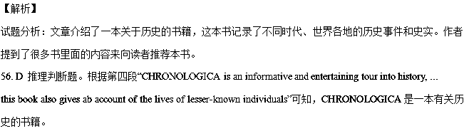
- B推理判断题。作者在文中以提问的方式提到很多与历史有关的人物或事件，像“from the foundation of
Rome to the creation of the internet. ...tales of kings and queens, hot air balloons…and monkeys in space...why
being a Roman Emperor wasn’t always as good as it sounds, how the Hundred Years’ War didn’t actually last for
100 years and why Spencer Perceval holds a rather unfortunate record”，说明作者是在引用书中的内容；文章没
有提及其它书籍，因此不是使用了对比手法。
【名师点睛】
推断文章出处是高考英语阅读中一个比较常见的考点。主要考查考生能否从内容特点、文体特点、语言风格等判断出所读文章的具体出处。比如，如果所读材料具有较强的时效性或新闻性，则可能出自新闻报道；如果所读材料侧重历史事实，且措辞严谨，则可能出自历史教科书；如果所读材料中涉及工作要求、工资待遇、联系电话等，则可能出自招聘广告；如果所读材料轻松、休闲，则可能出自旅游杂志或休闲杂志等。第56题属于这一类题目。根据文章中出现的历史事件不难推断出CHRONOLOGICA是一本历史书。
考点：考查信息类短文阅读
B
Before birth, babies can tell the difference between loud sounds and voices. They can even distinguish their mother’s voice from that of a female stranger. But when it comes to embryonic learning(胎教), birds could rule the roost. As recently reported in The Auk: Ornithological Adrances, some mother birds may teach their young to sing even before they hatch(孵化). New-born chicks can then imitate their mom’s call within a few days of entering the world.
This educational method was first observed in 2012 by Sonia Kieindorfer,a biologist at Flinders University in South Australia, and her colleagues. Femake Australian superb fairy wrens were found to repeat one sound over and over again while hatching their errs, when the errs were hatched, the baby birds made the similar chirp to their mothers—around that served as their regular “feed me!” call.
To find out if the special quality was more widespread in birds, the researchers sought the red-backed fairy wren, another species of Australian songbird. First they collected sound data from 67 nests in four sites in Queensland before and after hatching. Then they identified begging calls by analyzing the order and number of notes. A computer analysis blindly compared calls produced by mothers and chicks, ranking them by similarity.
It turns out that baby red-backed fairy wrens also emerge chirping like their moms. And the more frequently mothers had called to their errs, the more similar were the babies’ begging calls. In addition, the team set up a separate experiment that suggested that the baby birds that most closely imitated their mom’s voice were rewarded with the most food.
This observation hints that effective embryonic learning could signal neurological(神经系统的) strengths of children to parents. An evolutionary inference can then be drawn.” As a parent, do you invest in quality children, or do you invest in children that are in need?” Kleindorfer asks.” Our results suggest that they might be going for quality.”
58.The underlined phrase in Paragraph 1 means“ ”.
A. be the worst B. be the best C. be the as bad D. be just as good
59.What are Kleindorfer’s findings based on?
A. Similarities between the calls moms and chicks. B. The observation of fairy wrens across Australia.
C. The data collected from Queensland’s locals. D. Controlled experiments on wrens and other birds.
60.Embryonic learning helps mother birds to identify the baby birds which .
A. can receive quality signals B. are in need of training
C. fit the environment better D. make the loudest call
【名师点睛】
【答案】58.B 59.A 60.C
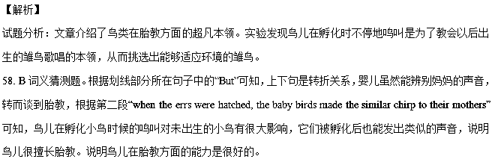59. A细节理解题。根据第二段“Femake Australian superb fairy wrens were found to repeat one sound over and over again while hatching their errs”可知，研究发现是对澳大利亚两种会鸟鸣的鸟儿进行了记录，根据第三段“the researchers sought the red-backed fairy wren, another species of Australian songbird.”可知，研究人员并未在全澳洲范围展开调查；未对其它鸟类进行记录研究，排除D项。根据倒数第三段“A computer analysis blindly compared calls produced by mothers and chicks, ranking them by similarity.”可知，A项正确。
60. C细节理解题。根据倒数第二段“the baby birds that most closely imitated their mom’s voice were rewarded with the most food”和最后一段“Our results suggest that they might be going for quality.”可知，模仿母鸟模仿得最好的雏鸟得到最多的食物，研究结果表明，母亲会选择质量好的雏鸟、孩子。
【名师点睛】
猜测词义题概况
词义猜测是应用英语的重要能力，也是高考必考的题型。它不但需要准确无误地理解上下文，而且要有较大的泛读量，掌握或认识较多的课外词汇。考生应学会通过构词、定义、同位、对比、因果、常识、同义、反义及上下文线索等确定词义。
一、题型特点与命题方式：
此类题型有逐渐增加的趋势，尤其是猜测词组、句义题。因为猜测词组、句义题涉及题材背景、句子结构、文章主旨、作者的观点态度等。联系主旨、整合上下文信息是解答这类题的关键。近几年阅读理解的生词率略有上升，加大了猜测难度。命题者着重考查考生利用同义或反义关系、构词法、语法和语篇文脉等理解生词的能力。
【命题趋势】
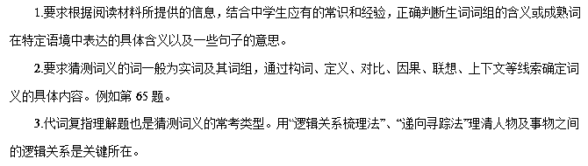 【设问形式】
The underlined word “…” in the second(third…) paragraph refers to(means) ______.
By saying that “…” in the first(second…) paragraph, the author means that ______.
In paragraph …, “…” can be replaced by “______”.
The meaning of “…” in paragraph… is related to ______.
Which of the following has the closest meaning to…(paragraph…)?
The underlined sentence in the … paragraph probably means that _____.
解题思路
做这种类型的题目，要根据词、词组、句子所在的语境上下文来判断其意义。因此熟练掌握一些猜词技巧是做好这类题的关键。命题者在出这类题时惯用常规词义来麻痹考生，我们要特别注意熟词生义，切不可脱离语境主观臆断。
考点：考查科普说明文阅读
25.【2017·江苏卷】C
A new commodity brings about a highly profitable, fast-growing industry, urging antitrust(反垄断)regulators to step in to check those who control its flow. A century ago, the resource in question was oil. Now similar concerns are being raised by the giants(巨头) that deal in data, the oil of the digital age. The most valuable firms are Google, Amazon, Facebook and Microsoft. All look unstoppable.
Such situations have led to calls for the tech giants to be broken up. But size alone is not a crime. The giants’ success has benefited consumers. Few want to live without search engines or a quick delivery, Far from charging consumers high prices, many of these services are free (users pay, in effect, by handing over yet more data). And the appearance of new-born giants suggests that newcomers can make waves, too.
But there is cause for concern. The internet has made data abundant, all-present and far more valuable, changing the nature of data and competition. Google initially used the data collected from users to target advertising better. But recently it has discovered that data can be turned into new services: translation and visual recognition, to be sold to other companies. Internet companies’ control of data gives them enormous power. So they have a “God’s eye view” of activities in their own markets and beyond.
This nature of data makes the antitrust measures of the past less useful. Breaking up firms like Google into five small ones would not stop remaking themselves: in time, one of them would become great again. A rethink is required—and as a new approach starts to become apparent, two ideas stand out.
The first is that antitrust authorities need to move form the industrial age into the 21st century. When considering a merger(兼并), for example, they have traditionally used size to determine when to step in. They now need to take into account the extent of firms’ data assets(资产) when assessing the impact of deals. The purchase price could also be a signal that an established company is buying a new-born threat. When this takes place, especially when a new-born company has no revenue to speak of, the regulators should raise red flags.
The second principle is to loosen the control that providers of on-line services have over data and give more to those who supply them.Companies could be forced to consumers what information they hold and how much money they make from it. Governments could order the sharing of certain kinds of data, with users’ consent.
Restarting antitrust for the information age will not be easy But if governments don’t wants a data economy by a few giants, they must act soon.
61.Why is there a call to break up giants?
A. They have controlled the data market. B. They collect enormous private data.
C. They no longer provide free services. D. They dismissed some new-born giants.
62.What does the technological innovation in Paragraph 3 indicate?
A. Data giants’ technology is very expensive. B. Google’s idea is popular among data firms
C. Data can strengthen giants’ controlling position. D. Data can be turned into new services or products
63.By paying attention to firms’ data assets, antitrust regulators could .
A. kill a new threat B. avoid the size trap
C. favour bigger firms D. charge higher prices
64.What is the purpose of loosening the giants’ control of data?
A. Big companies could relieve data security pressure.
B. Governments could relieve their financial pressure.
C. Consumers could better protect their privacy.
D. Small companies could get more opportunities.
【答案】61.A 62. C 63.B 64.D
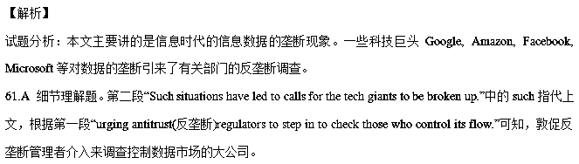62.C 推理判断题。根据第三段“Internet companies’ control of data gives them enormous power. So they have a “God’s eye view” of activities in their own markets and beyond.”可知，互联网公司对数据的掌控使得它们拥有了很大的权力，说明数据会加强大公司的统治地位。
63.B 推理判断题。根据倒数第三段“The first is that antitrust authorities need to move form the industrial age into the 21st century. When considering a merger(兼并), for example, they have traditionally used size to determine when to step in. They now need to take into account the extent of firms’ data assets(资产) when assessing the impact of deals.”可知，以前介入的标准是看公司的规模，而现在是把数据库的范围考虑在内。
64.D推理判断题。根据倒数第二段“Companies could be forced to consumers what information they hold
and how many money they make from it. Governments... with users’ consent.”可知，由于大公司垄断数据信息，不利于小公司更好地服务消费者，也不利于政府开展工作。弱化这种垄断将会给小公司带去更多的发展机会。
【名师点睛】
推理判断题
高考英语阅读理解所涉及的考点比较多，比如考查常识理解、细节理解、语义理解、主旨理解、推理判断等。但比较而言，难度最大而且最容易出错的是推理判断题。因为推理判断题通常要求考生不仅要理解原文的文字信息，而且还要进行一定的判断和推理，并以此推断出文章的隐含意义。推理判断题属于主观性很强的高层次阅读理解题，做这类题目时，要严格依据作者所陈述的细节、事实以及作者的措辞、态度和语气，找出能够表露作者思想倾向和感情色彩的词语，然后利用自己已获得的相关知识进行推理判断，从而得出符合逻辑的结论。此时应特别注意：当问及作者的看法、意图与态度时，不要误认为是在问“你”的想法。
考点一 考查因果关系的推断
因果关系的推断是高考英语推断题中考得比较多的一类。因果关系的推断有时只涉及一个或几个细节，有时涉及一个或几个段落，有时甚至涉及全文。一般说来，推断因果关系所涉及的内容越多，难度也就越大，同学们越要仔细。
考点二 考查作者观点的推断
推断作者观点也是高考英语阅读中一个比较常见的考点。这类考题的命题特点是：命题者要求考生根据阅读材料中的某些事实推断出作者所持的观点和态度。同学们在做这类题时，一定要注意作者在文中的措辞，尤其是表达感情色彩的形容词、副词、动词及所举的例子（如有直接引语，也要特别注意），才能推断出作者的弦外之音。
此类试题的干扰项通常具有以下特点：或是社会的一种普遍倾向，或是与本文无关的观点，或是与作者相反的看法等。
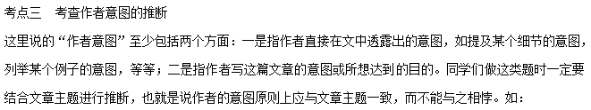考点四 考查读者对象的推断
推断读者对象的考题在高考中出现得不多，只在部分省、市的考题中偶尔出现。这类考题的特点是：命题者要求先读一篇材料，然后要求考生根据所读材料推断出该材料的读者对象是什么。同学们做这类题要注意的是，先读懂文章大意，然后比较所给四个选项的人群特点，再寻找其相关点，最后得出一个合情合理的答案。例如第64题。
考点五 考查隐含意义的推断
对隐含意义的推测是阅读理解中难度较大的一类考点。所谓推断隐含意义，就是要求考生在理解原文表面文字信息的基础上，作出合乎情理的推理与判断，从而得出文章的隐含意义和深层意义。对隐含意义的推测属于主观性较强的高层次阅读理解，同学们在做这类题目时，一定要严格依据作者所陈述的细节、事实以及作者的措辞、态度和语气，找出能够表露作者思想倾向和感情色彩的词句，然后利用自己的相关知识进行推理判断，从而得出符合逻辑的结论。例如第72题。
考点六 考查特定结论的推断
简单地说，高考英语对阅读理解的考查主要是两大类：一类是细节理解；一类是推理判断。推理判断题除前面分析的因果关系的推断、作者观点的推断、作者意图的推断、读者对象的推断、文章出处的推断、隐含意义的推断等之外，还有许多结论性的推断，即要求考生根据所读文章对某种结论作出推断。因这类考题涉及面比较广，出题形式比较灵活，所以一并归入“特定结论的推断”。
考点：考查科普说明文阅读
26.【2017·江苏卷】D
Old Problem, New Approaches
While clean energy is increasingly used in our daily life, global warning will continue for some decades after CO₂ emissions(排放) peak. So even if emission were to begin decrease today, we would still face the challenge of adapting to climate. Here I will stress some smarter and more creative examples of climate adaptation.
When it comes to adaptation, it is important to understand that climate change is a process. We are therefore not talking about adapting to a new standard, but to a constantly shifting set of conditions. This is why in part at least, the US National Climate Assessment says that: “there is no ‘one-size fit all’ adaptation.” Nevertheless, there are some actions that offer much and carry little risk or cost.
Around the world people are adapting in surprising ways, especially in some poor countries, Floods have some more damaging in Bangladesh in recent decades. Mohammed Rezwan saw opportunity where others saw only disaster. His not-for-profit organization runs 100 river boats that server as floating libraries, schools, and health clinics, and are equipment with solar panels and other communication facilities. Rezwan is creating floating connectivity (连体) to replace flooded roads and highways. But he is also working at a far more fundamental level: his staff people how to make floating gardens fish ponds prevent starvation during the wet season.
Around the world, people are adapting in surprising ways, especially in some poor countries, Fllods have become more damaging in Bangladesh in recent decades. Mobammed Rezwan saw opportunity where others saw only disaster. His not-for-profit organization runs 100 river boats that serve as floating libraries, schoods, and health clinics, and are equipped with solar panels and other communicating facilities. Rezwan is creating floating conmetivity(连接) to replace flooded roads and highways. But he is also working at a far more fundamental level: his staff show people how to make floating gardens and fish ponds to prevent starvation during the wet season.
Elsewhere in Asia even more astonishing actions are being taken. Chewang. Nophel lives in a mountainous region in India, where he is known as the Ice Man. The loss of glaciers(冰川)there due to global warming represents an enormous threat to agriculture. Without the glaciers, water will arrive in the rivers at times when it can damage crops. Norphel’s inspiration come from seeing the waste of water over winter, when it was not needed. He directed the wasted water into shallow basins where it froze, and was stored until the spring. His fields of ice supply perfectly timed irrigation(灌溉) water. Having created nine such ice reserves. Nophel calculates that he has stored about 200, 000m³ of water. Climate change is a continuing process, so Norhel’s ice reserves will not last forever. Warming will overtake them. But he is providing a few years during which the farmers will, perhaps, be able to find other means of adapting.
Increasing Earth’s reflectiveness can cool the planet. In southern Spain the sudden increase of greenhouses (which reflect light back to space) has changed the warming trend locally, and actually cooled the region. While Spain as a whole is heating up quickly, temperatures near the greenhouses have decreased. This example should act as an inspiration for all cities. By painting buildings white, cities may slow down the warming process.
In Peni, local farmers around a mountain with a glacier that has already fallen victim to climate change have begun painting the entire mountain peak white in the hope that the added reflectiveness will restore the life-giving ice. The outcome is still far from clear, But the World Bank has included the project on its of ‘100 ideas to save the planet”.
More ordinary forms of adaptation are happening everywhere. A friend of mine owns an area of land in western Victoria. Over five generations the land has been too wet for cropping. But during the past decade declining rainfall has allows him to plant highly profitable crops. Farmers in many countries are also adapting like this—either by growing new produce, or by growing the same things differently. This is common sense, But some suggestions for adapting are not. When the polluting industries argue that we’ve lost the battle to control carbon pollution and have no choice but to adapt, it’s a nonsense designed to make the case for business as usual.
Human beings will continue to adapt to the changing climate in both ordinary and astonishing ways. But the most sensible form of adaptation is surely to adapt our energy systems to emit less carbon pollution. After all, if we adapt in the way, we may avoid the need to change in so many others.
65.The underlined part in Paragraph 2 implies .
A. adaptation is an ever-changing process B. the cost of adaptation varies with time
C. global warming affects adaptation forms D. adaptation to climate change is challenging
66.What is special with regard to Rezwan’s project?
A. The project receives government support. B. Different organizations work with each other.
C. His organization makes the best of a bad situation. D. The project connects flooded roads and highways.

67.What did the Ice Man do to reduce the effect of global warming?
A. Storing ice for future use. B. Protecting the glaciers from melting.
C. Changing the irrigation time. D. Postponing the melting of the glaciers.
68.What do we learn from the Peru example?
A. White paint is usually safe for buildings. B. The global warming tread cannot be stopped.
C. This country is heating up too quickly. D. Sunlight reflection may relieve global warming.
69.According to the author, polluting industries should .
A. adapt to carbon pollution B. plant highly profitable crops
C. leave carbon emission alone D. fight against carbon pollution
70.What’s the author’s preferred solution to global warming?
A. setting up a new standard. B. Reducing carbon emission.
C. Adapting to climate change. D. Monitoring polluting industries.
【答案】65. A 66. C 67. A 68.D 69.D 70. B
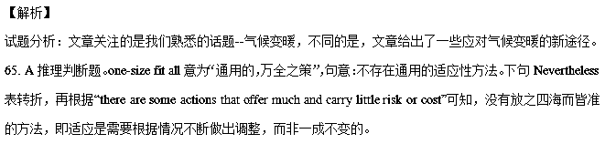66. C 细节理解题。根据第四段“Mohammed Rezwan saw opportunity where others saw only disaster.”可知，Rezwan会从危机中看到机遇，会充分利用现有条件。
67. A 细节理解题。根据第五段“Norphel’s inspiration come from seeing the waste of water over winter, when it was not needed. He directed the wasted water into shallow basins where it froze, and was stored until the spring. ”可知，把冰川融化后的水储存起来以备不时之需，是减少气候变暖危害的方法之一。
68. D 推理判断题。根据倒数第四段“By painting buildings white, cities may slow down the warming process.”和倒数第三段“painting the entire mountain peak white in the hope that the added reflectiveness will restore the life-giving ice”可知，将墙壁涂成白色是利用了光的反射原理，这样可以缓解气候变暖。
69. D 推理判断题。根据倒数第二段“When the polluting industries argue that we’ve lost the battle to control carbon pollution and have no choice but to adapt, it’s a nonsense”可知，作者不赞成“我们已经在与碳污染的斗争中失败了”这样的说法，说明作者建议污染企业行动起来。
70. B推理判断题。根据最后一段“But the most sensible form of adaptation is surely to adapt our energy systems to emit less carbon pollution.”可知，作者认为，最合理的方法仍然是减少二氧化碳的排放。
【名师点睛】
词义猜测技巧
1、根据定义或上下文解释进行猜测
有时短文中出现一个需要猜测其意义的词或短语，下面接着出现其定义或解释，这就是判断该词或短语意义的主要依据。例如：
Annealing is a way of making metal softer by heating it and then letting it cool very slowly.
句子给予annealing 以明确的定义，即“退火”。
2、根据同位关系进行猜测
阅读中出现的难词有时后面紧跟一个同位语，对前面的词进行解释，这时可利用同位关系对前面或后面的词义或句意进行猜测。例如：
They traveled a long way, at last got to a castle, a large building in old times.
同位语部分a large building in old times 给出了castle 的确切词义，即古时候的“城堡”。
We are on the night shift—from midnight to 8 a.m.— this week.
两个破折号之间的短语很清楚地表明night shift 是“夜班”的意思。
The “Chunnel”, a tunnel(隧道) connecting England and France, is now complete.
此句中a tunnel connecting England and France是Chunnel的同位语。因此，The “Chunnel”就是英法之间的海底隧道。
3、根据构词法(前缀、后缀、复合、派生等)进行猜测
在英语中，有很多词可以在前面加前缀，在后面加后缀，从而构成一个词，乍看起来，这个词可能是新词，但掌握了一定的构词知识，就不难猜出它的词义。例如：
“Our parties are aimed for children 2 to 10,” Anaclerio said, “and they’re very interactive and creative in that they built a sense of drama based on a subject.”
文中interactive是由前缀inter-(相互的)和active(活动的，活跃的)而构成的，同时根据上下文的意思可以判断，该词的含义应是“互动的”。
Perhaps, we can see some possibilities for next fifty years. But the next hundred?
possibility 是 possible 的同根名词， 据此可以判断定 possibility 意思是“可能性”。
4、根据因果关系进行猜测
在一篇阅读文章中，根据原因可以预测结果，根据结果也可以找出原因。例如：
The lack of movement caused the muscles to weaken. Sometimes the weakness was permanent. So the player could never play the sport again.
从后面的结果“永远不能再运动”中，可以推测 permanent 的意思为“永远的，永久的”。
5、根据上下文的指代关系进行猜测
文章中的代词it, that, he, him 或them可以指上文提到的人或物，其中it和that还可以指一件事。有时代词指代的对象相隔较远，要认真查找;也有时需要对前面提到的内容进行总结，才能得出代词所指代的事。例如：
Like Schmid, the editors of several self-published art magazines also champion (捍卫) found photographs. One of them, called simply Found, was born one snowy night in Chicago, when Davy Rothbard returned to his car to find under his wiper(雨刷) an angry note intended for someone else: “Why’s your car HERE at HER place?”
them指的是前面出现的self-published art magazines。
6、根据同义关系进行猜测
当词或短语之间有并列连词and 或or时，其连接的两项内容在含义上是接近的或递进的，由此确定同等关系中的某个生词所属的义域，由此可推知其大致意思。
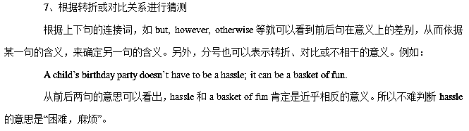考点：环保类短文阅读
27.
Whenever the word “hero” comes to me, I immediately think of three Hs: honourable, hardworking, and happy.When I think more about this word, I picture someone who has accomplished good things for people and tries to do the right thing. Hattie Elizabeth Alexander is one person whom I find to be very heroic.
Hattie was born in Baltimore, Maryland on April 5, 1901.During her time at College she earned her Bachelor's Degree in Bacteriology and Physiology.These were just the first steps towards what she was finally going to be remembered for.After college Hattie attended the Johns Hopkins School of Medicine and received her medical degree.
After her education, she pursued her career, and after much time and hard work, she drastically reduced the number of infants (幼儿) dying from meningitis (脑膜炎)．Hattie was very dedicated to her work and helped at as many locations as she could.Spending substantial (大量的) time in the labouratory, Hattie successfully developed a cure against the disease, which decreased the death rate to 20 per cent.At the same time, she was also a teacher working with Columbia University.
She was a caring lady interested in other people's lives.When she was teaching at Columbia University, other members would talk to her about students that were failing their classes, and somehow Hattie could always find convincing reasons as to why they should not be driven away.Later, Hattie became an instructor in Pediatrics at New York City's Babies Hospital.After many honours, she became the first woman president of the American Pediatric Society in 1965.This was her last major achievement, for soon after, Hattie died of cancer on June 24, 1968.
Hattie is my hero because her positive attitude and strength helped her accomplish great things for others.She gave them her strength by developing medicines against diseases, which, by doing so, made them stronger.This is what makes Hattie Elizabeth Alexander my hero.
1. According to the passage, Hattie Elizabeth Alexander________.
A．received her Bachelor's Degree in Johns Hopkins School
B．spent all her time in the labouratory developing cures for illnesses
C．cared a lot about others' private lives
D．always tried her best to help prevent students from dropping out of college
2．What does the underlined word “drastically” in Paragraph 3 probably mean?
A．Slightly. B．Hardly. C．Greatly. D．Totally.
3. Hattie is considered to be a hero by the author in that________.
A．she was an honourable, hardworking and happy person
B．she was a very dedicated woman doctor with many honours
C．she was a caring lady who helped many students finish college
D．she was the first woman president of APS
4. Which of the following would be the most proper title for the text?
A．An honourable woman
B．A woman accomplishing great things
C．My hero—Hattie Elizabeth Alexander
D．The first woman president of the APS
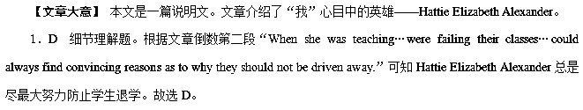2．C 词义猜测题。根据第三段第一句“…after much time and hard work, she drastically reduced the number of infants (幼儿) dying from meningitis (脑膜炎)．”可知应该是大大减少了死于脑膜炎的幼儿的数量。可知C项符合题意。
3．A 推理判断题。根据第一段第一句“Whenever the word ‘hero’ comes to me, I immediately think of three Hs: honourable, hardworking, and happy.”及最后一段的内容可知因为她是一个受人尊敬、勤奋和幸福的人。故选A。
4．C 主旨大意题。根据第一段第一句“Whenever the word ‘hero’ comes to me, I immediately think of three Hs: honourable, hardworking, and happy.”和最后一段第一句“Hattie is my hero because her positive attitude and strength helped her accomplish great things for others.”可知C项“My hero—Hattie Elizabeth Alexander”为最佳标题。
28.
“How do you explain the fact that even though you were both blind and deaf, you were able to accomplish so much？” Queen Victoria of England asked Helen Keller.
Ms Keller answered, “If it had not been for Anne Sullivan, the name of Helen Keller would have remained unknown.”
In fact, “Little Annie”， as she was called when she was young, was no stranger to hardship. She was almost sightless herself (due to a childhood fever) and was, at one time, diagnosed as hopelessly “insane” and was locked in the basement of a mental institution. On occasion, Little Annie would even violently attack anyone who came near.
An elderly nurse believed there was hope, however, and she made it her mission to show love to the child. She still continued to visit for she believed Little Annie could recover, if she was shown love.
Eventually, doctors noticed a change in the girl. Where they witnessed anger and coldness they noted gentleness and love. They moved her upstairs where she continued to improve. Then the day finally came when this seemingly “hopeless” child was released.
Anne Sullivan grew into a young woman with a desire to help others as she, herself, was helped by the kind nurse. It was she who saw the great potential in Helen Keller. She loved her, disciplined her，played with her and worked with her until the weak candle became a beacon of light to the world. She worked wonders in Helen's life; but it was a loving nurse who first believed in Little Annie and lovingly transformed an uncommunicative child into a compassionate teacher.
“If it had not been for Anne Sullivan, the name of Helen Keller would have remained unknown.” But if it had not been for a kind and dedicated nurse, the name of Anne Sullivan would have remained unknown. And so it goes. And how far forward will it lead?
1. When she was young, Little Annie________．
A．enjoyed being locked in the basement of a mental institution
B．complained about her loneliness
C．showed her friendly attitude to others
D．suffered from mental illness
2. Why did the “hopeless” Little Annie change into a helpful one?
A．Because an efficient way was found by doctors to cure her illness.
B．Because a nurse who was concerned about her helped her constantly.
C．Because she was taken good care of by her relative.
D．Because the illness was defeated by her own strong will.
3. How did Anne Sullivan help Helen Keller?
A．She devoted all her time to dealing with everything for Helen Keller.
B．She promised Helen Keller never to leave her.
C．She trained Helen Keller to control her behaviour.
D．She encouraged Helen Keller to make friends with others.
4. Which of the following might be the best title for the text?
A．A caring nurse
B．Chain of love
C．Without respect, without success
D．God helps those who help themselves
【文章大意】 本文是一篇记叙文。年幼的Anne Sullivan生活艰辛、身体多病，但是在医生、护士的帮助之下，她成了一名充满爱心、乐于助人的老师。
1．D 细节理解题。根据第三段的内容可知，Anne Sullivan年少时生活艰辛，并饱受疾病折磨，因此答案为D，其他选项的内容均和原文表达不符。
2．B 细节理解题。根据第四段和第五段可知，一位年长的护士帮助了年幼的Anne Sullivan。她用爱和关怀把曾经冷漠的孩子改变成了一位充满爱心、乐于助人的老师。故选B。
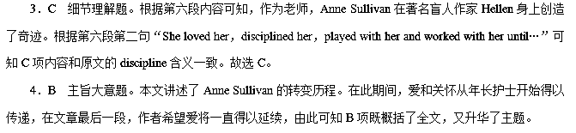29.
When Paula GrzelakSchultz spotted a piece of paper tucked under her windshield (挡风玻璃) wipers, she thought she was getting fined for leaving her car in a bar parking lot overnight. With a heavy sigh, GrzelakSchultz removed the paper and unlocked her car.
Hardly had she unfolded the paper when she got shocked. It was a letter from the manager of Original Joe's Restaurant & Bar in Sherwood Park, Canada.
“Just wanted to thank you for leaving your car parked overnight，” Jay McLean, managing partner at Original Joe's, wrote.“I'm not sure if you had consumed alcohol at our restaurant or not, but we wanted to thank you for not drinking and driving.”
Inside it, GrzelakSchultz also found a voucher (代金券) for 1 pound of chicken wings.
“Please accept this as a thank you for being responsible，” McLean wrote.“Life is valuable, have a great weekend.”
GrzelakSchultz was touched.
“I was sure it was going to be a ticket or a scolding from someone for leaving my vehicle there for so long，” GrzelakSchultz told CBS News.“I was truly surprised and so pleased that the manager took the time to acknowledge my good judgement.”
She decided to share the man's good deed on Facebook.
“Wow! I'm so impressed. Definitely going back，”GrzelakSchultz wrote in a Facebook post on Tuesday that has since gone widespread with nearly 8，500 shares.“Not just because of the voucher, but also because of how well this guy treats his regular customers.”
Exactly a week later, GrzelakSchultz returned to the restaurant to thank McLean for his kindness, and discovered that she's not the only customer to receive this letter.
“He's been doing it for over a year, with no expectations.”She explained.“Just being a good guy.”
1. At first sight of the paper, Paula thought it was________.
A．a ticket B．a voucher
C．a letter D．a thankyou card
2. What truly surprised GrzelakSchultz?
A．She was not fined by the police.
B．She was not scolded for parking.
C．She was considered as responsible.
D．She got a voucher for chicken wings.
3. What can we learn about Jay McLean?
A．He simply meant to be good.
B．He hoped to attract more customers.
C．He wanted to be popular on the Internet.
D．He intended to please regular customers.
4. Which can best describe the change of Paula's feelings?
A．sad—excited—surprised—relieved
B．sad—surprised—pleased—impressed
C．surprised—sad—disappointed—pleased
D．disappointed—surprised—excited—delighted
【文章大意】 本文是一篇记叙文。文章介绍了Original Joe's Restaurant & Bar的经理给在自己店停车场停车的客人写感谢信，感谢他们没有酒后驾车。其中一位客人Paula很是感动，并在Facebook上发文了。
1．A 细节理解题。根据文章第七段“‘I was sure it was going to be a ticket or a scolding from someone for leaving my vehicle there for so long’…”可知Paula认为它要么是罚单，要么是责骂信，故选A。
2．C 推理判断题。根据第七段“‘I was truly surprised and so pleased that the manager took the time to acknowledge my good judgement.’”可知作者吃惊是因为别人认可了她良好的判断，认为她是有责任心的人，故选C。
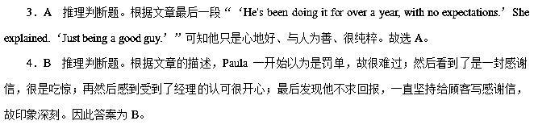30.
In my profession as an educator and health care provider, I have worked with numerous children infected with the virus that causes AIDS. The relationships that I have had with these special kids have been gifts in my life. They have taught me so many things, but I have especially learned that great courage can be found in the smallest of packages.
Tyler was born infected with HIV and from the very beginning of his life, he was dependent on medications to survive. When he was five, he had a tube surgically inserted in a vein in his chest. This tube was connected to a pump, which he carried in a small backpack on his back. Medications were prepared inside this pump and were continuously supplied through this tube to his bloodstream. At times, he also needed supplemented (补充的) oxygen to support his breathing.
Tyler wasn't willing to give up one single moment of his childhood to this deadly disease. It was not unusual to find him playing and racing around his backyard, wearing his medicineladen backpack and dragging his tank of oxygen behind him. Tyler's mum often teased him by telling him that he moved so fast that she needed to dress him in red. That way, when she peered through the window to check on him playing in the yard, she could quickly spot him.
This fateful disease eventually wore down Tyler. He grew quite ill and, unfortunately, so did his HIVinfected mother. When it became apparent that he wasn't going to survive, Tyler's mum talked to him about death. She comforted him by telling Tyler that she was dying too, and that she would be with him soon in heaven.
A few days before his death, he whispered to me, “ I might die soon. I'm not scared. When I die, please dress me in red. Mum promised she's coming to heaven, too. I'll be playing when she gets there, and I want to make sure she can find me.”
1. What do we know about the tube inserted in Tyler's chest?
A．It contained oxygen that helped Tyler breathe freely.
B．Medications in the pump could be supplied through it.
C．It was filled with medications that Tyler needed.
D．It should be replaced by a new one after a year.
2. Tyler's mum dressed him in red in order to________．
A．stress the importance of the colour
B．find him as quickly as possible
C．meet the demand of him
D．encourage him to play and race happily outdoors
3. Tyler's mum helped him face the death in the following ways EXCEPT that________．
A．she said to him that it would not long before she died
B．she promised to meet him in heaven soon
C．she had a frank talk with him about death
D．she gave him a medicineloaded package
4. Which of the following might be the best title for the text?
A．Gifts in my life
B．A fateful disease
C．Dying in red
D．No more tears in heaven
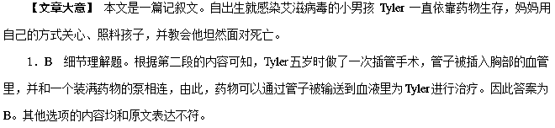2．B 细节理解题。根据第三段的第三、四句可知，妈妈让孩子穿上红色衣服的目的是可以尽快发现他。因此答案为B。
3．D 细节理解题。根据第四段的第三、四句内容可知，妈妈帮助孩子面对死亡时并没有给孩子装药的包裹，而是安慰他要坦然面对死亡。因此答案为D。
4．C 主旨大意题。本文讲述了自出生就感染艾滋病毒的小男孩Tyler一直依靠药物生存，妈妈用自己的方式关心、照料孩子，并教会他坦然面对死亡的故事。在Tyler生命的最后时刻，他让“我”一定为他穿上红色衣服，以便死后可以在天堂和母亲重聚。由此可知C项既可以概括全文，又升华主题。
31.
A couple of years ago I graduated from art school. After graduation I was unsure of what to do with my degree. I had majored in Illustration (插图) and loved it, but didn't really feel interested in doing illustrations for any companies. This left me with few options other than freelance (自由职业的)jobs and nannying (保姆工作)．
I spent two years working as a nanny doing freelance illustration on the side. It just wasn't quite enough to pay rent, but I loved it, so I worked well over 50 hours a week, trying to keep up with both.
Just under a year ago I went to a friend's wedding. I couldn't think of a gift for them and really didn't have a lot of money to spare so I used my talents to create a portrait for them. It wasn't much, and I hoped it would be a good gift. When I handed the portrait to them and they unwrapped it, the looks on their faces were something I did not expect. There were joyful tears in their eyes as they cried, “That's us! This is so beautiful！”
It's funny because when I was in art school portraits were always my least favourite assignment. I hated drawing people and was always so much more interested in drawing little furry creatures. Once I saw the looks on my friends' faces after giving them their portrait it was all over. I suddenly loved portraits and wanted to do more.
I now take portraits to every wedding I go to and have given them as gifts to the families I nannied for. Every time the reaction makes all of the hard work and time I put into them so worth it.
I've just started offering couple, family and pet portraits as an item on my Etsy shop.
1. After graduation, the author chose to________．
A．do illustrations for a company
B．draw portraits
C．work as a nanny & a freelance
D．draw furry creatures
2. Why did the author decide to draw a portrait for her friends as a wedding present?
A．Her friends requested her to do so.
B．She thought it was meaningful.
C．She hadn't enough money available to buy good gifts.
D．She was fond of drawing people.
3. How did the friends feel when they received their portrait?
A．Delighted. B．Frightened.
C．Embarrassed. D．Shocked.
4. What may be the best title of the passage?
A．Your major is your future career
B．I gave a gift and it turned into a career
C．I sacrificed a lot for my job
D．You are to do what you desire to do
【文章大意】 本文是一篇记叙文。文章讲述了作者没钱为朋友买结婚礼物，于是为他们画了一幅肖像作为礼物，结果却成了自己的一份事业。
1．C 细节理解题。根据第一段最后一句“This left me with few options other than freelance (自由职业的) jobs and nannying (保姆工作) .”和第二段第一句“I spent two years working as a nanny doing freelance illustration on the side.”可知作者毕业之后选择了做保姆和自由职业者。故选C。
2．C 细节理解题。根据第三段中“I couldn't think of a gift for them and really didn't have a lot of money to spare so I used my talents to create a portrait for them.”可知她没有足够的钱为朋友买礼物。故选C。
3．A 细节理解题。根据第三段最后两句“When I handed the portrait to them and they unwrapped it, the looks on their faces were something I did not expect. There were joyful tears in their eyes as they cried, ‘That's us! This is so beautiful！’”可知朋友们收到他们的肖像时感到很高兴。故选A。
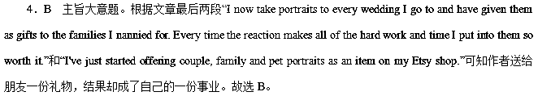32.
An early morning winter storm had brought several inches of snow to my small town in the mountains. Schools were canceled, roads were dangerous and all I wanted to do was to stay in bed. Still，I knew I had to get the day started so I put on warm clothes and walked outside. The snow got all over my shoes. The cold wind dried my lips and my eyes. My 47yearold back ached in anticipation (预想) of the shoveling_(铲雪) I would have to do if the snow didn't stop soon.
Yet, when I looked out on the white blanket that covered the ground, I couldn't help but smile a bit. It was so beautiful. It softened the bare trees and hid the dead grass. In the distance I could hear the sound of the snowplow (雪犁) on the road, the barking of a happy dog and the laughter of children playing outside, enjoying their way off from school.
The sweet music of that laughter brought back a hundred memories of winters past. I remembered catching snowflakes (雪花) on my tongue, building snowmen, making snow angles, running down hills and always losing snowball fights with first my brothers and then my own children. Standing there in that warm coat of memories made the wind a little less cold and my back a little less sore (疼痛的)．I turned up my head, stuck out my tongue and for the first time in years caught a snowflake on it. It tasted so fresh and clean. It tasted like youth, like joy and like love.
May you always feel young in spirit, no matter how old or achy your body may be. May you always delight in the simple joys of life. May you always share your happiness with the hearts of children. And may you always give your love, your light, your laughter and your warmth to others even on the coldest days.
1. What was the author's first reaction when he knew it snowed heavily?
A．He was upset.
B．He was happy.
C．He was thankful.
D．He was moved.
2．From which senses did the author describe the joy of having snow?
A．Taste and smell.
B．Sight and smell.
C．Smell, hearing and taste.
D．Sight, hearing and taste.
3. What does the author mainly want to tell us with this article?
A．Appreciate every snowstorm you spend with your family.
B．Snow brings both fun and trouble.
C．Memories can change our opinion.
D．We should stay young at heart.
4．From the underlined sentence in Paragraph l, we can know that “________”．
A．my back ached because of the cold weather
B．I didn't want to start my day on such a snowy day
C．my back would ache upon thinking of cleaning up the snow
D．the snow didn't stop and I felt too cold
【文章大意】 本文是一篇记叙文。文章作者讲述自己在大雪后外出看到的雪景以及孩子们雪中玩闹的场景，文章最后表达了一些祝福。
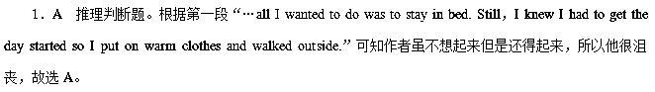2．D 推理判断题。根据第二段“…when I looked out on the white blanket that covered the ground, I couldn't help but smile a bit.”以及“In the distance I could hear the sound of the snowplow (雪犁) on the road…”以及第三段“I remembered catching snowflakes (雪花) on my tongue…”可知作者主要是从视觉上、听觉上以及味觉上三方面体会到下雪的快乐，故选D。
3．D 推理判断题。根据最后一段“May you always feel young in spirit, no matter how old or achy your body may be. May you always delight in the simple joys of life.”可知答案为D。
4．C 句意猜测题。根据此句的本意：我一想到如果雪不停我就得铲雪，我背部就疼。可知只有C项意思最为相近，故选C。
33.
Two years ago I fell off the steps of a bus while climbing down and twisted my ankle.What followed was the usual way that is common in the US.A few hours later I was treated and discharged.What was uncommon was that I received extra care while going to ER (emergency room) and while I was in the hospital.
People were kind to me, men and women alike.They wheeled me into a private room instead of making me wait in the crowded waiting room.Someone came and asked me if the temperature is OK.When I said I was cold, he brought me a blanket and some magazines, in case I got bored.The nurses stopped by, making pleasant chats with me.People always came to ask me if I was in too much pain and if I needed anything…
There were other people who were brought in while I was waiting.Patients groaning in pain were given the care they needed and then ignored.My injury was not the priority, so while I was not pushed to the front of the line, my several hours' stay in the hospital was made as pleasant as possible.Why would people do that? They gave others care, while I got kindness.
Like any other good looking, healthy, independent person, man or woman，it looks as if the world is nicer to rich people, and the world is nicer to attractive people.I'm not in the dating world.It's not about free drinks and gifts.It's about people being nice.
I'm grateful for any positive behaviour because I know this is temporary.Eventually I will join the groups of the elderly, the weak and the seemingly unattractive.One thing I refuse to do is to make excuses for being attractive.I know it's temporary.I know it's the luck of the draw and I know that I'm just one of the many.Does it matter to my husband, my mother and my kids what I look like? No.And I wouldn't have it any other way.
1. What caused the author into deep thought?
A．She was given less care in the hospital.
B．Patients were only given physical care in the hospital.
C．She didn't get treatment immediately in the hospital.
D．Other patients in the hospital didn't get the same kindness as her.
2. What can we know about the author?
A．She is an attractive lady.
B．She shows great pity to old patients.
C．She doesn't like free drinks or gifts.
D．She was treated unequally in the hospital.
3. Which of the following does the author agree with?
A．The hospital should treat attractive patients in preference to others.
B．The positive behaviour that being attractive brings can last long.
C．Old patients should get much more care from the hospital.
D．Being attractive means nothing to the people truly important to you.
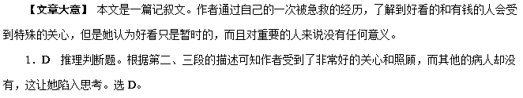2．A 推理判断题。根据倒数第二段“…it looks as if the world is nicer to rich people, and the world is nicer to attractive people.”再结合前文的描述可知作者长得好看，选A。
3．D 推理判断题。根据最后一段的描述，并结合最后三句“Does it matter to my husband, my mother and my kids what I look like? No.And I wouldn't have it any other way.”可知作者认为长得好看对重要的人来说没有任何意义。选D。
34.
Marvin Minsky is often called the Father of Artificial Intelligence.His work helped inspire the creation of the personal computer and the Internet.
Artificial Intelligence
Before Minsky, computers were more like calculators, performing maths operations at speeds much faster than humans.Minsky was the first to say that computers can one day be as intelligent as human beings.He was so convinced about this, that in 1919, he and his friend John McCarthy invented the term “Artificial Intelligence” at the Massachusetts Institute of Technology.
Minsky wrote a book called Perceptrons, describing a particular type of “artificial neural (神经的) network”．Neural networks have made a comeback in a new field of Computer Science called Deep Learning.Deep Learning is used to recognize things and people in pictures (as seen in Facebook and Google Photos), language translation (try Google Translate sometimes), and so on.
Robotics, Microscopes and Virtual Reality
How many of you have done Robotics at school and loved it? You have Minsky to thank again, for his work on Robotics.One of his biggest inventions was the confocal scanning microscope, an instrument that is still widely used today in medical and scientific research.
Minsky was really futuristic.He created one of the first headmounted graphics displays (头戴式图形显示), which gave rise to the exciting area of Virtual Reality.This year, Facebook is releasing Oculus, a virtual reality headset, which you can use to play games with your friends in a 3D environment.
Minsky's major prediction that computers will one day become as intelligent as humans is now called the Theory of Singularity.
1. Which of the following statements is TRUE?
A．Minsky himself invented the term “Artificial Intelligence” in MIT.
B．Minsky transformed computer into a machine more intelligent than human beings.
C．Apart from Information Technology, Minsky's invention is also used in medical field.
D．Minsky invented a headset, with which players can play games in a 3D environment.
2. Which is NOT the function of Deep Learning?
A．Recognize people in Facebook.
B．Spot items in Google Photos.
C．Summarize main idea of a passage.
D．Translate English into French.
3. Which is NOT one of Minsky's characteristics according to the passage?
A．Farsighted.
B．Creative.
C．Pioneering.
D．Considerate.
4. In which section of a newspaper can you read this passage?
A．Technology. B．Travel.
C．Environment. D．Life.
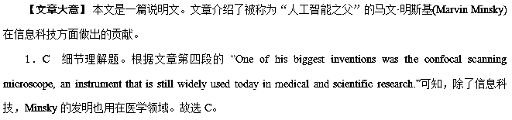2．C 细节理解题。根据文章第三段的 “Deep Learning is used to recognize things and people in pictures (as seen in Facebook and Google Photos), language translation (try Google Translate sometimes), and so on.”可知，Deep Learning包括A、B、D，不包括总结文章的大意。故选C。
3．D 推理判断题。根据文章第一段的 “His work helped inspire the creation of the personal computer and the Internet.”可知，Minsky是有创造力的；根据第二段的“Minsky was the first to say that computers can one day be as intelligent as human beings.”可知，Minsky是有远见和开创性的。文章没有提到Minsky是考虑周到的。故选D。
4．A 推理判断题。文章介绍了被称为“人工智能之父”的马文·明斯基(Marvin Minsky)在信息科技方面做出的贡献，所以本文出自报纸的科技版面，故选A。
35.
In a shocking upset, 70yearold Republican candidate Donald Trump rode a wave to victory as voters elected him the 5th President of the United States.
Actually，a lot of experts had predicted that Democratic candidate Hillary Clinton would come out on top.Throughout the campaign，one of Trump's main challenges was to persuade voters that he has the attitude，knowledge and judgment to be president.In the end，he was able to attract more than enough voters to his side.
Hillary Clinton admitted the election to Trump in a phone call at around 2：30 am.“ Hillary has worked very long and very hard over a long period of time，”Trump told his supporters during his victory speech.“We owe her a major debt of gratitude for her service to our country.”
Hillary Clinton delivered her speech later in the day.“ We must accept this result and then look to the future，”she told her disappointed supporters.“Donald Trump is going to be our president.We owe him an open mind and the chance to lead.”
Trump's rise to the presidency comes after a long career as a realestate developer.He built skyscrapers，resorts and golf courses.He also risked other businesses, including Trump Steaks，Trump Natural Spring Water，and an airline called Trump Shuttle.In 2004, he became a TV star with the reality show The Apprentice.
Now Trump and his team will have to face many difficult things.They'll have to work to bring the country together after a divisive campaign that upset millions of Americans.Throughout the country，millions of Americans are out of work and struggling to make ends meet.The new president must also address international issues.They include the war on terrorism and the refugee crisis.Still, Trump says he sees a bright future ahead.“Every single American will have the opportunity to realize his or her fullest potential，”he told his supporters.
1. What should many experts think of Trump's victory?
A．It is expected. B．It is satisfying.
C．It is annoying. D．It is surprising.
2. How old was Donald Trump when he became a TV star?
A．10 years old. B．14 years old.
C．58 years old. D．62 years old.
3. What can be learned about Donald Trump from the passage?
A．He is a successful businessman.
B．He has been serving in government.
C．He thought badly of Hillary Clinton.
D．He is worried about America.
4. What is the last paragraph mainly about?
A．The problems with America.
B．The challenges Trump will face.
C．Trump's ideas about his future work.
D．The decisions Trump will have to make.
【文章大意】 本文为说明文。文章介绍了最新当选的美国总统特朗普获胜的过程及人生经历和将要面临的各种新挑战。
1．D 推理判断题。根据第二段中的“Actually, a lot of experts had predicted that Democratic candidate Hillary Clinton would come out on top.” (实际上，很多专家曾预言，民主党总统候选人希拉里·克林顿将是胜出者)可推知，特朗普 (Donald Trump) 获胜是令人惊讶的。故选D。
2．C 推理判断题。根据第一段中的“In a shocking upset，70yearold Republican candidate Donald Trump…” 可推知，特朗普出生于1946年；再根据倒数第二段中的“In 2004, he became a TV star with the reality show The Apprentice.”可推算出，特朗普成为电视明星时是58岁。故选C。
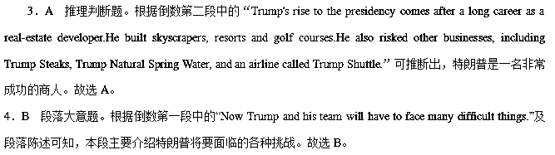36.
The following list includes some books that come highly recommended by millions of readers and also a short summary of the highlights of each work.
The GoGiver, by Bob Burg and John David Mann
I didn't even expect that such a short book could make a huge difference in my way towards life.It simply explains complex laws that direct mankind, and concludes that there is always truth in the opposite.
Dao De Jing, by Laozi
Dao De Jing is one of the finest books on philosophy written by Laozi, an ancient Chinese philosopher and poet.It is sincere, exciting and makes you think a lot.Read it and get in touch with the clear educative understandings that give you enough tips to pursue your life goal full of passion.
The Science of Getting Rich, by Wallace D．Wattles
I had my own misunderstandings of getting rich till I read this book.The book made a huge difference to my life after I discovered the secrets mentioned.Read it and it teaches you how to become rich, not immediately, but step by step.
The Power of Habit, by Charles Duhigg
I never knew habits played such an important role in shaping our future until I read this book.It says, you are what your habits are, and also suggests the proven techniques to create new habits that change our lifestyles and eventually our lives, It is a mustread for everyone who wishes to form lifetime habits.
The Road Less Travelled, by Scott Peck
Simply put, buy this book for the path towards understanding in a spiritual way that strengthens your personal growth.This book never gives you easy solutions to the challenges of life. It simply is part of life and leaves you with better understanding to lead a fulfilled life.
1. Which book can help you chase your dream passionately?
A．Dao De Jing.
B．The GoGiver.
C．The Road Less Travelled.
D．The Science of Getting Rich.
2. Who can tell you the secrets of becoming rich?
A．Laozi. B．Scott Peck.
C．Charles Duhigg. D．Wallace. D．Wattles.
3. Which of the following ideas may Scott Peck agree with?
A．Habits can shape our future.
B．There is always truth in the opposite.
C．Difficulty is often part of personal growth.
D．We should find easy solutions to challenges.
4. What can we know about the books mentioned above?
A．They are all easily written.
B．They are all popular books.
C．All their writers are foreigners.
D．All the books are about life goals.
【文章大意】 本文是一篇广告应用文。文章主要介绍了一些成千上万的读者推荐的非常受欢迎的书籍。
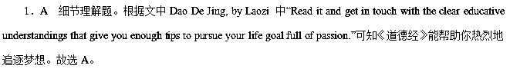2．D 细节理解题。根据文中The Science of Getting Rich, by Wallace D. Wattles所在段落的“Read it and it teaches you how to become rich…”可知Wallace D．Wattles写的这本书能帮助你变得富有。故选D。
3．C 细节理解题。根据最后一段“This book never gives you easy solutions to the challenges of life. It simply is part of life and leaves you with better understanding to lead a fulfilled life.”可知C项“困难只是成长的一部分”符合题意，故答案为C。
4．B 推理判断题。根据文章第一段的描述“The following list includes some books that come highly recommended by millions of readers and also a short summary of the highlights of each work.”可知这些书有那么多的读者推荐，故很受欢迎。故选B。
37.
Don't have plenty of time for reading? If you are interested in nonfiction books, here are good choices for you.
A Room of One's Own
This essay by English writer Virginia Woolf is based on several lectures given in two woman's colleges at Cambridge University in 1928.In it, Woolf describes that it's circumstance not talent that allows men to be more successful at writing.Women, in other words, spend so much time cooking, cleaning, and tending to their children that they have no time left for art.To write well, therefore, a woman must have a room of her own.While on its surface，this essay appears to be only about writing, it is actually about wealth and class，freedom and imprisonment, and the power struggle between sexes.
The Art of War
Written by the Chinese warrior Sunzi in the 5th century BC, The Art of War is widely considered to be one of the best books about military strategy in human history.Consisting of 13 chapters, each detailing a separate aspect of warfare, the book has been translated into every major language and has thousands of editions.For centuries, it has been cited (引用) and praised by world leaders both for its detailed study of military strategy (军事策略) and its philosophical (哲学的) examination of strong, effective leadership.
Letter to My Daughter
This 2009 book of essays and poems by Maya Angelou，a respectable American poet, is written for the daughter she never had—the millions of women, both young and old，that she considers to be her “family”．From the viewpoint of a caring, older relative, this book contains lessons selected from her own life experiences, including the birth of her only child, a son, as well as the formation and loss of friendships.
A Brief History of Time
If you' re short on time，then why not read about，well，the creation of time? This 1988 book from brilliant scientist and mathematician Stephen Hawking explores mindbending questions about the creation of the universe, including if and when it will end, and if so, how. Despite heavy subject matters，Hawking addresses these questions in a way that's easy to understand even for those who know little about physics.
1. What can we learn about the contents of the books?
A．A Room of One's Own is about more than writing.
B．The Art of War also gives definition of philosophy.
C．Letter to My Daughter is actually a common family letter.
D．A Brief History of Time mainly focuses on the mystery of time.
2. What can be inferred from the passage?
A．Woolf looks down upon men in writing.
B．The book by Sunzi is helpful in policymaking.
C．Maya devotes herself to fighting for women's rights.
D．As a physicist, Hawking is equally famous in writing.
3. What is the purpose of the passage?
A．To promote the four books.
B．To make comments on the four books.
C．To recommend the four books to readers.
D．To make comparisons between the four books.
【文章大意】 本文是一篇应用文。作者向读者推荐了四本书。
1．A 推理判断题。根据A Room of One's Own下最后一句“While on its surface, this essay appears to be only about writing, it is actually about wealth and class, freedom and imprisonment, and the power struggle between sexes.”可知A Room of One's Own并不只是关于写作，它有更深的含义。故选A。
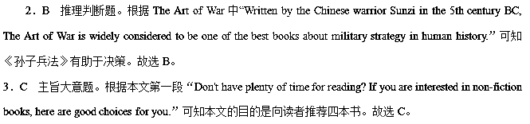38.
Every year in America, highschool students who want to go to college take a national examination called the Scholastic Aptitude Test, or SAT in a shortened way. Their score is an important factor in determining which colleges will admit them or whether any will be admitted at all. The Scholastic Aptitude Test measures one's mathematical ability and use of the English language. Traditionally, the English part involved grammatical questions and paragraphs that test reading comprehension.
But the SAT folks have added a single question, to be answered in an essay, handwritten on the spot. That's an interesting way to test writing ability, but content aside, have you ever seen young people's handwriting lately? Or anyone's for that matter, in this age of computer keyboards? Students write numbers and sign their names on bank checks. They scribble class notes in what can generously be described as the written word.
Yet today's kids are asked to write, thoughtfully and clearly, for several minutes on this SAT Test. Good luck to the text scorers who must work out difficultly the scrawl (潦草的字迹) of young people who've been typing on computers since the age of three! Teachers insist that good handwriting can not only help one's score on the SAT, but also, later on in life, impress potential employers. And don't forget, we all have to turn to handwriting from time to time, as computers go down when power goes out.
Then how to improve the handwriting? Well, with a few simple steps you can improve your handwriting.
Position the pen. You should hold the pen between the forefinger and the thumb, then rest it near the first knuckle (指节) of the middle finger. The rest of your fingers should be curled (卷曲) under your hand and your hand should remain relaxed.
Evaluate your writing. Make changes to your letters till you like how they look.
Take your time. Speed is bound to make your writing messylooking.
Practise. Practise it a lot; it's not enough to do it once and hope for the best. It has to be something you work at to make great improvements.
1. The underlined word “scribble” in Paragraph 2 probably means “________”．
A．write quickly and roughly
B．type simply and correctly
C．paint clearly and neatly
D．describe properly and well
2. According to Paragraph 3, students with good handwriting skill________．
A．can pass the SAT
B．can develop good characters
C．can impress their classmates
D．can get more job opportunities
3. Which of the following should you avoid when improving your handwriting?
A．Practising writing a lot.
B．Writing as fast as you can.
C．Relaxing your hand when holding the pen.
D．Changing your letters till you like how they look.
4. The text is to present the fact that________．
A．writing seems to be very important in the SAT
B．those who will go to college have to take the SAT
C．students should practise handwriting more often
D．kids don't know how to write in the computer age
【文章大意】 本文是一篇论说文。文章由SAT考试增加书面表达引出话题。当前学生不注重书写，此项改革旨在让学生改掉书写潦草的坏习惯。
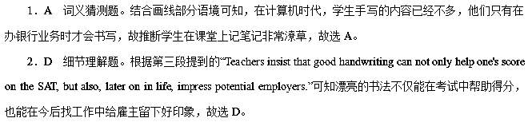3．B 细节理解题。根据最后三段的首句Evaluate your writing；Take your time；Practise.可知没有提到B项，这是写作中应该避免的。故选B。
4．C 推理判断题。文章由SAT考试增加书面表达引出话题，指出当前学生不重视书写，而此项改革旨在让学生改掉书写潦草的坏习惯，故选C。
39.
Have you ever wondered that we parents are the true fighters in the collegeadmission wars? We are pushing our kids to get good grades, take SAT preparatory courses and build résumés so they can get into the college of our first choice. In our eyes, a degree from Stanford or Princeton is the ticket for life. We see our kids' college background as something showing how well or how poorly we've raised them. But we don't realize we are selfish. We think more about ourselves than the kids.
It's true getting into college has generally become tougher because the number of high school graduates has grown. We suffer great anxiety; we worry there won't be enough honours to show off. Fearful parents urge their children to apply to more schools than ever. We hold the belief that graduates of best universities must enjoy more success because they get a better education. All that is seemingly acceptable—and mostly wrong.
“We haven't found any convincing evidence that a prestigious university (名牌大学) matters，” says Ernest T．Pascarella of the University of Iowa, coauthor of “How College Affects Students”， an 827page report of hundreds of studies of the college experience.
According to some studies, graduates of prestigious universities do earn much money. But even this seems like just a coincidence.
Kids count more than their colleges. Getting into Yale may mean intelligence, talent and ambition. But there are many other things that are equally important. The reason: so many similar people go elsewhere. Getting into college isn't life's only competition. In the next competition, the results may change. Princeton economists Alan Krueger studied admissions to one top PhD programme. High scores on the GRE helped explain who got in; degrees of prestigious universities didn't.
So, parents, lighten up. America is a competitive society; our kids need to adjust to that but too much pushiness can be destructive. The very ambition we place on our children may get some into Harvard but may also set them up for disappointment. They may have been so accustomed to being on top that anything less disappoints them.
1. Parents are the true fighters in the collegeadmission wars, probably because________．
A．they make more preparations than their children
B．they focus on the results more than their children
C．they decide which university fits their children best
D．they think more about themselves than their children
2. The writer believes that in the present USA________．
A．a top college means a bright future
B．children suffer greater anxiety now than in the past
C．being admitted to college has become more and more difficult
D．children should apply to more schools than ever to enter a top college
3. What is the meaning behind the sentence “Kids count more than their colleges.”？
A．Continuing education is more important to a person's success.
B．A person's happiness should be valued more than their education.
C．What kids learn at college cannot match job market requirements.
D．Kids' actual abilities are more important than their college background.
4. What does Krueger's study suggest?
A．Getting into PhD programmes may be more competitive than getting into college.
B．Degrees of prestigious universities do not guarantee entry to graduate programmes.
C．Graduates from prestigious universities do not care much about their GRE scores.
D．Connections built in prestigious universities may be kept long after graduation.
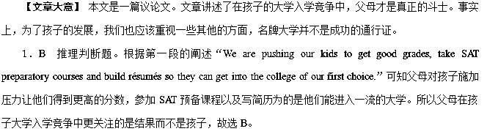2．C 细节理解题。根据第二段的“It's true getting into college has generally become tougher because the number of high school graduates has grown.”可知高中毕业生数量的增加使得进入大学变得越来越困难。由此判断选项C正确。故选C。
3．D 句意理解题。此句表达的意思是：孩子比他们的大学重要。根据下文的描述“Getting into college isn't life's only competition. In the next competition, the results may change.(进入大学并不是生活的唯一竞争，在下一场竞争中，结果可能就不一样了。)”可知这里的意思是孩子的能力比大学背景更重要，故选D。
4．B 推理判断题。根据Alan Krueger的研究“High scores on the GRE helped explain who got in; degrees of prestigious universities didn't.”可知研究生入学考试的高分帮助进入博士课程，但是名牌大学的学位不行。言下之意，名牌大学的学位并不能保证进入研究生项目。故选B。
40.
It is not only praise or punishment that determines a child's level of confidence. There are some other important ways we shape our kids—particularly by giving instructions and commands in a negative or positive choice of words. For example, we can say to a child “Don't run into traffic！” or “Stay on the footpath close to me.” In using the latter, you will be helping your kids to think and act positively, and to feel competent in a wide range of situations, because they know what to do, and aren't scaring themselves about what not to do.
Why does such a small thing make a difference? It is all in the way the human mind works.When we think, we automatically rehearse. For example, if someone offered you a million dollars not to think of a blue monkey for two minutes, you wouldn't be able to do it. When a child is told “Don't fall off the tree，” he will think of two things: “don't” and “fall off the tree”．That is, he will automatically create the picture of falling off the tree in his mind. A child who is vividly imagining falling off the tree is much more likely to fall off. So it is far better to use “Hold on to the tree carefully.”
Clear, positive instructions help kids to understand the right way to do things. Kids do not always know how to be safe, or how to react to the warning of the danger in negative words. So parents should make their commands positive.“Sam, hold on firm to the side of the boat” is much more useful than “Don't you dare to fall out of the boat？” or worse still “How do you think I'll feel if you drown？” The changes are small but difference is obvious.
Children learn how to guide and organize themselves from the way we guide them with our words, so it pays to be positive.
1. Positive choice of words helps kids to________．
A．do things carefully
B．build up their confidence
C．improve their imagination
D．learn in different situation
2. What can we infer from Paragraph 2?
A．A child will act on what is instructed.
B．One can't help imagining what is heard.
C．A child will fall off the tree when told not to.
D．One won't think of a blue monkey when given money.
3. Which of the following commands helps kids to be safe?
A．Fasten your seat belt.
B．Don't play by the lake.
C．How do you think I'll feel if you get hurt?
D．Don't you dare to walk through the red light.
4. The main idea of the passage is that________．
A．praise makes kids confident
B．right instructions keep kids safe
C．clear commands make kids different
D．choice of words can make a difference
【文章大意】 本文主要是告诉人们如何去教育孩子。要给孩子提供积极正面的指导，而不是负面消极的各种“不准”或“不要”。
1．B 推理判断题。根据第一段“It is not only praise or punishment that determines a child's level of confidence. There are some other important ways we shape our kids—particularly by giving instructions and commands in a negative or positive choice of words.”可知积极正面的话语会让孩子们树立信心。
2．B 推理判断题。根据第二段“When we think, we automatically rehearse. For example, if someone offered you a million dollars not to think of a blue monkey for two minutes, you wouldn't be able to do it.”可知，越让不要去想人们越禁不住会去想，故选B。
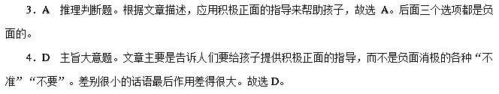41.
The Man Booker Prize for Fiction is awarded for a novel written by a writer from the Commonwealth or the Republic of Ireland and it aims to represent the very best in contemporary fiction. The prize was originally called the BookerMcConnell Prize, which was the name of the company that sponsored it, though it was betterknown as simply the “Booker Prize”．In 2002, the Man Group became the sponsor and they chose the new name, keeping “Booker”．
Publishers can submit books for consideration for the prize, but the judges can also ask for books to be submitted that they think should be included. Firstly, the Advisory Committee gives advice if there have been any changes to the rules for the prize and selects the people who will judge the books.The judging panel changes every year and usually a person is only a judge once.
Great efforts are made to ensure that the judging panel is balanced in terms of gender (性别) and professions within the industry, so that a writer, a critic, an editor and an academic are chosen along with a wellknown person from wider society. However, when the panel of judges has been decided, they are left to make their own decisions. Meanwhile, the prize sponsor has no further right to take part in any more.
The Man Booker judges include critics, writers and academics to maintain the consistent quality of the prize and its influence is such that the winner will almost certainly see the sales increase considerably, in addition to the ￡ 10，000 that comes with the prize.
1. Who can submit books to the prize?
A．Judges. B．Writers. C．Readers. D．Sponsors.
2. Why is the prize named the Man Booker Prize?
A．Because the prize is given to writers from the Commonwealth.
B．Because the prize was known as simply the “Booker Prize”．
C．Because the prize is sponsored by the Man Group and they kept the name.
D．Because the prize is aimed to award the very best contemporary fiction.
3. Which task can be done by the Advisory Committee?
A．Changing the rules for the prize on their own.
B．Selecting the judging committee.
C．Making decisions on who is the winner.
D．Submitting books for consideration for the prize.
4. The consistent quality of the prizes is guaranteed by ________．
A．the prize money
B．the gender of the judges
C．the makeup of the panel of judges
D．the increase in sales of the winner
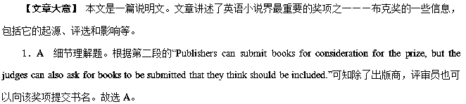2．C 细节理解题。根据第一段的“The prize was originally called the BookerMcConnell Prize, which was the name of the company that sponsored it, though it was betterknown as simply the ‘Booker Prize’. In 2002, the Man Group became the sponsor and they chose the new name, keeping ‘Booker’．”可知，布克奖以赞助商布克公司命名，故答案为C。
3．B 细节理解题。根据第二段的“…the Advisory Committee gives advice if there have been any changes to the rules for the prize and selects the people who will judge the books.”可知顾问委员会可以选择评审书单的人员，故选B。
4．C 细节理解题。根据“The judging panel changes every year and usually a person is only a judge once.”和 “Great efforts are made to ensure that the judging panel is balanced in terms of gender (性别) and professions within the industry, so that a writer, a critic, an editor and an academic are chosen along with a wellknown person from wider society.”以及最后一段可知，布克奖始终如一的公信力和权威性，指的是除评审员之外，还有全体陪审员，且是每年更换的。故答案为C。

