
绝密☆启用前
英语
本试卷共8页。全卷满分150分，考试时间120分钟。
考试范围：高考全部内容。
注意事项：
1.答题前，考生务必将自己的姓名准考证号填写在答题卡上。
2.回答选择题时，选出每小题答案后，用铅笔把答题卡对应题目的答案涂黑。如需改动，用橡皮擦干净后，再选涂其它答案标号。回答非选择题时，将答案写在答题卡上。写在本试卷上无效。
3.考试结束后，将本试题和答题卡一并交回。
第一部分 听力(共两节，满分30分)
做题时，先将答案标在试卷上。录音内容结束后，你将有两分钟的时间将试卷上的答案转涂到答题卡上。
第一节(共5小题；每小题1.5分，满分7.5分)
听下面5段对话。每段对话后有一个小题，从题中所给的A、B、C三个选项中选出最佳选项，并标在试卷的相应位置。听完每段对话后，你都有10秒钟的时间来回答有关小题和阅读下一小题。每段对话仅读一遍。
1.How will the woman get home?
A. By car. B. By bus. C. By train.
2. Where has the woman been recently?
A. Italy. B. Brazil. C. Australia.
3. How long can the man keep his magazines?
A. Two weeks. B. Three weeks. C. One month.
4.Where does the conversation take place?
A. In a hospital. B. At the barber's. C. At a restaurant.
5. What does the man think the woman's father should do?
A. Go to see a doctor. B. Listen to the woman. C. Stop smoking.
第二节(共15小题；每小题1.5分，满分22.5分)
听下面5段对话或独自。每段对话或独白后有几个小题，从题中所给的A、B、C三个选项中选出最佳选项，并标在试卷的相应位置。听每段对话或独自前，你将有时间阅读各个小题，每小题5秒钟；听完后，各小题将给出5秒钟的作答时间。每段对话或独白读两遍。
听第6段材料，回答第6至7题。
6. W hat is the weather like now?
A. Warm. B. Cold. C. Hot.
7. What does the woman like to do in summer?
A. Buy clothes. B. Eat hot pot. C. Do outdoor sports.
听第8段材料，回答第10至12题。
8. What is the woman doing?
A. Renting a house. B. Buying a house. C. Designing a house.
9. Where can the woman park her car?
A. In a garage. B. In a parking lot. C. In a yard.
听第9段材料，回答第13至16题.
10. Why does the man say sorry?
A. His behavior worries the woman.
B. He is unable to meet the woman.
C. He is too busy in his work.
11 .What does the man's sister look like?
A. Slim. B. Short. C. Fat.
12. What does man's sister usually wear?
A. Short black hair. B. White dresses. C. White shoes.
13. How long has the man been married?
A. About 5 years. . B. About 15 years. C. About 50 years.
14. What present did the man give his wife last year?
A. A pearl necklace. B. A diamond necklace. C. A gold necklace.
15. What do we know about the man's wife?
A. She likes wearing cheap earrings.
B. She can't wear silver earrings.
C. She doesn't like something special.
16. How much does the bracelet cost actually?
A. $450. B.$490. C.$500.
听第10段材料，回答第17至20题。
17. What completely changed how women dressed?
A. The households. B. The war. C. The views.
18. What did working women like to wear during the war?
A. Blue jeans. B. Leather shoes. C. Cotton skirts.
19. Why did clothes makers begin to design shorter skirts?
A. To look attractive. B. To avoid unsafe machines. C. To save materials.
20. How many married women worked outside during the war?
A. Above 30%. B. About 25%. C. About 20%.
第二部分阅读理解(共两节，满分40分)
第一节(共15小题；每小题2分，满分30分)
阅读下列短文，从每题所给的四个选项(A、B、C和D)中，选出最佳选项。
A
Young Writers Workshop
Since 1983 the workshop has offered teens the opportunity to explore new directions in their writing. The workshop sections are small(12 teen students). Fostering the sense of belonging to a learning community, trusting one's own language and voice·and learning to think for other-these are the qualities and skills that the workshop strives to develop.
TERP Young Scholars
The program welcomes talented teen students to an extraordinary learning opportunity at the University of Maryland. Participants benefit from its vast resources，including libraries, computer and labs. They also enjoy trips to nearby Washington, movie nights，activities at the student union，mixers, and more. It offers college courses that are at the cutting edge of theory，thought and technology. Upon successful completion，they can earn three college credits of this university.
Books Summer Program
It is a lively and warm camp for outstanding teens who love literature and ideas. In the past eleven years, it has gathered exceptional middle and high school students to read selections from the greatest works of literature, experience college-level discussions and have fun with others. You'll also discuss the likes of Plato, Jefferson, Tolstoy, Borges and Vonnegut.
Zeal Travel
We offer our teens two-week and three-week long trips to Hawaii，Alaska, Australia, Costa Rica, and Spain. All trips include 15-25 hours of community service activities. Every trip also includes exciting outdoor pursuits like surfing, scuba diving，ice climbing, zip line tours, hiking, and more.
21.Which program will students attend to earn college credits?
A. Young Writers Workshop. B. TERP Young Scholars.
C. Books Summer Program. D. Zeal Travel.
22. What can students do in Books Summer Program?
A. Learn how to write stories. B. Make friends with famous writers.
C. Play some games with others. D. Read and discuss the greatest works.
23. Which of the following can best describe Zeal Travel?
A. Adventurous and meaningful. B. Educational and inspiring.
C. Traditional and helpful. D. Crazy and challenging.
B
Eric Davis got interested in firefighting when he was in the army. And while much of his job today is related to EMS(emergency medical services)，his first love is fighting fires. "I enjoy the job and working with people. I enjoy firefighting.” he says.
Davis studied in a firefighting school for about three months and took part in classroom work，physical exercise，and hands-on training such as fighting live fires in buildings filled with straw.
Davis says the blindfold(蒙眼的)training prepared him for real fires. "By the time we get to a fire，if it's going pretty good，the whole house will be filled with smoke. And anytime you get near the fire, you won't be able to see at all. Zero visibility(能见性)is the same as darkness. The blindfold training works.”
Davis believes his most important duty is making sure he's prepared for any situation he might come across. To keep physically fit，he runs several times a week and works out. He takes classes to keep up his skills and trains regularly by fighting practice fires. Sometimes this includes cutting holes in roofs, which helps allow smoke to pass out and improves visibility for firefighters inside the building.
Firefighting means plenty of risks. Besides，Davis says·"You have to be willing to help any person you come across.” If someone is trapped，Davis or another firefighter will put himself at risk to get the person out. Davis says he is not afraid when he's fighting a fire. He does what's needed.
24. What is David's main duty at present?
A. Providing emergency medical care. B. Fighting fires in tall buildings.
C. Giving firefighters training. D. Saving people trapped in fires.
25. Where did David learn firefighting?
A. In the army. B. In the hospital.}
C. In the classroom. D. In a professional school.
26. Why were learners trained blindfold?
A. To experience how the blind feel. B. To protect their eyes from the smoke.
C. To recreate a real fire situation. D. To prepare for firefighting at night.
27. What can we infer about Davis?
A. He was once an army man. B. He tries his best to be a good firefighter.
C. He helps improve the working conditions. D. He is worried about the safety of firefighters.
C
For some people, running outdoors is a great way to exercise. What may not be so great is seeing trash all over the ground. Well, some people are doing something about it. They are plogging! Plogging began in Sweden in 2016. A Swedish man named Erik Ahlstrom became concerned about the amount of trash and litter he saw each day on his way to work and he began picking up the trash. That is how plogging was born!
Plogging, by that term，may have officially begun in Sweden. But many people who exercise outdoors have been doing this for years. Take Jeff Horowitz for example. He is a personal trainer in Washington，D. C. He would often pick up trash while running outside. He even turned it into a game; he would try to pick up the trash without stopping.
Today, plogging is an official activity, one that is becoming increasingly popular. Plogging can build closer social connections in a community, and it can also be fun. When Dana Allen goes plogging around D. C., she invites her friends, and they make a day of it. Although Allen enjoys plogging，she doesn't do it all the time. When she is training for a serious marathon race，the trash has to wait.
Cities around the world now hold plogging events. The goal is to spread the idea that littering is not acceptable. Along with cleaning up the environment, there may be another reason to choose plogging. One fitness app，Lifesum，records one hour of plogging as burning 288 calories. Usual jogging burns about 235 calories.
Getting ready to plog is similar to getting ready to jog. Ploggers do some deep knee bends as well as some balancing exercises and then they put on protective gloves. There are other safety rules for plogging. The main one is to plog in areas where there are not too many people. Stopping quickly in front of someone. to pick up an empty bag of potato chips, for example, could cause a crash.
28. What do we know about Jeff Horowitz from the text?
A. He was the first person to plog. B. He has been actually plogging.
C. He is in support of eco-travelling. D. He is an expert in picking up trash.
29. What is so special about Dana Allen's plogging?
A. She doesn't always do it with her friends.
B. She always finds it interesting to do it.
C. She nearly does it in a park every day.
D. She doesn't insist doing it every day.
30. What do the numbers in Paragraph 4 mainly tell us?
A. Picking up trash is important. B. Plogging events are of little use.
C. Flogging is a better workout. D. The idea of plogging is strange.
31. Why should ploggers choose to plog in less crowded areas?
A. To avoid a crash. B. To save energy.
C. To pick up more trash. D. To make it unknown.
D
Anyone who has studied biology, watched a nature documentary, or, for that matter, simply enjoyed time in the outdoors, has likely been amazed by the variety of plant and animal life on our planet.
To date, about 1.5 million species have been formally described in the scientific literature, most of them insects. Proportionally, bacteria make up less than 1% of all described species.
Scientists generally agree that many more species exist than are formally described，but they disagree about how many there really are. Some studies have estimated 2 million or fewer, whereas others suggest as many as 12 million. In a new paper published in The Quarterly Review of Biology，researchers from the University of Arizona have estimated that there are roughly 2 billion living species on Earth, over a thousand times more than the current number of described species. In coming up with their estimate，the researchers took advantage of the fact that many estimates now agree on the projected number of insect species, around 6.8 million. They incorporated new estimates of species boundaries revealed by DNA sequences, which suggest there might be six times as many insect species，increasing the total to 40 million for insect species alone.
They then reviewed all groups of organisms associated with insects as parasites. They found that each insect species most likely hosts a unique species of mite(螨)，roundworm，a one-celled microsporidian(微孢子虫), and a one-celled organism called apicomplexan(顶覆虫). Most importantly, the researchers estimated that each insect species is likely to host at least 10 bacterial species found nowhere else. Based on these estimates，they conclude that there should be around 2 billion species on Earth.
32. How many bacterial species are formally described in the scientific literature?
A. About 1.5 billion. B. About 1.5 million.
C. About 150 thousand. D. About 15 thousand.
33. Which of the following do scientists generally agree on?
A. There are many more species not included in the scientific literature.
B. There are about 1.5 million insects described in the scientific literature.
C. There are about 12 million species existing but not known to the scientists.
D. There tire about 6. 8 million insect species not hosting parasites.
34. Which word can best explain "hosts" underlined in the last paragraph?
A. Attracts. B. Supports. C. Kills. D. Invites.
35.What's the main idea of the passage?
A. A discovery of new bacterial species.
B. Different theories to estimate species.
C. A new estimate of biodiversity on Earth.
D. Different opinions on the number of species.
第二节(共5小题；每小题2分，满分10分)
根据短文内容，从短文后的选项中选出能填入空白处的最佳选项。选项中有两项为多余选项。
Why don't birds on a wire get a shock? 36 Firstly, the bird not only forms a circuit with the wire，but it also offers a high resistance to current，so the current passes through the wire instead of the bird.
It's a bit like this, would you prefer going on a smooth road or a road full of potholes? The answer is obvious and just like you. 37 All objects offer some amount of resistance to the flow of current，depending on the material. 38 However the more important reason why current does not pass through the bird is, there is barely any, if at all. voltage difference(电压差)across the bird. Current flow is actually just the flow of minute charged particles that are invisible to the naked eye. 39 The amount of energy needed to move the charges from one point to another is measured in terms of the potential difference between the two points.
A bird perched on high-tension wires has both its feet placed firmly on the same wire, so the potential difference from one end of the bird to the other is，for all purposes, next to nil(零).
If the bird were to touch the wire and simultaneously another wire, it would receive a mild shock. On the other hand if it were to touch the wire and some other object connected to the ground, it would receive a deadly shock. 40
A. Many of us are puzzled at it.
B. There are two reasons for that.
C. The current prefers taking the easier path.
D. This explains why birds don't get shocked on a wire.
E. This is just one of the reasons why birds don't get a shock.
F. The greater the potential difference, the greater is the current flow.
G. These charged particles need an energy input in order for them to get transferred.
第三部分 英语知识运用(共两节，满分45分)
第一节 完形填空(共20小题；每小题1.5分，满分30分)
阅读下列短文，从短文后各题所给的四个选项(A、B、C和D)中，选出可以填入空白处的最佳选项。
A couple days ago, my 9-year-old son and I were grocery shopping. At the check-out，a mother was trying to understand her bill. She didn't have enough 41 for her milk and cheese. The grocery store manager 42 the items from her cart and carried them away to the refrigerator section.
Although there have been 43 I myself didn't have money to buy groceries my family needed. I 44 whispered to my son and told him to run and get the manager back with the items. He was 45 . He didn't understand me. I was trying to do an act of kindness, but it 46 .
The lady 47 with her son and fewer groceries than she had planned. I told the checkout guy to 48 me for her milk and cheese and that we'd run to the parking lot and 49 her. He said "You'd do that?" and I said "Yes, I’ ve been there before and want to 50 they have what they need.”
He quickly called the manager back, 51 up my items and hers.and my son and I ran to the 52 .But the mom and her son 53 . I have no idea where they went. They were gone in60seconds and with them went my 54 to gift these necessary items. We were too late. I felt 55 and terrible for not speaking up and telling her what I wanted to do for her, 56 , I wouldn't miss the chance for 57 kept thinking about my 58 : because I didn't want to 59 her，didn't want to cause a fuss(忙乱)…
So I ask myself and you dear friends，if we allow our minds to 60 our actions towards acting for love and kindness，is it still an act of kindness?
41 .A. time B. space C. money D. knowledge
42. A. removed B. stopped C. found D. demanded
43. A. arrangements B. possibilities C. chances D. times
44. A. yet B. even C. again D. also
45. A. excited B. confused C. regretful D. thoughtful
46. A. moved on B. slowed down C. took place D. went wrong
47. A. slipped B. left C. signaled D. returned
48. A. charge B. promise C. forgive D. pay
49. A. watch B. understand C. catch D. thank
50. A. pay back B. go back C. pick up D. make sure
51. A . rang B. picked C. raised D. brought
52. A. car B. gate C. grocery D. parking lot
53. A. separated B. disappeared C. mistook D. missed
54. A. contribution B. thought C. opportunity D. mood
55. A. ashamed B. lucky C. anxious D. hopeless
56. A. but B. or C. though D. thus
57. A. success B. celebration C. kindness D. expression
58. A. fault B. hesitation C. difficulty D. expectation
59. A. inform B. disturb C. embarrass D. shock
60. A. fill B. quicken C. strengthen D. slow
第二节(共10小题；每小题1.5分，满分15分)
阅读下面材料，在空白处填入适当的内容(1个单词)或括号内单词的正确形式。
Have you ever wondered where Lego(乐高积木)came from? Like many great inventions, the story is not just one of a great idea,61. one of a ton of hard work and perseverance(毅力).
The story started in Denmark. Ole Christiansen was a carpenter 62. was struggling with his small business. His wife died 63. (short) after his fourth son was horn. He had to work hand to support his family alone. He started making wood toys, but they didn't sell well. He decided his toys needed a name, and lie chose 64. name “Lego”.
Unfortunately, several years later, his workshop 65. (burn) to the ground. Soon, he started to make a few plastic toys. He got the idea to create a “system" of toys that would build up kids' 66. (imagine)and creativity. He decided to stop 67. (make)wood toys and focus only on the connected plastic toys. Then he started to build more and more kinds of 68.
(model).Each one had to be of the 69. (high)quality, which can be reflected in Lego's motto-“Only the best is good enough.”
Thanks to their perseverance, kids can enjoy Lego toys, movies, amusement parks and clothing. But none of this would have existed at that time if they 70. (give up)when times got hard.
第四部分 写作(共两节，满分35分〕
第一节 短文改错(共10小题；每小题1分，满分10分)
假定英语课上老师要求同桌之间交换修改作文，请你修改你同桌写的以下作文。文中共有10处语言错误，每句中最多有两处。每处错误仅涉及一个单词的增加、删除或修改。
增加：在缺词处加一个漏字符号(∧)，并在其下面写出该加的词。
删除：把多余的词用斜线(\)划掉。
修改：在错的词下画一横线，并在该词下面写出修改后的词。
注意：1.每处错误及其修改均仅限一词；
2.只允许修改10处，多者(从第11处起)不计分。
My grandpa used to be a teacher who is retired now. He has been living the busy and active life，going online，writing articles for newspapers, but attending academic conferences all over the country. He also has many hobby，such as growing flowers at home, collecting stamps and coins and especial drinking tea. There are many different tea sets and almost all kinds tea in his home, most of that I can't name.
My grandpa is so very crazy about tea that he can't live without enjoying tea several times a day. He once told nee he would be sleepy with tea. I often help making tea and drink together with me. I love my grandpa.
第二节 书面表达(满分25分)
英国某同学打算邀请中国学生开展“手拉手”活动(The Hand-in-Hand Program)，正在站招募参加者。假如你是李华，你对该活动很感兴趣，现请你给活动负责人Mr. Smith写一封申请信，包括以下要点：
1.个人意向；2.个人优势；3.个人作用。
注意；1.词数100左右(开头和结尾已给出，不计入总词数)；
2.可以适当增加细节，以使行文连贯。
Dear Mr. Smith，
I react about your Hand-in-Hand Program on your website just now.

Yours,
Li Hua

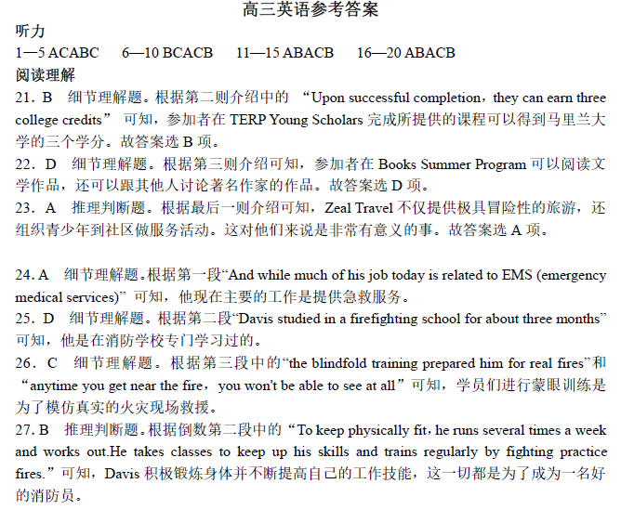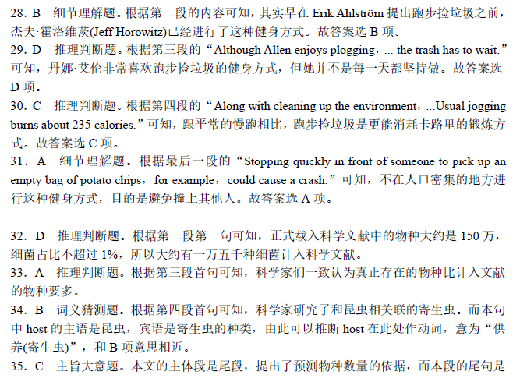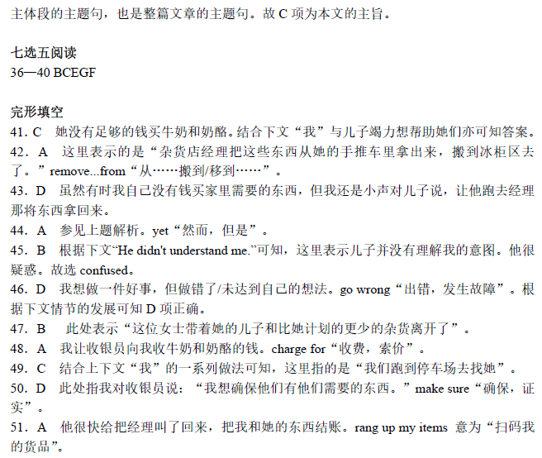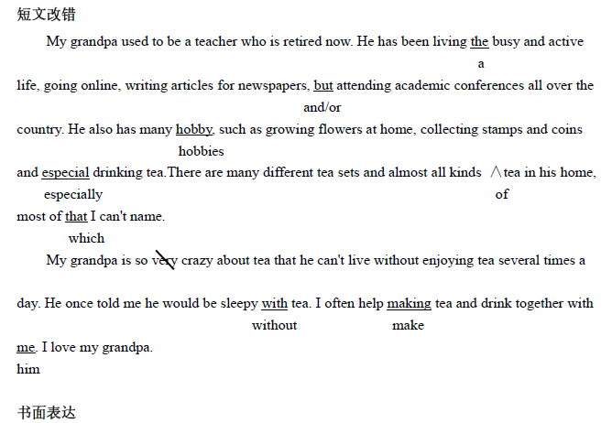
听力原文
Text 1
M：We can take the bus or the train home when the Hip-hop class is over.
W：No.I told my sister to come and pick me up.
Text 2
M：I really envy you，Linda.You seem to have been everywhere.
W：That's right.I have visited several countries，such as Italy，France，Russia，Brazil，and recently
Australia.
Text 3
W：Now，two books and three magazines.
M：By the way，how long can I keep them?
W：You can keep magazines two weeks，and books，as long as one month.
Text 4
W：How do you want it，sir?
M：I just want to have my hair cut a little shorter，please.
W：Would you like it washed?
M：No，thank you.I did before I came.
Text 5
M：Hello! I'm glad to see you.How is your father?
W：My father is very sick.He coughs so badly.
M：To my understanding，he really should listen to the doctor and stop smoking.
Text 6
M：I need to buy some winter clothing.It's getting freezing these days.
W：I'm not a winter person.Do you like winter?
M：Well，at least I won't sweat like a pig in winter.
W：I remember you always sweat easily.
M：Yeah.Besides，I do enjoy eating Chinese hot pot with my friends.The hot pot is just not that
wonderful to eat in summer，is it?
W：I do love the sunshine for I can do so many outdoor activities，like swimming in the warm sea
water，etc.How I miss summer!
M：I don't like it for it's so hot.
Text 7
M：Mrs.White! How do you like this house?
W：It's very nice.It faces south and it's full of light.But it's near the busy street and it's always so
crowded.
M：Actually，but it's only 600 pounds a month.
W：Really? How many rooms are there?
M：Four.It includes a living room，a kitchen，a bathroom and a bedroom.
W：Can I park in a garage or a parking lot?
M：You needn't.There is a small yard.
W：Wonderful.Can I move in tomorrow?
M：Sure.
Text 8
M：There is no need to worry.I'll call my sister to pick you up at the airport.Sorry，but I have to
work that day.
W：You mean you won't come to get me?
M：I'm terribly sorry.
W：That's all right.What does your sister look like?
M：Well，she's thin，she has long black hair and she is about 1.70 meters tall.
W：OK.
M：She usually wears a white dress with black high-heel shoes.And she carries a brown bag.You
won't miss her.
W：All right.So that day I'll look for some beautiful lady with a brown bag?
M：Exactly.
W：What is her name?
M：Linda.You can call her Linda.
W：OK.
Text 9
W：Hello，Sir.What can I do for you?
M： Yeah! I'm looking for a piece of jewelry for my wife.Our fifth anniversary is coming next
Friday.
W：Wow，that's very sweet.I'm glad I can help.Anything particular you have in mind，Sir?
M：Not really I'm at a loss.
W：Well，how about this pearl necklace? Look how shiny it is!
M：Actually I bought a gold necklace for her last year，so I'd like to try something different.
W：OK.Then what do you think of this pair of silver earrings? They cost only $120 for this special
heart-shaped design.
M：They look nice and the price is reasonable，but my wife is allergic to silver.
W：I see.Maybe you want to consider this bracelet.It is a little expensive，$500，but we can offer
a 10% discount today.
M：This one is her style.OK，I'll take it.
W：Wait for a while.
M：Thank you very much.
Text 10
During World War II，every one in three American men left home to serve in the military，and
women worked in jobs out of the home.These women not only continued to manage their
families，but they also worked in factories，labs，power plants，etc.The war completely changed
women' s responsibility during these years — and this completely changed how they dressed ，
because women were doing more tasks requiring labor like driving trucks.Safety became more
important over looking attractive.
Working women put away their high heeled
shoes and silk dresses and wore cotton shirts
and blue jeans instead.During the war，certain materials were saved for other purposes，and to use
less of cloth，clothes makers began designing shorter skirts and slimmer clothing.
By the end of the war，over six million American women had joined the workforce，and
nearly one out of every four married women worked outside the home.Although many were
replaced by men once the men returned from war ， working out of the home changed people's
views of what women could do.

