上高二中2019届高三全真模拟考试
英语试题
（考试时间：120分钟 试卷满分：150分）
注意事项：
1. 答卷前，考生务必将自己的姓名、准考证号填写在答题卡上。
2. 回答选择题时，选出每小题答案后，用铅笔把答题卡上对应题目的答案标号涂黑。如需改动，用橡皮擦干净后，再选涂其他答案标号。回答非选择题时，将答案写在答题卡上，写在本试卷上无效。
3. 考试结束后，将本试卷和答题卡一并交回。
第一部分 听力
做题时，先将答案标在试卷上。录音内容结束后，你将有两分钟的时间将试卷上的答案转涂到答题卡上。
第一节
听下面5段对话。每段对话后有一个小题，从题中所给的A、B、C三个选项中选出最佳选项。听完每段对话后，你都有10秒钟的时间来回答有关小题和阅读下一小题。每段对话仅读一遍。
例：How much is the shirt?
A. £ 19. 15. B. £ 9. 18. C. £ 9. 15.
答案是 C。
1. What does the woman ask John to do?
A. Get something to eat. B. Have a discussion with Pete.
C. Leave the room for a moment.
2. How much will the speakers pay for the match?
A. £24. B. £42. C. £48.
3. Why can’t the woman pick up the man now?
A. Her car is under repair. B. She can’t open the car door.
C. She locked her car keys in her house.
4. Where are the speakers?
A. In a restaurant. B. In the man’s office. C. In a theater.
5. How does the man feel?
A. Relieved. B. Worried. C. Angry.

第二节(共 15 小题；每小题 1.5 分，满分 22.5 分)
听下面5段对话或独白。每段对话或独白后有几个小题，从题中所给的A、B、C三个选项中选出最佳选项，并标在试卷的相应位置。听每段对话或独白前，你将有时间阅读各个小题，每小题5秒钟；听完后，各小题将给出5秒钟的作答时间。每段对话或独白读两遍。
听第6段材料，回答第6、7题。
6. What are the speakers talking about?
A. A notebook computer. B. A mobile phone. C. A new T-shirt.
7. What can the tiny computers do?
A. Receive messages. B. Switch lights on and off. C. Operate the air conditioner.
听第7段材料，回答第8、9题。
8. What is the woman doing?
A. Looking through her schedule. B. Learning about some festival customs.
C. Deciding on the time for a holiday trip.
9. When is Easter this year?
A. April 6th. B. April 8th. C. April 9th.
听第8段材料，回答第10至12题。
10. What are the speakers doing?
A. Cooking. B. Watching TV. C. Doing shopping.
11. What does the man like best?
A. Ice cream. B. Milk. C. Cheese.
12. When does the conversation take place?
A. At noon. B. In the late afternoon. C. At night.
听第9段材料，回答第13至16题。
13. How often will the man be available to work?
A. No more than two evenings a week. B. Up to three evenings a week.
C. At least three evenings a week.
14. Why does the man apply for a part-time job?
A. To gain work experience. B. To improve his social skills. C. To earn money.
15. What is the man good at?
A. Solving problems. B. Communicating with people. C. Working in a group.
16. What will the man do on September 10th?
A. Have a lesson. B. Work for the community. C. Meet the woman.
听第10段材料，回答第17至20题。
17. From whom did the speaker get the information of the project?
A. Her neighbors. B. Her cousins. C. Her friends.
18. Where did the speaker come from?
A. China. B. Thailand. C. Australia.
19. What does the speaker ask her family to do?
A. Learn about sea animals. B. Recycle as much as possible.
C. Take part in the cleaning project.
20. What will One-Day Clean-up focus on January 11th next year?
A. The woodlands. B. The seaside. C. The rivers.
第二部分 阅读理解(共两节，满分40分)
第一节 (共15小题；每小题2分，满分30分)
阅读下列短文，从每题所给的A、B、C和D四个选项中，选出最佳选项，并在答题卡上将该项涂黑。
A
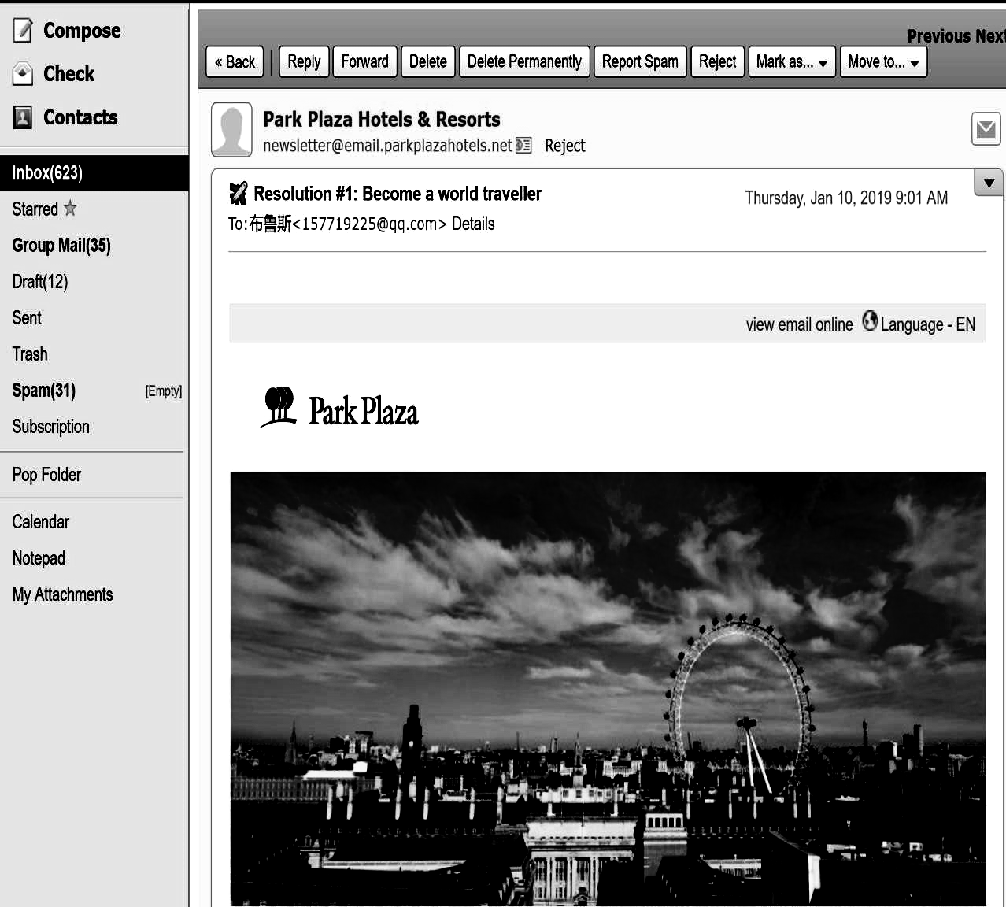
#You’ve received a message from Park Plaza Hotels and Resorts#
TO: Ran<157916227@qq.com>

Dear RAN,
Thank you for choosing Park Plaza Hotel for your stay in Reykjavik, Iceland.
As you have reserved 4 rooms or more with us, we kindly inform you that our GROUP cancellation policy applies as below :
Cancellations shall be sent no later than 8 weeks prior to arrival date. If cancellation is received between 8 and 4 weeks prior to arrival, the travel guest will be charged a 50% cancellation fee. All cancellations received later than 4 weeks before arrival are non-refundable. Cancellations must be sent in writing and reconfirmed by Park Plaza Hotel in writing to be valid.
It is the responsibility of the travel guest to send cancellations in time .Groups must be prepaid unless otherwise agreed up on.
We kindly ask you to confirm and agree to this email within the next
72 hours to confirm the reservation. Otherwise, w e reserve the right to cancel the reservation.
Kind regards,
Park Plaza Hotel - Sales department

21. What is the purpose of this email?
A. To introduce the hotel to the guest.
B. To tell the guest how to cancel the reservation.
C. To show the hotel’s appreciation for the reservation.
D. To inform the guest of cancellation rules and request confirmation.
22. Which of the following is true about cancellation policy?
A. You can’t cancel the reservation.
B. You can call to cancel the reservation.
C. You can’t get any refund if you cancel the reservation at arrival.
D. You can get full refund if you cancel the reservation before arrival.
23. What do we know about the reservation status(状态)?
A. It has been confirmed. B. It needs to be confirmed within 3 days.
C. It has been cancelled. D. It will be cancelled within 3 days.
B

In recent years I have had two very good roles on television: Florence, the wisecracking maid on the series The Jeffersons, and Mary, the mother who holds things together on 227. But 17 years ago, in 1972 when I was just getting started in theater work, I thought I’d never make it as an actress. For that matter, I couldn’t even hold my life together or afford a home of my own.

Back then I had about as much self-confidence as a chicken in a fox’s nest. I was recovering from surgery and had been off work for six months from my job as a United Airlines reservations agent. I’d had some bit parts in local theater groups, but those came and went, not leading to anything bigger.

Worse, as a single mother with three youngsters, I had no place to live. My children were staying with their father while I recovered in an aunt’s apartment. Lying in bed, staring hopelessly at the wall, I didn’t know what to do or where to turn.

Then one Sunday morning I aimlessly turned on the television set, and there were actor Robert Young and his wife talking about their faith. I sat right up in bed. They said, “ When one door closes, a better one opens,” Well, I wasn’t going to just sit staring at the closed one. So I got up and trudged(跋涉) on. Even if my shoes wore out, I decided, my faith wouldn’t.

Later, when I began filling small parts in television productions, that self-confidence showed. I’d always done my best to play the role as I thought the director wanted, but now I found myself freer to interpret it, I was more natural, more me.

24. What do the underlined words “ hold my life together” in paragraph 1 probably mean?

A. Enjoy my life B. Support myself C. Abandon my life D. Fight against my life

25. How did the author feel when she worked in the local theater?

A. Confident B. Excited C. Nervous D. Disappointed

26. What can we learn about the author from paragraph 3?

A. She lived in her own apartment B. She had to stay with her father

C. She was confused about her future D. She was looked after by her kids

27. What is the author’s purpose of writing this passage?

A. To share her understanding of faith with us B. To prove her success in the TV acting

C. To show thanks to her respected aunt D. To tell how hard she brought up her children.
C
It began as a game: High school and college students studying computer technology figured out they could use personal computers to break into telephone company computers and make free, long-distance telephone calls. These young computer talents soon gained the name "hackers".
Police arrested a few hackers, but many went on to even more complex hacking. One of them was arrested for making illegal telephone calls and later he used a phone to change a police officer's credit records to get back at the officer for arresting him. He also used a computer to change his college records to give himself better grades.
As hackers gained experience, they began invading computers at banks, airlines and other businesses. In one case a hacker instructed an airline' s computer to give him free airplane tickets.
The U.S. government is worried that hackers may break into its networks of defense computers. The government's secrets are easily attacked because thousands of government computers are connected by telephone lines that hackers can get into.
In November 1988, a college student entered a U.S. Defense Department computer network called Arpanet. The hacker injected a computer program that made copies of itself throughout Arpanet. Some hackers use viruses to destroy all the data in a computer. But in this case, government officials shut down the network before the program reached every computer in the system. Shutting down the system angered many researchers who were using the computers. The hacker turned himself in to the police and he was charged with a crime.
The incident put the spotlight on computer hacking in the United States. Many companies have hired experts to protect their computers from hackers, and many computer experts now advise companies on how to protect their computers.
The U.S. government believes foreign governments have hired hackers to try to break into top-secret defense computers.
Experts disagree over whether a computer network can ever be safe from hacking. But in the future, some of the most outstanding minds in the U.S. will be working to frustrate the attempts of computer hackers.
28. What did the first hackers do?
A. They broke into government computers. B. They destroyed airplane ticket systems.[来源:学科网]
C. They played computer games. D. They made free phone calls.
29. Why can U.S. government computers be easily hacked into?
A. They have no defense systems. B. They are connected by telephone lines.
C. They are partly accessible to the public. D. They lack complex processing programs.
30. What happened to the government computers in November 1988?
A. They lost all of the important data. B. They were shut down by researchers.
C. They were invaded by a college student.
D. They got totally ruined by a computer program.
31. What did companies decide to do to protect their computer systems?
A. Employ computer talents. B. Build secret defense systems.
C. Ask the government for help. D. Collect and analyze the data of hackers.
D
The clock always seems to be ticking rather too fast in the doctor’s office and the queue of patients outside the door seems to be pressing rather too hard. Some say it’s high time for the model of short, sharp one-to-one appointments to give way to shared medical appointments (SMAs共享医疗预约).
SMAs are doctor-patient visits in which a group of patients receive patient education and counseling(咨询), physical examination and medical support in a group setting. Typically SMAs are designed to have one or more doctors attend to a group of patients who share a common illness or medical condition. In contrast to one-to-one visits, SMAS provide a longer appointment time-frame as well as the opportunity for patients to have improved access to their physicians and meanwhile pick up additional information and support from peers.
However, doctors who have pioneered the shared appointment approach report that there are significant challenges involved. Dr. Sumego, director of shared medical appointments, Cleveland Clinic,identifies culture change as the most significant challenge. Physicians and nurses are trained in a model of personal service and privacy; the SMA approach is a fundamental challenge to those fixed ideas. They need shared goals and a way of testing the innovation against agreed standards. Dr. Sumego says, “The physicians may be worried about the possible chaos and efficiencies that are marketed. They also have to make the patients understand what their appointment is, and what the expectation is.”
“So, if an organization was looking to start shared medical appointments, I would advise them to start the buy-in from a few champion physicians, develop the work-flow and develop some experience. Provide some support behind what that best practice should look like. Create some standards so that, as the concept spreads, you can employ that experience to start the next shared medical appointments and the next.”
32. What is the purpose of the SMA approach?
A. To improve medical service. B. To promote doctors’ reputation.
C. To conduct medical research. D. To meet patients’ expectation.
33. According to Dr. Sumego, what prevents the SMA approach from being widely adopted?
A. Personal service. B. Fixed ideas. C. Lack of equipment. D. Shared goals.
34. What can the underlined “buy-in”in Paragraph 4 be replaced by?
A. practice. B. organization. C. purchase. D. support.
35. What can be learned about the SMA approach in the last paragraph?
A. It is currently being questioned. B. It is impractical in some areas.
C. It will enjoy wide popularity soon. D. It should be carried out step by step.
第二节 (共5小题；每小题2分，满分10分)
根据短文内容，从短文后的选项中选出能填入空白处的最佳选项。选项中有两项为多余选项。
Live Every Day Like It’s A Holiday
We feel great on holiday because we let go of everyday stresses and strains. ___36___ So whether or not you’re going away this summer, there’s plenty you can do to make sure you benefit from that holiday feeling.
Sleep like a holidaymaker
Sleep like a baby when you’re on your holidays but stay awake when you’re in your usual routine? ___37___ To reset your sleep pattern, avoid bringing problems to bed. That includes your phone, TV or laptop. Make sure the room is dark and cool. Aim for at least seven hours’ —just as you would on holiday.
Get moving
___38___ Given that exercise is cheap, healthy and reduces stress, it makes absolute sense to build it into your day. A walk will release happy hormones, and eases anxiety and mild depression.
___39___
Part of the joy of going away is lingering over delicious food with families. Take up the holiday habit of sitting down as a family for at least one meal a day. Families who eat together experience less anxiety, less depression and less obesity, research has found.
Be a tourist in your own city
Part of the thrill of a holiday is the novelty of discovering a new place and doing new things. ___40___ At weekends, check out a new music venue, visit a different museum or have a drink in that interesting-looking pub you’re always walking past. It will get you out of routine and make you feel alive. A bit like a holiday, really.
A. Make your meals a celebration.
B. Carve out some dedicated quiet time.
C. If so, you might need to examine your sleep habits.
D. Just make sure you schedule it into your day or week.
E. But it’s also easy to be a holidaymaker in the place you live.
F. Research has even shown that vacations help health and well-being.
G. When you’re travelling, you walk around new cities without a second thought.
第三部分 语言知识运用(共两节，满分45分)
第一节 完形填空(共20小题；每小题1.5分，满分30分)
阅读下面的短文，从短文后各题所给的A、B、C和D四个选项中，选出可以填入空白处的最佳选项，并在答题卡上将该项涂黑。[来源:Z,xx,k.Com]
As my husband, Doug, stood on the busy New York city street to stop a taxi, I tried to protect my daughter from the cold December wind and rain. I put my head down to kiss her__41__face.
Frustrated and wet, my husband gave up his attempt to hail a taxi. I knew the feeling. Just after her first birthday, we were told our daughter Katie has a ___42___ brain illness. Since that moment, Doug and I felt like __43___ in a marathon race where the finish line kept disappearing. We knew Katie was running out of ___44___. It had taken months before we finally had a name for the ___45___, but we were told only a few specialists in the world knew how to ___46___ it. Now, as we finally found a brilliant doctor to ___47___ our girl, we were in a strange city in the cold rain.
Just at the moment, a middle-aged woman ___48__ and said, “Pardon me? May I offer you a(n) ___49__?
Before we could say ___50___, she continued, “It’s really no ___51___ for me. Just get in.”
It was then that I noticed her thick Irish ___52___, which ___53___ me up like hot soup. We ___54___ said, “Thanks! Roosevelt Hospital, please,” as we got in her car for the ride.
“Are you going for the baby?” she asked us.
I nodded my head, holding back my ___55__.
At the hospital, we ___56__ her a dozen times for the ride. As the woman hugged me, I noticed her face was ___57___ with tears. She promised to pray for us before she left.
After three more visits to New York and two more __58___ surgeries (手术), Katie is cured. But the voice of the Irish Angel still rang as a constant ___59__ of a tiny ray of light that appeared in our __60__ days.
41. A. smiling B. tiny C. round D. beautiful
42. A. rare B. simple C. normal D. natural
43. A. passers-by B. judges C. lawyers D. runners
44. A. money B. confidence C. time D. courage
45. A. race B. illness C. doctor D. challenge
46. A. fix B. check C. reach D. explain
47. A. protect B. meet C. encourage D. save
48. A. pulled over B. put up C. turned down D. stood by
49. A. ride B. seat C. car D. umbrella
50. A. nothing B. anyone C. anything D. someone
51. A. difference B. question C. trouble D. loss
52. A. appearance B. accent C. custom D. hair
53. A. picked B. called C. woke D. warmed
54. A. normally B. simply C. angrily D. regularly
55. A. tears B. anger C. smile D. surprise
56. A. respected B. praised C. thanked D. accepted
57. A. annoyed B. disappointed C. happy D. wet
58. A. eye B. brain C. kidney D. heart
59. A. warning B. effort C. reminder D. exercise
60. A. busiest B. luckiest C. happiest D. darkest
第二节 (共10小题；每小题1.5分，满分15分)
阅读下面短文，在空白处填入 1个适当的单词或括号内单词的正确形式。
Almost all the ice covering the Bering Sea has melted(融化), scientists have confirmed, ____61____(throw) communities living around __62____(it) shores into disorder. The region’s ice cover ___63____(normal) lasts for at least another month, and this year it has disappeared earlier than any other year except 2017.
Living in __64___ northern Pacific Ocean between Alaska and Russia, the Bering Sea is experiencing the climate change and has drawn attention this year for record-breaking levels of winter melting. In February, rising Arctic temperatures ___65____(lead) to around half the region’s disappearing in the space of two weeks.
A report __66_____(send) by the International Arctic Research Centre at the University of Alaska Fairbanks has outlined the real-world effects of these surprising environmental ___67____(change) on the many communities __68____ live in the Bering Sea region.
In their report, the International Arctic Research Centre scientists wrote that while not every year will be as bad as this one, ice ___69_____(form) is likely to remain low if the Bering Sea’s waters remain warm. They also warn that communities will need to “prepare for more winters ___70____ low sea ice and stormy conditions”.
第四部分 写作(共两节，满分35分)
第一节 短文改错(共10小题；每小题l分，满分10分)[来源:Zxxk.Com]
假定英语课上老师要求同桌之间交换修改作文，请你修改你同桌写的以下作文。文中共有10处语言错误，每句中最多有两处。每处错误仅涉及一个单词的增加、删除或修改。
增加：在缺词处加一个漏字符号(∧)，并在其下面写出该加的词。
删除：把多余的词用斜线(＼)划掉。
修改：在错的词下画一横线，并在该词下面写出修改后的词。
注意：
1. 每处错误及其修改均仅限一词；
2. 只允许修改10处，多者(从第11处起)不计分。
I’m happy to know about that you are interested in Spring Festival couplets(对联), symbol of traditional Chinese culture. The tradition of put up Spring Festival couplets dates back to the Song Dynasty. Therefore, not until the Ming Dynasty did Spring Festival couplets become popular nationwide.
With black or golden character written on red paper, they are sticking on doors or walls. They are made up of positive words what convey wishes for love, health, success, wealth, happy and so on. A common theme of Spring Festival couplets is people’s desire for a better life in the coming year. In addition, praising your motherland is another popular theme.
Hopefully, you can have a better understanding because of my carefully explanation.[来源:学科网]
第二节 书面表达（满分25分）
假如你是李华，你的美国朋友Trevor对中国俗语很感兴趣，前些天给你发了一封邮件，向你请教“良言一句三冬暖，恶语伤人六月寒”的含义，请你结合以下要点给他回封邮件：
1.该俗语的含义;
2.你从中得到的启示。
注意: 1.词数100左右;
2.可以适当增加细节，以使行文连贯;
3.开头和结尾已给出，不计入总词数。
Dear Trevor,
Glad to receive your email and willing to explain to you the saying you mentioned in your email.

[来源:Z#xx#k.Com]

Hope my explanation will be helpful to you.
Yours, Li Hua
