

动词的时态、语态和语气是高考中的重中之重，也是英语句子结构的核心。英语句子的灵动性很大程度上体现在动词的各种变化上，因此谓语动词的时态、语态、语气的运用三位一体，不可分割。在单项填空题型中，时态和语态是考查的热点，但是语气问题也不可忽视。在备考过程中应该对谓语动词变化的各种情况都能够了如指掌。可以预测，未来高考仍然会以考查时态为主，但考查形式会更多地结合语态和语
气等形式，越来越侧重在语境中考查动词的时态、语态和语气，所以要求考生首先要掌握时态、语态和语气的基本用法，同时在所设置的语境中根据所给信息进行判断。也就是说，考生应学会通过上下文来确定所用时态、语态和语气。

热点题型一 一般时态
例1、The real reason why prices ________，and still are，too high is complex，and no short discussion can satisfactorily explain this problem.
A．were B．will be
C．have been D．had been
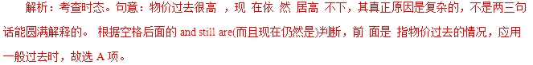
答案：A
【提分秘籍】
1．一般现在时
(1)表示经常发生的、习惯性的、反复出现的动作或状态。 常与表示习惯的副词(词组)always，every time，now and then，occasionally，often，seldom，sometimes，usually， every day/night等连用。
(2)按时间表、时刻表、日程表等安排将要发生的动作，用一般现在时。只限于go，arrive，leave，start，stay，return，begin，come等动词。
(3)用在时间、条件或让步状语从句中， 用一般现在时表示将来。
Around two o’clock every night，Sue will start talking in her dream.It somewhat bothers us.
每天晚上两点左右，苏就 说梦话。这使我们有点烦心。
If it doesn’t rain，we’ll go on a picnic as planned.
如果不下雨，我们将按计划去野餐。
Whatever you say，I will not change my mind.
无论你说什么，我都不会改变主意。
The flight takes off at 2：30 every Wednesday and Friday.
飞机每周三、周五2：30起飞。
2．一般过去时
表示在过去某一时间点发生的动作或所处的状态，与现在没有关系或表示过去一段时间内反复发生的动作， 常 与 every day，often，sometimes等时间状语连用。
—Haven’t seen you for ages! Where have you been?
——好长时间没见你了！你去哪里了？
—I went to Ningxia and stayed there for one year，teaching as a volunteer.
——我去了宁夏，在那里待了一年，作为一名志愿者教学。
3．一般将来时
(1)“shall/will＋动词原形”表示现在看来以后要发生的动 作或存在的状态。“will＋动词原形”还可以表示说话时临时做出的决定。
(2)“be going to＋动词原形”表示①现在打算或计划将 来 要做的事情；②表示根据某种迹象认为在最近或将来要发生的事情。
(3)“be to＋动词原形”表示①预先安排好的计划或约定；②表示说话人的意志、意图、指责、义务、命令等；③表示 注定要发生的事情。
(4)“be about to＋动词原形”表示正要或即将要做某事， 该结构不与表示具体的将来时间状语连用。
—What time is it?
——几点了？
—I have no idea.But just a minute，I will check it for you.
——我不知道。但是等一会儿，我给你查一下。
—Mr.Li was ill in hospital.
——李老师生病住院了。
—Oh，I didn’t know.I’ll go to see him tonight.
——哦，我还不知道呢。我今晚去看他。
I am to meet Mr.Brown at eleven o’clock this morning.
我要在今天上午11点见布朗先生。
I was about to go out when it began to rain.
我正要外出，这时开始下雨了。
【举一反三】
—Dr.Jackson is not in his office at the moment.
—All right.I ________ him later.
A．will call B．have called
C．call D．will be calling
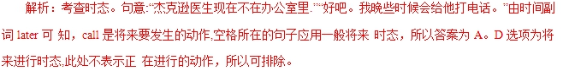
答案：A
热点题型二 进行时态
例2、 He must have sensed that I ________ him.He suddenly glanced at me and said quietly，
“Why are you staring at me like that？”
A．would look at B．looked at
C．was looking at D．am looking at
解析：考查时态。句意：他一定感觉到了我正在看他。他突 然瞥了我一眼，轻轻地说：“你为什么那样盯着我看?” must have done是对过去发生的情况的推测，因此“我正 在看他”也是发生在过去，而且是正在进行，故用过去进行时。
答案：C
【提分秘籍】
1．现在进行时
(1)表示说话时正在进行或表示现阶段正在进行的动作，虽然此时此刻该动作不一定正在进行。
(2)表示按计划或安排即将发生的动作，常限于go，come,leave，start，arrive，return，work，sleep，stay，have， wear等表示移动、方向的动词。
(3)表示说话人现在对主语的行为表示赞叹或厌恶等(常与always，constantly，continually等副词连用)。
2．过去进行时
表示过去某一时刻或某一段时间内正在进行的动作，常同表示过去的时间状语从句以及at that time，at that moment，at this time yesterday，at ten o’clock yesterday等连用。
She was phoning someone，so I nodded to her and went away.
她正在跟别人打电话，因此我朝她点了点头就走开了。
3．将来进行时
表示将来某一时刻正在进行的动作，或表示要从将来某一时刻开始，并继续下去的动作。
Daniel’s family will be enjoying their
holiday in Huangshan this time next week.
丹尼尔一家人下星期这个时候将在黄山度假。
【举一反三】
We have been trying to train the young people who were hired last month，but they________their best to learn.
A．were not doing B．didn’t do
C．are not doing D．hadn’t done
解析：考查时态。句意：我们已经一直在尽力训练上个月 聘请的年轻人，但是他们不尽力学习。根据题干的but判断是这些年轻人现在不尽力学习，应用现在进行时。故选C。
答案：C
热点题型三 完成时态
例3． In the last few years，China ________ great achievements in environmental protection.
A．has made B．had made
C．was making D．is making
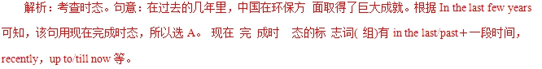
答案：A
【提分秘籍】
1．现在完成时
(1)表示发生在过去而对现在仍有影响的动作，常用的时间 状语：already，just，yet，never，before，lately，recently，in the last(past) few years，up to now，so far等。
(2)表示从过去某时开始而延续至今的动作或状态，常与for,since等表示一段时间的状语连用。
(3)在条件、时间、让步状语从句中，表示将来某时间前已完成的动作。
(4)This/It is the first/second...time＋that从句，that从句 中 谓语要用现在完成时。
(5)It(This)is the best(worst，most interesting等)＋名词＋定语从句，从句中的谓语用现在完成时。
—Have you heard about the recent election?
——你听说过近期的选举吗？
—Sure，it has been the only thing on the news for the last three days.
——当然了，它是近来三天新闻中唯一的事情了。
It is the most instructive lecture that I have attended since I
came to this school.这是我自从到这个学校以来所参加过的最有教育意义的讲座。
This is the first time that we have seen a film in the cinema
together as a family.
这是第一次我们一家人去电影院看电影。
I will not believe you unless I have seen it with my own eyes.
除非我亲眼看到，否则我不会相信你的。
2．过去完成时
(1)表示在过去某一时间或某一动作之前完成的动作或存在的状态，即过去的过去。
(2)表示从过去某一时间开始，一直延续到过去的另一时间的动作，常用的时间 状 语：by then，by that time，by the end of，by the time＋句子等。
(3)表示“愿望、打算”的动词(如hope，want，expect，
think，mean，suppose，plan，intend)用于过去完成时表示
过去本打算实现而未实现的希望或计划。
(4)在“hardly(scarcely)．..when...”，“no sooner...than...” 句型中，主句用过去完成时，从句用一般过去时，意为“一……就……”。
Sofia looked around at all the faces: she had the impression that she had seen most of the guests before.
索菲娅环视了所有的面庞，她有印象——绝大多数的客人以前她都见过。
He was unhappy when he sold his guitar.After all，he had had it for a very long time.
他把自己的吉他卖掉时并不高兴。毕竟，他拥有这把吉他已经很长时间了。
I had intended to call on you，but I had an unexpected visitor.
我本来打算去看你，但是来了一位不速之客。
By the time Jack returned home from England，his son had graduated from college.
杰克从英国回到家时，他的儿子已经大学毕业了。
Hardly/No sooner had I got home when/than the rain poured down.
我刚到家，大雨就倾盆而下了。
3．将来完成时
表示在将来某个时间之前完成的动作，并且往往对将来某一时间产生影响。常用时间状语为“by＋将来某个时间”。
By the time Mr.Smith arrives at the supermarket，we will have stayed there for one hour.
等到史密斯先生到达超市时，我们将已经在那里待了一个小时了。
【举一反三】
Just as I got to the school gate，I realized I ________ my book in the cafe.
A．have left B．had left
C．would leave D．was leaving
解析：考查时态。句意：就在我到达学校门口的时候，我 意识到我把书忘在咖啡馆里了。realized是发生在过去的动作，而leave动作又发生在realized动作之前，是过去的过去，因此用过去完成时。
答案：B
热点题型四 高考涉及的其他时态
例4、—Where is Peter？I can’t find him anywhere.
—He went to the library after breakfast and ________ his essay there ever since.
A．wrote B．had written
C．has been writing D．is writing
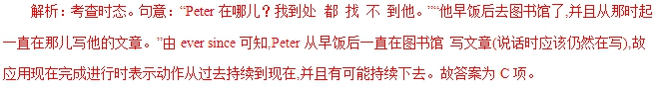
答案：C
【提分秘籍】
1．过去将来时
表示从过去某时间看将要发生的事情，多用于宾语从句中。
He hoped that he would be given a more suitable job in 2016.
他希望在2016年能得到更合适的工作。
2．现在完成进行时(have/has been doing)
表示过去某一时刻之前开始的动作或产生的状态一直延续 到现在,并有可能继续下去,常和for,since引导的时间状语连用。
Since the time humankind started gardening，we have been trying to make our environment more beautiful.
自从人类开始园艺技术的时候起，我们就一直在努力让我们 的环境变得更加美丽。
The manager has been telling the workers how to improve the program since 9 am.
自从上午9点经理就一直在告诉工人如何改善这一方案。
3．过去完成进行时(had been doing)
表示过去某一时刻之前开始的动作或产生的状态一直延续到过去某一时刻，这一动作可能已经停止也可能还在进行。
She told me that she had been studying French for 5 years.
她告诉我她已经学习法语5年了。(动作仍继续)
She told me that she had been waiting for me for an hour.
她告诉我她已经等我一个钟头了。(动作不再继续)
【举一反三】
—The plane is leaving right now，but Jim hasn’t arrived yet.
—Well，he said he________here on time.
A．came B．would come
C．can be D．will be
解析：句意：——飞机马上要起飞了，但是吉姆还没有到.——他说过他会准时到这儿。由答语可知应用过去将来时,故选B。
答案：B
热点题型五 被动语态
例5、 Despite the previous rounds of talks，no agreement ________ so far by the two sides.
A．has been reached B．was reached
C．will reach D．will have reached
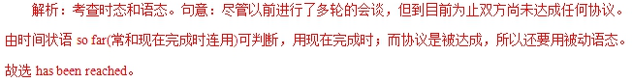
答案：A
【提分秘籍】
1．被动语态的构成为“be＋过去分词”，只要变换be的形式就可以得到不同时态的被动语态，除be外被动语态的构 成 形式还有：get/become＋过去分词。
2．只要及物动词或相当于及物动词的短语才有被动语态,不及物动词或短语无被动语态。常考的不及物动词或短语：
last，cost，spread，happen(to)，take place，belong to， break out，go out，run out，work out。
3．主动形式表示被动含义
(1) 表示感受、感官的系动词如feel，sound，taste，look等,后面跟形容词、名词构成系表结构，常常以主动形式表示被动意义。
(2) 当sell，read，draw，wash，write，open，wear，run， burn等不及物动词后带状语(well/easily等)修饰，用来表示主 语内在的品质或性能时用主动形式表示被动含义。
While waiting for the opportunity to get promoted，Henry did his best to perform his duty.
在等待机会被提拔期间，亨利尽力履行好自己的职责。
—So what is the procedure?
——那么程序是什么样？
—All the applicants are interviewed before a final decision is made by the authority.
——所有的应征者都被面试后官方才作出最后的决定。
Food supplies in the flood－stricken area are running out.
We must act immediately before there’s none left.
洪水灾区的食品即将用完。
我们必须在他们用完之前采取措施。
Your reason sounds reasonable.你的理由听起来很合理。
His books sell well，so they will be sold soon.
他的书很畅销，因此很快就会卖光。
【举一反三】
—Did you enjoy the party?
—Yes.We ________ well by our hosts.
A．were treated B．would be treated
C．treated D．had treated
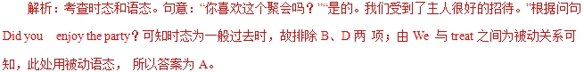
答案：A

1.【2018·北京】1. —Hi, I’m Peter. Are you new here? I haven’t seen you around?
—Hello, Peter. I’m Bob. I just _________ on Monday.
A. start B. have started C. started D. had started
【答案】C
【解析】考查时态。句意：——嗨，我是彼得。你是新来的吗？我没有在附近见过你。——你好，彼得。我是鲍勃。我周一刚刚开始住在这儿。根据两人谈话内容可知，Bob现在在这儿，他开始(start)住在这儿是发生在周一的事情，周一是一个过去的时间，故该句应用一般过去时态，C选项正确。
2.【2018·北京】4. Susan had quit her well-paid job and _________ as a volunteer in the neighborhood when I visited her last year.
A. is working B. was working C. has worked D. had worked
【答案】B
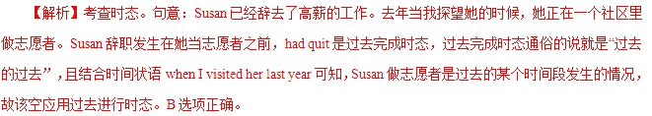
3.【2018·北京】7. China’s high-speed railways _________ from 9,000 to 25,000 kilometers in the past few years.
A. are growing B. have grown C. will grow D. had grown
【答案】B
【解析】考查时态。句意：在过去的几年里，中国的高速铁路已经从9,000公里增长到25,000公里。该句时间状语为in the past few years。中国高速铁路的增长是从过去一直到现在几年里的情况，故该句应用现在完成时态。B选项正确。
4.【2018·北京】9. A rescue worker risked his life saving two tourists who _________ in the mountains for two days.
A. are trapping B. have been trapped C. were trapping D. had been trapped
【答案】D
【解析】考查语态和时态。句意：一个救援人员冒着生命危险挽救了两个被困在山里两天的旅游者。“who ___ in the mountains for two days”是定语从句，修饰two tourists，two tourists和trap之间是被动关系，该空应用被动语态。由risked可知，营救人员救游客是过去的事情，被困两天发生在营救人员救了他们之前，即“过去的过去”，该空应用过去完成时态。综上，D选项正确。
5.【2018·天津】13. My washing machine ___________this week, so I have to wash my clothes by hand.
A. was repaired B. is repaired
C. is being repaired D. has been repaired
【答案】C
【解析】考查时态。句意：这周我的洗衣机正在修，所以我不得不手洗衣服。根据后句so I have to wash my clothes by hand.可知，洗衣机正在修，故用现在进行时态的被动语态。故选C。
6.【2018·天津】10. I can't find my purse. I___________ it in the supermarket yesterday, but I'm not sure.
A. should leave B. must have left
C. might leave D. could have left
【答案】D
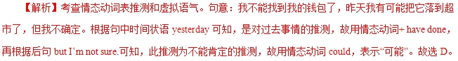
7.【2018·江苏】31. Hopefully in 2025 we will no longer be e-mailing each other, for we _______ more convenient electronic communication tools by then.
A. have developed B. had developed
C. will have developed D. developed
【答案】C
【解析】考查时态。句意：希望在2025年，我们不再互相发电子邮件，因为到那时候我们将开发更方便的电子通信工具。根据时间状语in 2025，可知用将来时；再根据时间状语by then到那时，可知用完成时。结合两者可知用将来完成时。故选C。
8.【2018·江苏】30. I was sent to the village last month to see how the development plan _______ in the past two years.
A. had been carried out B. would be carried out
C. is being carried out D. has been carried out
【答案】A
【解析】考查时态。句意：上个月我被派到村里去看看在过去的两年里发展计划是如何执行的。根据句中时间状语last month和in the past two years可知用过去完成时。故选A。
1．[2017·北京卷] —________that company to see how they think of our product yesterday?
—Yes. They are happy with it.
A．Did you call B．Have you called
C．Will you call D．Were you calling
【答案】A
【解析】句意：--你昨天有没有给那家公司打电话问问他们对我们的产品感觉怎么样？--打了，他们很满意。空格所在题干有一个很明显的时间状语yesterday，发生在过去，肯定用过去式，故选A。
【考点】考查时态。
2．[2017·北京卷] In the 1950s in the USA, most families had just one phone at home, and wireless phones ________ yet.
A．haven't invented B．haven't been invented
C．hadn't invented D．hadn't been invented
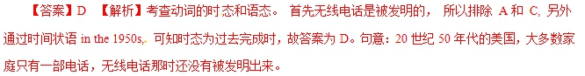
3．[2017·北京卷] People ________ better access to health care than they used to, and they're living longer as a result
A．will have B．have
C．had D．had had
【答案】B 【解析】考查动词的时态。句子是在描述现在的医疗便捷，表达的是现在的状态，所以应该用一般现在时，故答案选 B。句意：人们现在有权使用比过去更好的医疗服务，所以人们更长寿了。
4． [2017·江苏卷] He hurried home，never once looking back to see if he ________．
A．was being followed B． was following
C．had been followed D．followed
【答案】A【解析】考查动词的时态和语态。根据题意可知，此处应该是他“被跟踪”，动词follow与主语he之间构成被动关系，又因为hurried是过去式，故用过去进行时的被动语态，故选A项。句意：他匆忙赶回家，从来没有回过头去看看他是否被跟踪。
5． [2017·江苏卷] He's been informed that he ________ for the scholarship because of his academic background.
A．hasn't qualified B．hadn't qualified
C．doesn't qualify D．wasn't qualifying
【答案】C 【解析】考查动词的时态。根据has been informed及句意可排除B项和D项；“没有资格”属于客观事实，所以应用一般现在时。故选C项。句意：他被告知，由于他的学术背景，他没有资格获得奖学金。
6．[2017·天津卷] I ________down to London when I suddenly found that I was on the wrong road.
A．was driving B．have driven
C．would drive D．drove
【答案】A 【解析】考查动词时态。be doing…when…是固定句式，表示“正在做……这时突然……”。句意：我正开车去伦敦，这时我突然发现自己走错路了。
【2016·北京】23. —Excuse me, which movie are you waiting for?
—The new Star Wars. We ________ here for more than two hours.
A. waited B. wait C. would be waiting D. have been waiting
【答案】D
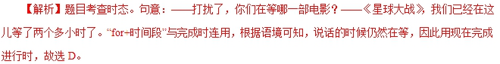
【2016·江苏】29.Dashan, who_________crosstalk, the Chinese comedic tradition, for decades, wants to mix it up with the Western stand-up tradition.
A. will be learning B. is learning C. had been learning D. has been learning
【答案】D
【解析】本句的时间状语是“for decades几十年来”，该时间状语通常和现在完成的有关时态连用，本句强调这几十年来大山一直努力把中国相声和西方的脱口秀相结合。所以使用现在完成进行时，强调动作的延续性和反复性。故D正确。
【2016·浙江】9. Silk ______ one of the primary goods traded along the Silk Road by about 100 BC.
- had become B. was becoming C. has become D.is becoming
【答案】A
【解析】句意：到公元前100年为止，丝绸已经成为丝绸之路上交易的主要商品之一。时间状语是by+过去时间，谓语用过去完成时。故选A。
【考点】考查动词时态。
【2015·北京】22.--Did you enjoy the party?
--Yes,we___by our hosts.
A.were treated B.would be treated. C.treated D.had treated
【答案】A
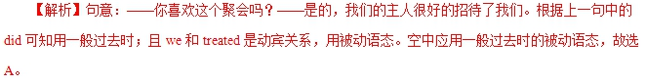
2.【2015·北京】26.in the last few years,China ___ great achievements in environmental protection.
A.has made B.had made C.was making D.is making
【答案】A
【解析】句意：在过去的这些年里，中国在环境保护中取得了很大的成就。由时间状语in the last few years可推知动作从过去一段时间持续到现在并对现在造成影响，用现在完成时。故选A。
【2015·北京】30. —Dr. Jackson is not in his office at the moment.
—All right. I____ him later.
A. will call B. have called C. call D will be calling
【答案】A
【解析】句意：——Dr.Jackson现在不在办公室。——好的，我待会再打给他。由later可知，表示的是将来要执行的动作，用一般将来时。故选A。
【2015·重庆】1. —Is Peter coming?
—No, he____ his mind after a phone call at the last minute.
- changes B. changed C. was changing D. had changed
【答案】B
【解析】句意：彼得来了吗？没有，刚才接到一个电话后改变主意了。根据at the last minute在最后一秒可能发生在过去，故用一般过去时。
【2015·重庆】13. In my hometown, there is always a harvest supper for the farmers after all the wheat____ cut.
A. will have been B. will be C. was D. has been
【答案】D
【解析】句意：在我的家乡，麦子丰收过后农民会有一个庆祝晚餐。现在完成时表示动作已经完成，才会举行庆祝活动，故选D项。
【2015·浙江】8. Albert Einstein was born in 1879. As a child, few people guessed that he a famous scientist whose theories would change the world.
A. has been B. had been C. was going to be D. was
【答案】C
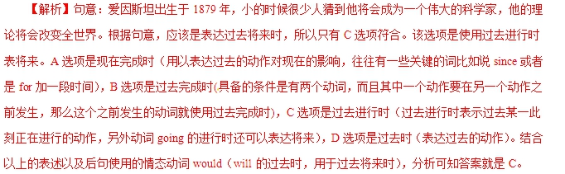
【2015·天津】9. Despite the previous rounds of talks, no agreement______ so far by the two sides.
A. has been reached B. was reached
C. will reach D. will have reached
【答案】A
【解析】句意：尽管之前多轮谈判，但到目前为止双方没有达成任何协议。根据句中的时间状语so far“到目前为止”可知用现在完成时。主语agreement与reach为被动关系，根据句意可知选A。
.【2015·天津】6. Jane can’t attend the meeting at 3 o’clock this afternoon because she ______ a class at that time.
A. will teach B. would teach
C. has taught D. will be teaching
【答案】D
【解析】句意：简不能参加今天下午3点钟的会议，因为她那个时候在一个班上课。根据句中的时间状语at that time，指代at 3 o’clock this afternoon，表示在将来的某一时刻正在做某事，故用将来完成时。故选D。
【2015·四川】4.More expressways in Sichuan soon to promote the local economy.
A. are being built B. will be built C. have been built D. had been built
【答案】B
【解析】本句为时态题，根据时间状语soon可知，考查了将来时，故选择B。句意为：四川将建设更多的高速公路以促进当地的经济。
【2015·陕西】24. At college, Barack Obama didn’t know that he the first black president of the United States of America.
A. was to become B. becomes C. is to become D. became
【答案】A
【解析】句意：在大学的时候，奥巴马不知道他将成为美国第一个黑人总统。用过去将来时表示过去某个时间将要发生的事情，所以选A。
【2015·陕西】22. Mary really hard on his book and thinks he’ll have finished it by Friday.
A. worked B. has been working C. had worked D. has worked
【答案】B
【解析】句意：Marty一直努力写书，我想他到周五为止将已经完成了。用现在完成进行时表示从过去到现在一直进行的动作。所以选B。
【2015·福建】26.To my delight, I from hundreds of applicants to attend the opening ceremony.
A. was chosen B. was being chosen C. would choose D. had chosen
【答案】A
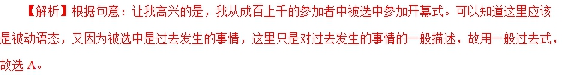
【2015·江苏】30.The real reason why prices ____ , and still are, too high is complex, and no short discussion can satisfactorily explain this problem.
A. were B. will be C. have been D. had been
【答案】A
【解析】句意：过去和现在价格一直居高不下的真正原因很复杂，简短的讨论解释这一问题无法让人满意。根据题干中“and still are”的提示可知过去价格也居高不下，故用一般过去时，表示过去的状态。故选A项。
【2015·安徽】29.It is reported that a space station ______ on the moon in years to come.
A. will be building B. will be built C. has been building D. has been built
【答案】B
【解析】句意：据报道，人们在接下来的几年里将在月球上建一个空间站。根据“in years to come”可知用将来时，space station和build是动宾关系，应该使用被动语态，故选B。
【2015·安徽】24.Just as I got to the school gate, I realised I ______ my bank in the cafe.
A. have left B. had left C would leave D. was leaving
【答案】B
【解析】句意：我刚一到学校门口，就意识到我把书落在餐馆了。realized后省略了that，这里是一个宾语从句，从句时态与主句保持一致，“落下”的动作发生在“意识到”之前，应该用过去完成时，故选B。
【2015·湖南】28.He must have sensed that I ________ him. He suddenly glanced at me and said quietly, "Why are you staring at me like that?"
A. would look at B. looked at C. was looking at D. am looking at
【答案】C
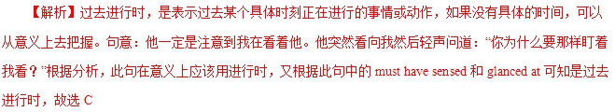
【2015·湖南】25.I wasn't able to hide my eagerness when I ________, "What do you wish me to do now?"
A. ask B. have asked C. am asking D. asked
【答案】D
【解析】一般过去时表示过去某个时间里发生的动作，常和表示过去的时间状语连用。此题主句的时态为一般过去时，表示这个事情和动作发生在过去，故从句时态也要用一般过去时。句意：我不能隐藏我的渴望，当我问道，“你现在希望我做些什么？”故选D
【2015·湖南】22.As you go through this book, you ________ that each of the millions of people who lived through World War II had a different experience.
A. will find B. found C. had found D. have found
【答案】A
【解析】一般将来时表示将要发生的动作或情况。在一般将来时的句子中，有时有表示将来时间的状语，有时没有时间状语，这时要从意思上判断是否指未来的动作或情况。句意：当你通读这本书的时候，你将会发现成千上万的经历过二战的每个人都有不同的经历。根据句意，判断主语的时态为一般将来时，故选A。
【2015·湖南】32.I had a strong desire to reach in and play with the toy, but ________ thankfully by the shop window.
A. am held back B. held back
C．hold back D．was held back
【答案】D
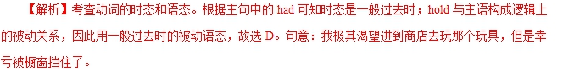
1．(2014·北京卷)—Hi, let's go skating.
—Sorry, I'm busy right now. I ________(fill) in an application form for a new job.
【答案】am filling
【解析】本题考查动词时态。句意：“嗨，我们去滑冰吧。”“对不起，我现在正忙着呢。”我正在填一份新工作的申请表。由时间状语right now可知，在说话这一刻“填表”的动作正在发生，故用现在进行时态。
2．(2014·天津卷)We won't start the work until all the preparations________(make)．
【答案】have been made
【解析】句意：在所有准备工作就绪以后我们才开始工作。在时间、条件状语从句中，可以用一般现在时、现在完成时表将来。从句中的动作make要先于主句谓语动词的动作start之前发生，应用现在完成时表将来。
3．(2014·安徽卷)The twins, who________(finish) their homework, were allowed to play badminton on the playground.
【答案】had finished
【解析】根据语境可知，完成作业是在were allowed之前发生的动作，属于“过去的过去”，应使用过去完成时。句意：已完成作业的双胞胎被允许到操场上打羽毛球。
4．(2014·陕西卷)During his stay in Xi'an, Jerry tried almost all the local foods his friends ________(recommend)．
【答案】had recommended
【解析】本题考查时态。句意：在西安逗留期间，Jerry几乎品尝了他朋友推荐的当地所有的名吃。根据时间先后关系来看，应该是朋友先推荐，然后Jerry才品尝，tried为过去式，所以recommend这一动作发生在“过去的过去”，故用过去完成时态。
5．(2014·湖南卷)Since the time humankind started gardening, we ________(try) to make our environment more beautiful.
【答案】have been trying
【解析】句意：自从人类开创园艺工作以来，我们一直在努力使我们的环境更加美丽。根据时间状语从句“Since the time”可知，try这一动作从过去一直持续到现在，并且有可能继续下去，故主句应用现在完成进行时。
6．(2014·江西卷)—Tony, why are your eyes red?
—I ________(cut) up peppers for the last five minutes.
【答案】have been cutting
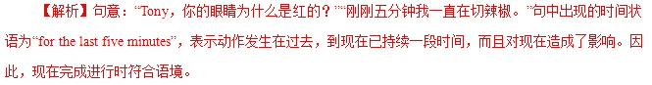
7．(2014·福建卷)—Haven't seen you for ages! Where have you been?
—I went to Ningxia and________(stay) there for one year, teaching as a volunteer.
【答案】stayed
【解析】本题考查时态。句意：“好长时间没见你了！你去哪里了？”“我去了宁夏，在那里待了一年，作为一名志愿者教学。”根据句中的关键词went可知stay这一动作也发生在过去，故用一般过去时。延续性动词如stay，study，live等的一般过去时可与介词“for＋一段时间”连用。
8．(2014·四川卷)She ________(phone) someone, so I nodded to her and went away.
【答案】was phoning
【解析】句意：当时她正打电话给别人，所以我对她点了点头，离开了。过去进行时表示在过去某一时刻或某一段时间内正在进行或发生的动作，其形式为was/were＋现在分词。根据句意可知，空格处用过去进行时表示在过去某一时刻正发生的动作。
9．(2014·重庆卷)You'd better write down her phone number before you ________(forget) it.
【答案】forget
【解析】本题考查动词时态。句意：趁着还没有忘记，你最好把她的电话号码写下来。before本意是“在……之前”，在句中引导时间状语从句，根据具体的语境在句中可译为“趁着……，以免……”，从句中用一般现在时态表示将来的动作。根据语境可知forget为将来的动作，故此处用一般现在时表示将来。
10．(2014·江苏卷)—How much do you know about the Youth Olympic Games to be held in Nanjing?
—Well, the media________(cover) it in a variety of forms.
【答案】have covered
