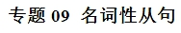


名词性从句是高考的必考点，它在句中可以作主语、宾语、 表语和同位语。单项填空题对名词性从句的考查集中在引导词上，其中连接代词that与what，if与whether是考查的重点。解决名词性从句的问题的关键是：
一、通过从句的位置辨别从句的类型；
二、分析从句，看看从句中所缺少的句子成分和句意，最终确定选用合适的连接词。


热点题型一 主语从句
例1、【2018·天津】The gold medal will be awarded ___________to wins the first place in the bicycle race.
A. whomever B. wherever
C. whoever D. whatever
【答案】C
【解析】考查名词性从句连接词。句意：无论谁获得自行车比赛第一名，金牌将授予他。分析句子可知，宾语从句中缺少主语，故用whoever，表示“任何人，无论谁”。故选C。
【变式探究】[2017·北京卷] Every year, ________ makes the most beautiful kite will win a prize in the Kite Festival.
A．whatever B．whoever
C．whomever D．whichever
【答案】B
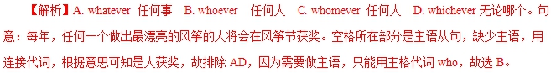
【提分秘籍】
1．引导主语从句的连接词：连词that，whether等；连接代词what，who，whose，whatever，whichever，whoever等；连接副词when，where，why，how等。
2．主语从句一般放在句首，但常用it作形式主语，而将主语从句移到句子的末尾。常见的句型有：
(1)It＋be＋形容词(necessary/likely/important/certain等)＋that从句
(2)It＋be＋名词(短语)(a pity/a shame/no wonder等)＋that从句
(3)It＋be＋过去分词(said/told/reported等)＋that从句
(4)It＋不及物动词(seem,appear,happen,matter等)＋that从句
Whatever she says will not make any difference to our arrangements.
无论她说什么都不会对我们的安排有影响。
But what I still can’t figure out is why I never got tired,never felt better in my life.
但我仍然不明白的是为什么我从来不厌倦，从未感到我的生活更好过。
It remains to be seen whether the newly formed committee’spolicy can be put into practice.
这个新形成的委员会的政策能否实施还有待观察。
That we are invited to the concert this evening is good news to us.
我们被邀请去参加今晚的音乐会,这对我们来说是个好消息.
It’s a pity that you are leaving.
你要离开，真遗憾。
【举一反三】
________ Li Bai，a great Chinese poet，was born is known to the public，but some won’t accept it.
A．That B．Why
C．Where D．How
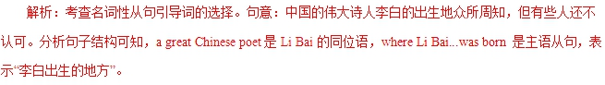
答案：C
热点题型二 宾语从句
例2、[2017·江苏卷] We choose this hotel because the price for a night here is down to $20，half of ________ it used to charge.
A．that B．which
C．what D．how
【答案】C 【解析】考查名词性从句。分析句子可知介词of后跟由what引导的宾语从句，what在从句中作charge的宾语，故选C项。句意：我们之所以选择这家酒店，是因为这里的价格低至20美元一晚，是过去收费的一半。
【提分秘籍】
1．引导宾语从句的连接词：连词that，whether，if；连接代词what，who，whose，whatever，whichever，whoever等;连接副词when，where，why，how，从句用陈述语序。
2．宾语从句一般放在及物动词或介词之后，但是，在下列情况下，须用it作形式宾语，而将真正的宾语放 到形式宾 语 或宾补之后。
(1)动词find/feel/think/consider/make＋it＋宾补(形容词或名词)＋不定式/宾语从句
(2)动词hate/like/dislike/appreciate＋it＋宾语从句
(3)动词短语see to/depend on/insist on＋it＋宾语从句
(4)固定搭配bring it to one’s attention/take it for granted that/owe it to sb.that＋宾语从句
3．一般情况下介词后只能用wh－类连接词引导宾语从句. 其他介词后面需要用that从句作宾语时,必须用it作形式宾语.
4．在doubt引导的宾语从句中，若主句为肯定句，宾语 从 句的连接词用whether/if，若主句为否定句或疑问句，宾语从句的连接词用that。
5．宾语从句的时态：一般情况下，宾语从句须与主句在时态上保持一致，即当主句是一般现在时时，从句可根据具 体 情况选用合适的时态；而当主句为过去时时，从句须用相 应 的过去时。当从句的内容为真理或客观事 实时， 须用一般现在时。
Experts believe that people can waste less food by shopping only when it is necessary.
专家们认为如果人们只在必要时购物，就会浪费较少的食物。
As many as five courses are provided，and you are free to choose whichever suits you best.
提供了多达五门的课程，你可以任意选择最适合你的一门。
I hate it when they talk with their mouths full of food.
我讨厌他们满嘴食物说话。
We are talking about whether we admit students into our club.
我们正在讨论是否让学生加入我们的俱乐部。
I think it necessary that we take plenty of boiled water every day.
我认为我们每天多喝白开水是有必要的。
【举一反三】
The exhibition tells us ________ we should do something to stop air pollution.
A．where B．why
C．what D．which
解析：考查宾语从句的引导词。句意：这次展览告诉我们为什么我们该做些事情来阻止大气污染。此处的从句用来作动词tells的宾语，因此该从句是宾语从句；这个展览告诉我们阻止大气污染的“原因”，所以此处要用why。
答案：B
热点题型三 表语从句
例3． 【2018·北京】This is _________ my father has taught me—to always face difficulties and hope for the best.
A. how B. which C. that D. what
【答案】D
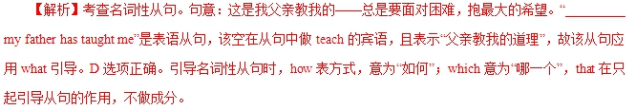
【变式探究】A ship in harbor is safe，but that’s not ________ ships are built for.
A．what B．whom
C．why D．when
解析：考查表语从句的引导词。句意：船 停 在 港口 是 安 全的，但那不是造船的本意。从ships are built for来看，表语从句的引导词作for的宾语。why和when是连接副词，不能作宾语，而whom指人，因此选what。
答案：A
【提分秘籍】
1．引导表语从句的连接词：连词that，whether，as if/though；连接代词what，who，whose，whatever，
whichever，whoever等；连接副词when，where，why， how，从句用陈述语序。
2．as if/as though意为“好像，仿佛”，引导的表语从句常跟在系动词(如seem，appear，look，taste，sound，feel，smell等)之后。若表语从句所述的是非真实的情况，从句用虚拟语气；若所述的是事实的或是极可能发生的情况，从句用陈述语气。
3．This/That/It is why＋从句(表结果) “这/那就是……的原因”
This/That/It is because＋从句(表原因) “这/那是因为……”
The reason why...is that＋从句 “……的原因是……”
The best moment for the football star was when he scored the winning goal.
对这位足球明星来说，最好的时刻就是他踢进制胜球的那一刻。
From space，the earth looks blue.This is because about seventy－one percent of its surface is covered by water.
从太空中看，地球是蓝色的。这是因为地球表面约百分之七十一都被水覆盖着。
I’d like to start my own business—that’s what I’d do if I had the money.
我想自己做生意——那是我如果有钱就会做的事情。
The reason why he didn’t pass the exam was that he was too careless.
他没有通过考试的原因是他太粗心了。
He was ill.That’s why he was absent.
他病了，那就是他缺席的原因。
It sounds as if you are from the south of the United States.
听起来你好像来自美国南部。
【举一反三】
—Lily is often absent from school.
—Yes，she is.That’s ________ she is in poor health.
A．why B．the reason
C．because D．how
解析：分析句子结构可知，That’s 之后应为表语从句。 根据句意可知，健康状况不好是缺席的原因，故首先应排 除A项；B项不符合逻辑；D项不符合题意。
答案：C
热点题型四 同位语从句
例4、—Is it true that Mike refused an offer from Yale University yesterday?
—Yeah，but I have no idea ________ he did it；that’s one of his favorite universities.
A．when B．why
C．that D．how
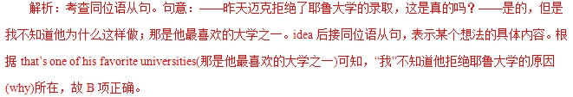
答案：B
【提分秘籍】
1．同位语从句通常用that引导，that无词义也不作成分， 但是不能省略，从句用陈述语序。同位语从句还可用whether,when，where，why，how等引导。
2．接同位语从句的常见名词：fact，news，idea，truth， hope，problem，information，belief，thought，doubt，promise，question等。
3．分隔式同位语从句。有时同位语从句的谓语较短，而从句内容较长，这时为避免“头重脚轻”，常常将谓语提到从句前面，形成分隔式同位语从句。
I made a promise to myself that this year，my first year in high school，would be different.
我给自己做出承诺：今年，是我上高中的第一年，将会与以往不同。
I have no idea where the journalist could have got his information from.
我不知道那个记者从哪里得到的消息。
When the news came that the war broke out，he decided to serve in the army.
当战争的消息传来时，他决定参军。
【举一反三】
It came as a great surprise to the public________some state leaders’ cellphones might have been monitored by
America’s National Security Agency.
A．that B．whether
C．what D．which
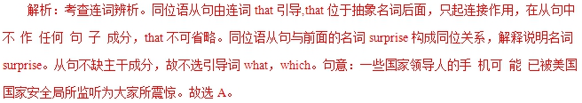
答案：A

1.【2018·江苏】By boat is the only way to get here, which is _______ we arrived.zx.x.k
A. where B. when
C. why D. how
【答案】D
【解析】考查名词性从句。句意：乘船是到达这里唯一的途径，这就是我们如何到达的。分析which引导的非限定性定语从句可知，后面为表语从句，这里用连接副词how引导表语从句，充当方式状语，表示“如何”。故选D。
2.【2018·天津】The gold medal will be awarded ___________to wins the first place in the bicycle race.
A. whomever B. wherever
C. whoever D. whatever
【答案】C
【解析】考查名词性从句连接词。句意：无论谁获得自行车比赛第一名，金牌将授予他。分析句子可知，宾语从句中缺少主语，故用whoever，表示“任何人，无论谁”。故选C。
3.【2018·北京】 Without his support, we wouldn’t be _________ we are now.
A. how B. when C. where D. why
【答案】C
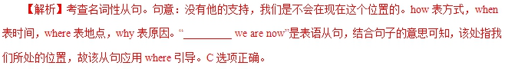
4.【2018·北京】This is _________ my father has taught me—to always face difficulties and hope for the best.
A. how B. which C. that D. what
【答案】D
【解析】考查名词性从句。句意：这是我父亲教我的——总是要面对困难，抱最大的希望。“_________ my father has taught me”是表语从句，该空在从句中做teach的宾语，且表示“父亲教我的道理”，故该从句应用what引导。D选项正确。引导名词性从句时，how表方式，意为“如何”；which意为“哪一个”，that在只起引导从句的作用，不做成分。
1.[2017·北京卷] Every year, ________ makes the most beautiful kite will win a prize in the Kite Festival.
A．whatever B．whoever
C．whomever D．whichever
【答案】B
【解析】试题分析：A. whatever 任何事 B. whoever 任何人 C. whomever 任何人 D. whichever无论哪个。句意：每年，任何一个做出最漂亮的风筝的人将会在风筝节获奖。空格所在部分是主语从句，缺少主语，用连接代词，根据意思可知是人获奖，故排除AD，因为需要做主语，只能用主格代词who，故选B。
2.[2017·北京卷] Jane moved aimlessly down the treelined street, not knowing________ she was heading.
A．why B．where C．how D．when
【答案】B 【解析】考查名词性从句。根据句意可知此处意为“不知道去什么地方”，故答案选 B。句意：简漫无目的地沿着林荫大道走着， 不知道要去哪里。
3.[2017·江苏卷] We choose this hotel because the price for a night here is down to $20，half of ________ it used to charge.
A．that B．which
C．what D．how
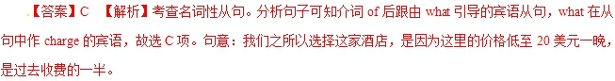
4.[2017·天津卷] She asked me ________ I had returned the books to the library, and I admitted that I hadn't.
A．when B．where
C．whether D．what
【答案】C 【解析】考查宾语从句。根据“…I admitted that I hadn't.”可知书还没还给图书馆，因此此处问的是是否(whether)已经还了。故选C项。句意：她问我是否已将那些书还给了图书馆，我承认没还。
【2016·北京】24.Your support is important to our work. ________ you can do helps.
A. However B. Whoever C. Whatever D. Wherever
【答案】C
【解析】题目考查主语从句。helps是谓语，“________ you can do”是主语部分，即主语从句，在主语从句中，do后缺少宾语，表示“任何事情”，因此用whatever引导，故选C。
【考点】考查主语从句
【2016·北京】29. The most pleasant thing of the rainy season is ________ one can be entirely free from dust.
A. what B. that C. whether D. why
【答案】B
【解析】句意：雨季最令人愉悦的就是人们可以完全不再受到沙尘的困扰。is后跟从句作表语，即表语从句，表语从句不缺少主语、谓语和宾语，因此用that，that只起引导作用，故选B。
【考点】考查表语从句
【2016·江苏】21.It is often the case ______anything is possible for those who hang on to hope.
A. why B. what C. as D. that
【答案】D
【解析】句意：通常对于那些心存希望的人来说一切皆有可能。此句中It为形式主语，that从句为真正的主语。故D项正确。
【考点】考查主语从句
【2016·天津】11. The manager put forward a suggestion ____ we should have an assistant. There is too much work to do.
A. whether B. that C. which D. what
【答案】B
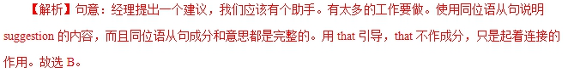
【考点】考查同位语从句。
【2015·北京】33.I truly believe ______beauty comes from within.
A. that B. where C. what D. why
【答案】A
【解析】句意：我很相信美丽源自于内心! 本题考查宾语从句。从句部分不缺少任何成分，因此用that起到连接作用，也可以省略。从句部分不缺少任何成分，因此用that起到连接作用，也可以省略。故选A。
【2015·安徽】25.A ship in harbor is safe, but that’s not ______ ships are built for.
A. what B. whom C. why D. when
【答案】A
【解析】句意：船停放在海港里是很安全的，但这并非建造船的目的。isn’t后跟从句作表语，表语从句中的for后缺少宾语，用what引导，what与for连用，表示目的。故选A。
【2015·浙江】6. If you swim in a river or lake, be sure to investigate is below the water surface. Often there are rocks or branched hidden in the water.
A. what B. who C. that D. whoever
【答案】A
【解析】句意：如果你在河里或湖里游泳，请确定查看水面下有什么？通常总有一些石头或树枝藏在水里。此处的what指代的是树枝或石头，B选项和D选项用于指人，that 只有语法意义。句式上，该句用了(If 从句，祈使句)的句式，非谓语to investigate 后接一个宾语从句的表达。分析宾语从句的成分可以发现，空格所做的成分是主语。根据下一句的表述中的树枝和石头，可以得出答案是what.
【2015·重庆】8.We must find out ____ Karl is coming, so we can book a room for him.
- when B. how C. where D. why
【答案】A
【解析】句意：我们必须弄明白什么时候来，因此我们能给他预定房间。Find out 后面跟着宾语从句。根据句意选when。
【2015·四川】8.The exhibition tells us we should do something to stop air pollution.
A. where B. why C. what D. which
【答案】B
【解析】考查宾语从句。本句考查宾语从句的引导词。宾语从句中不缺少主语和宾语，故选项C错误，选项D担当定语，也错误。根据意思：这个展览告诉了我们，我们为什么要停止空气污染而不是我们在哪儿停止空气污染，故选择B。
【2015·福建】29—I wonder _________ Mary has kept her figure after all these years.
—By working out every day.
- where B. how C. why D. If
【答案】B
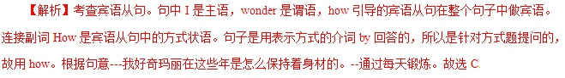 【2015·江苏】25._____ Li Bai, a great Chinese poet, was born is known to the public, but some won’t accept it.
A. That B. Why C. Where D. How
【答案】C
【解析】句意：李白是中国一位伟大的诗人，他的出生地是众所周知的，但有些人不愿接受这一事实。分析句子结构可知，a great Chinese poet做Li Bai的同位语，is前面是主语从句。比较选项只有where符合句意，where在从句中做地点状语。故选C项。
【2015·北京】35. _____we understand things has a lot to do with what we feel.
A. Where B.How C.Why D. When
【答案】B
【解析】句意：我们如何理解事情与我们所感受的有很大关系。根据句意可知，主语从句缺少方式状语，因此选择how。故选B。
1．(2014·大纲全国卷)Exactly________the potato was introduced into Europe is uncertain, but it was probably around 1565.
【答案】when
【解析】考查主语从句。句意：土豆被引进欧洲的确切时间不确定，但是可能是1565年左右。结合句意可知，when引导主语从句，且在从句中作时间状语。
2．(2014·北京卷)Some people believe ________ has happened before or is happening now will repeat itself in the future.
【答案】whatever
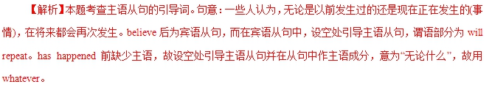 3．(2014·重庆卷)—Is it true that Mike refused an offer from Yale University yesterday?
—Yeah, but I have no idea ________ he did it; that's one of his favorite universities.
【答案】why
【解析】本题考查同位语从句的引导词。句意：“昨天迈克拒绝了耶鲁大学的录取，这是真的吗？”“是的，但是我不知道他为什么这样做；那是他最喜欢的大学之一。”idea后接同位语从句，表示某个想法的具体内容。根据that's one of his favorite universities(那是他最喜欢的大学之一)可知，“我”不知道他拒绝耶鲁大学的原因(why)。
4．(2014·福建卷)Pick yourself up. Courage is doing________you're afraid to do.
【答案】what
【解析】本题考查名词性从句的引导词。句意：振作起来。勇敢就是做你(明知自己)害怕做的事情。分析句子结构可知，动词doing后接的是宾语从句，从句中do后缺的是宾语，需用what引导。
5．(2014·陕西卷)________the delayed flight will take off depends much on the weather.
【答案】When
【解析】本题考查名词性从句的连接词。句意：那架延误的班机________会起飞在很大程度上取决于天气。分析题意和句子结构可知，这是一个含有主语从句的主从复合句；再分析句子成分可知，主语从句________the delayed flight will take off缺少状语。根据分析可知，此处要表达的是延误的飞机什么时候起飞。
6．(2014·湖南卷)As John Lennon once said, life is ________ happens to you while you are busy making other plans.
【答案】what
【解析】考查表语从句。句意：正如约翰·列侬曾经说过的一样，当我们正在为生活疲于奔波时，生活已离我们远去。what引导的是一个表语从句，且在表语从句中作主语。
7．(2014·四川卷)Grandma pointed to the hospital and said, “That's ________ I was born. ”
【答案】where
【解析】考查名词性从句。句意：奶奶指着医院说，“那是我出生的地方。”根据语境及句子结构可知，空格处用where引导表语从句。
8．(2014·天津卷)I think________impresses me about his painting is the colours he uses.
【答案】what
9．(2014·山东卷)It is difficult for us to imagine________life was like for slaves in the ancient world.
【答案】what
【解析】考查连接代词。句意：我们很难想象在古代奴隶的生活是什么样子的。what was...like？＝how was...？表示“某事怎么样呢？”。
10. (2014·江苏卷)—What a mess！You are always so lazy!
—I'm not to blame, mum. I am________you have made me.
【答案】what
【解析】本题考查名词性从句的引导词。句意：“真是一团糟！你总是这么懒惰！”“妈妈，我不应该受到责备。我这个样子都是你一手造就的。”分析句子结构可知，I am后是表语从句，引导词what在从句中作me的补足语，相当于the one/person that, 即I am the one/person that you have made me. 。类似的例子还有：He is no longer what(＝the one/person that) he used to be. 。what在此类句子中意为“……的，具有……特征的”，相当于the one that/the person that/the things that/all that。

