


状语从句则用来表示时间、地点、原因、条件、目的、结果 等方面的关系。单项填空题型中，该部分是必考内容。并列连词在这个题型中重点考查and，but，or，so等;状语从句的考查主要集中在条件状语从句、让步状语从句、时间状语从句、原因状语从句和结果状语从句等中。解决并列句和状语从句的关键是找出句子之间或从句与主句之间的逻辑关系。


热点题型一 时间状语从句
例1、We need to get to the root of the problem ________ we can solve it.
A．while B．after
C．before D．as
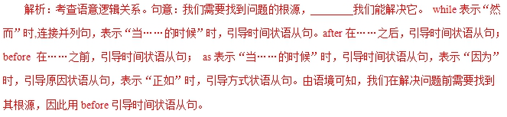
答案：C
【提分秘籍】
1．when，while和as引导的时间状语从句
when | 从句的动作和主句的动作可以同时发生，也可以先后发生。从句谓语动词为延续性动词或非延续性动词。
when | 作并列连词，意为“那时，这时”，常用于be about to do...when...；be doing...when...；had just done...when...;be on the point of doing...when...等结构中。
while | 从句的动作与主句的动作同时发生，强调一段时间，从句的谓语动词为延续性动词。
while | 表示“尽管”，引导让步状语从句。
while | while作并列连词，意为“而，却”，表示对比。
as | 从句的动作与主句的动作同时发生或交替进行，可译为“一边……；一边……；随着……”，从句谓语一般为延续性动词。
When we handed him the bag of food，he lit up and thanked us with watery eyes.
当我们递给他那包食物时，他对我们表示感谢，脸上露出喜色，眼睛也湿润了。
My only mistake was that I dropped some on the floor when/while I was packing them up.
我的唯一过错是当我打包时掉在了地上一些。
One Friday，we were packing to leave for a weekend away when my daughter heard cries for help.
一个周五，我们正在打包动身去过周末，就在这时我女儿听到了呼救声。
2．表示“一……就……”含义的词(短语)引导的时间状语从句
(1)as soon as；immediately；directly；instantly；the
moment/minute/instant；no sooner...than...；hardly...when...
(2)hardly...when...；no sooner...than...中主句用过去完成时,从句应用一般过去时；当hardly和no sooner 位于句首时，主 句要部分倒装。
I had hardly got to the office when my wife phoned me to go back home at once.
我刚到办公室，我妻子就打电话让我立刻回家。
He had no sooner finished his speech than the students started cheering.
＝No sooner had he finished his speech than the students started cheering.
他刚完成演讲学生们就欢呼起来。
The moment I heard the voice，I knew father was coming.
我一听到那个声音就知道父亲来了。
The boy burst into tears immediately he saw his mother.
那男孩一见到他妈妈便放声大哭。
3．引导时间状语从句的其他常见连词
(1)until与till引导的时间状语从句
until/till意为“直到……时”，引导时间状语从句时，表示主句的动作发生在从句的动作之前。当主句的谓语动词是 延 续性动词时，主句常用肯定形式；当主句的谓语动词是非 延 续性动词时，主句常用否定形式，意为“直到……才”。
(2)every/each time，next time，the first time，whenever等引导的时间状语从句。
(3)by the time引导时间状语从句时，从句用一般现在时,主句用将来完成时；从句用一般过去时，主句用过去完成时。
Whenever we met with difficulties，they came to help us.
每当我们遇到困难，他们就来帮忙。
By the time you come back，we will have finished the job.
当你回来的时候，我们将已经完成这项工作了。
【举一反三】
I believe you will have a wonderful time here ________ you get to know everyone else.
A．though B．as if
C．once D．so that
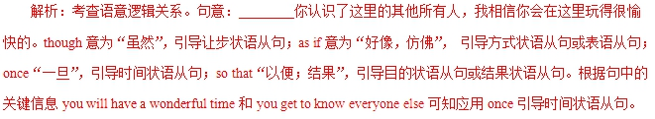
答案：C
热点题型二 让步状语从句
例2、________ the students came from different countries，they got along quite well in the summer camp.
A．While B．Unless
C．Since D．Until
解析：考查状语从句引导词的选择。句意：________学生们来自不同的国家，他们在夏令营相处得非常好。根据句意可知，本题前后为转折关系，所以应用while“尽管”来引导状语从句，表转折。故答案为A项。
答案：A
【提分秘籍】
1．although，though，as与while引导的让步状语从句
(1) although引导让步状语从句时，只能用正常语序；though可用正常语序，也可用倒装语序；as只能用倒装语序，即从句中的表语、状语或动词原形置于句首，若表语是单数名词，前置时要省略冠词。
(2) although/though不能与but连用，但可以和yet，still连用。
(3)though 还可以作副词，意为“可是，然而”,置于句末。
(4)while引导让步状语从句时，一般置于句首。
While I always felt I would pass the exam，I never thought I would get an A．尽管我一直觉得自己能通过考试，但是我从未想到会得A。
Although the job takes a significant amount of time，most students agree that the experience is worth it.
虽然这份工作要花大量的时间，但大多数学生都同意这次经历是值得的。
Happy as they were，there was something missing.
尽管他们快乐，但总缺少什么。
I’ve a bit of cold.It is nothing much，though.
我有点感冒，不过不太严重。
2．even if与even though 引导的让步状语从句
He is so busy.He cannot afford enough time with his son even if he wants to.
他很忙。即使他想陪他的儿子也没有足够的时间。
3．“no matter＋疑问词”与“疑问词＋ever”；
whether...or...(不管……还是……)引导的让步状语从句
(1) “no matter＋疑问词”引导让步状语从句时，可转化成 “疑问词＋ever”。
(2)whenever,wherever还可分别引导时间和地点状语从句。
It is generally considered unwise to give a child whatever he or she wants.
总的来说，孩子想要什么就给什么是不明智的。
However hard you try，it is difficult to lose weight without cutting down the amount you eat.
无论你多么努力，如果不减少饮食，那么减肥是很难做到的。
Don’t trust him，no matter what/whatever he says.
无论他说什么，不要相信他。
Whether you believe it or not，it is true.
不管你相信与否，那都是真的。
【举一反三】
_______ the forest park is far away，a lot of tourists visit it every year.
A．As B．When
C．Even though D．In case
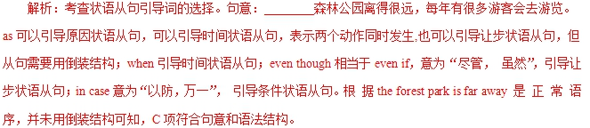
答案：C
热点题型三 条件状语从句
例3． You won’t find paper cutting difficult ________ you keep practicing it.
A．even though B．as long as
C．as if D．ever since
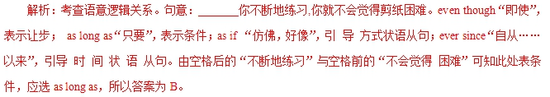
答案：B
【提分秘籍】
1．引导条件状语从句的连词：if；unless；so(as) long as；once；in case；on condition that；supposing/suppose (that);provided/providing。
2．“祈使句＋and/or/otherwise＋陈述句”的句型中，祈使句在意义上相当于条件状语从句。
3．条件状语从句中一般用一般现在时代替一般将来时，一般过去时代替过去将来时。
She says that she’ll have to close the shop unless business improves.
她说如果生意还没有起色的话，她就不得不把店关掉。
You can borrow my car as long as you promise not to drive too fast.
你可以借用我的车子只要你承诺不开太快。
Once they decide which college to go to，students should research the admission procedures.
学生一旦决定上哪所大 学，他们就应该了解一下入学手续。
【举一反三】
It is so cold that you can’t go outside________fully covered in thick clothes.
A．if B．unless
C．once D．when
解析：考查状语从句连词的选择。句意：天太冷，你不能去外面，除非你全裹在厚衣服里。unless相当于if...not(如果……不)，符合句意。if如果；once一旦；when当……的时候，都不符合语意逻辑。________fully covered in thick clothes为状语从句的省略，补充完整为“unless you are fully covered in thick clothes”。
答案：B
热点题型四 其他状语从句
例4、 Half an hour later，Lucy still couldn’t get a taxi ________ the bus had dropped her.
A．until B．when
C．although D．where
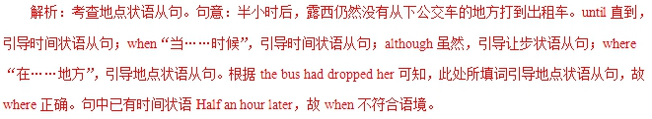
答案：D
【提分秘籍】
1.引导地点状语从句的从属连词where，wherever指具体地点时，从句可用于主句之前或之后；表示抽象条件的含义时,从句须放在主句之前。
2．目的状语从句的谓语动词一般含有情态动词can，could,may，might，should等。
3．as if/though引导方式状语从句时,从句中有时需用虚拟语气.
Leave your key with your neighbor in case you lock yourself out one day.
留一把钥匙给你的邻居，以防哪天你把自己锁在门外。
Today，we will begin where we stopped yesterday so that no point will be left out.
今天我们将在昨天停止的 地方 开始，为的是不漏掉知识点。
Now that you have grown up，you must do it by yourself.
既然你已经长大了，就必须自己做这件事。
【举一反三】
Cathy had quit her job when her son was born ______ she could stay home and raise her family.
A．now that B．as if
C．only if D．so that
解析：考查目的状语从句。句意：当儿子出生时凯茜就已辞去了工作，目的是她能够待在家里抚养孩子。now that“既然”，引导原因状语从句；as if“好像，仿佛”，引导方式状语从句；only if“只要”，引导条件状语从句；so that“目的是，结果是”，引导目的状语从句和结果状语从句。由关键信息quit her job以及stay home and raise her family可知，stay home and raise her family是前面辞职的目的，故要用so that
引导目的状语从句。
答案：D

1.【2018·天津】Let's not pick these peaches until this weekend ___________they get sweet enough to be eaten.
A. ever since B. as if
C. even though D. so that
【答案】D
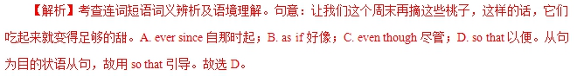
2.【2018·江苏】_______ you can sleep well, you will lose the ability to focus, plan and stay motivated after one or two nights.
A. Once B. Unless
C. If D. When
【答案】B
【解析】考查连词词义辨析及语境理解。句意：除非你睡得好，否则一两个晚上之后，你会失去专注、计划和保持动力的能力。A. Once一旦；B. Unless除非；C. If如果；D. When当……时候。故选B。
3.【2018·北京】_________ we don’t stop climate change, many animals and plants in the world will be gone.
A. Although B. While C. If D. Until
【答案】C
【解析】考查状语从句。句意：如果我们不阻止气候变化，那么世界上的很多动植物就会消失。动植物不灭绝的的前提条件是阻止气候变化。Although 尽管；While 当……时候，尽管，然而；If 如果；Until 直到。C正确。
1.[2017·北京卷] ________ birds use their feathers for flight, some of their feathers are for other purposes.
A．Once B．If
C．Although D．Because
【答案】C 【解析】考查状语从句。 前后两句之间是转折关系，故选C。句意：虽然鸟儿用它们的羽毛来飞行， 但是有些羽毛也可用作其他用途。
2.[2017·北京卷] If you don't understand something, you may research, study, and talk to other people ________ you figure it out.
A．because B．though
C．until D．since
【答案】C
【解析】句意：如果遇到不懂的东西，你可以搜索、研究，和别人交流直到弄明白。本题考查状语从句，A选项意为“因为”，B选项意为“尽管”，D选项“自从”或者“因为”，C选项“直到”符合语境，答案选C。
3.[2017·江苏卷] Located ________ the Belt meets the Road，Jiangsu will contribute more to the Belt and Road construction.
A．why B．when
C．which D．where
【答案】D 【解析】考查状语从句。由located一词可知此处缺少一个表示方位、地点的引导词，故用where引导地点状语从句。句意：位于“一带一路”交汇处，江苏将为“一带一路”的建设做出更多的贡献。
1．(2015·高考四川卷，T6)There is only one more day to go ________ your favorite music group play live.
A．since B．until
C．when D．before
解析：选D。考查状语从句的引导词。句意：在你最喜欢的乐队现场表演之前仅有一天的时间了。“There is＋时间＋before...”为固定句式，意为“还有多长时间，某事就会发生”。
2. (2014·高考安徽卷，T25)The meaning of the word “nice”changed a few times________ it finally came to include the sense “pleasant”．
A．before B．after
C．since D．while
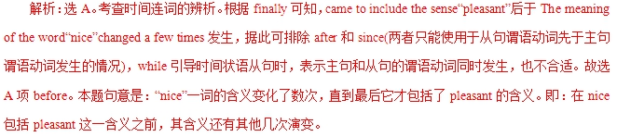
1．(2014·北京卷)________ the forest park is far away, a lot of tourists visit it every year.
【答案】Even though
【解析】本题考查状语从句的引导词。句意：________森林公园离得很远，每年有很多游客会去游览。even though相当于even if，意为“尽管，虽然”，引导让步状语从句。
2．(2014·北京卷)Some animals carry seeds from one place to another, ________ plants can spread to new places.
【答案】so
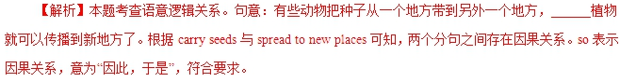
3．(2014·重庆卷)Half an hour later, Lucy still couldn't get a taxi ________ the bus had dropped her.
【答案】where
【解析】本题考查状语从句的引导词。句意：半小时后，露西仍然没有从下公交车的地方打到出租车。where在……地方，引导地点状语从句。根据the bus had dropped her可知，此处所填词引导地点状语从句，故where正确。
4．(2014·湖南卷)You will never gain success ________ you are fully devoted to your work.
【答案】unless
【解析】考查条件状语从句。句意：除非你完全致力于你的工作，否则你将永远不会获得成功。根据句意可知，完全致力于工作是成功的条件，故用unless。
5．(2014·福建卷)The climate here is quite pleasant, the temperature rarely, ________， reaching 30℃ in summer.
【答案】if ever
【解析】本题考查省略句。句意：这里的气候宜人，________，在夏季气温极少达到30摄氏度。if ever如果曾经有；如果曾经发生。根据句中的关键词quite pleasant(宜人)，rarely(极少)可知，空格处表达的意思是“如果曾经有(if ever)”。if ever相当于if it (the temperature) ever reached 30℃ in summer。
5．(2014·福建卷)The climate here is quite pleasant, the temperature rarely, ________， reaching 30℃ in summer.
【答案】if ever
【解析】本题考查省略句。句意：这里的气候宜人，________，在夏季气温极少达到30摄氏度。if ever如果曾经有；如果曾经发生。根据句中的关键词quite pleasant(宜人)，rarely(极少)可知，空格处表达的意思是“如果曾经有(if ever)”。if ever相当于if it (the temperature) ever reached 30℃ in summer。
6．(2014·四川卷)I'll be out for some time. ________ anything important happens, call me up immediately.
【答案】In case
【解析】考查状语从句。句意：我将外出一段时间。如果发生重要的事情，请立刻给我电话。in case“如果，假若……的话”，引导条件状语从句相当于if。根据句意可知，空格处用in case引导条件状语从句。
7．(2014·安徽卷)The meaning of the word“nice”changed a few times________it finally came to include the sense “pleasant”．
【答案】before
【解析】考查连词。根据finally可知，came to include the sense“pleasant”后于The meaning of the word “nice” changed a few times发生，因此用before。句意：nice一词的含义变化了数次之后，最后它才包括了pleasant的含义。
8．(2014·陕西卷)The young couple, who returned my lost wallet, left ________ I could ask for their names.
【答案】before

9．(2014·江苏卷)Lessons can be learned to face the future, ________history cannot be changed.
【答案】though
【解析】本题考查状语从句的引导词。句意：尽管不能改变历史，但是我们可以吸取教训来面对未来。此处用though引导让步状语从句。
10．(2014·江西卷)It was the middle of the night ________ my father woke me up and told me to watch the football game.
【答案】when
【解析】考查时间状语从句。句意：当我父亲叫醒我并让我看足球赛时，时间是半夜。此句并不是强调句型；结合句意可知，空处引导时间状语从句，故填when。

