

情景交际是用来评价学生交际能力的常考内容之一，从近三年的高考试题来看，这一题型的设计涉及日常生活中的各方面，如问候、介绍、告别、感谢、道歉、请求、祝愿、提供帮助等。考查最多的是：①道歉与应答；②建议与应答；③请求允许及应答。交际语言就是在不同的时间、不同的场合，面对不同的人所说的不同的话。也就是说，要学好交际语言，我们就必须要因人、因地、因时而异，所以语言环境、说话对象所隐含着的文化思维是约定俗成的，必须在长期的语言实践中，去熟悉、去感悟，千万不能将汉语的模式强加给英语，在测试中，这一点往往是我们中学生最大的误区。


热点题型一 常考的交际用语
例1、【2018·天津】—I'm moving in a few days and I wonder if you could help.
—___________. Just let me know when， and I'll be there.
A. You bet B. It depends
C. Forget it D. No kidding
【答案】A
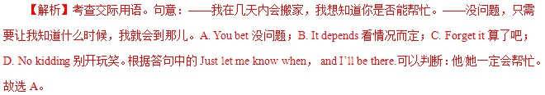
【变式探究】[2017·江苏卷] —What does the stuff on your Tshirt mean?
—It's nothing. Just something ________．
A．as clear as day
B．off the top of my head
C．under my nose
D． beyond my wildest dreams
【答案】B 【解析】off the top of one’s head不假思索地，即兴地，符合语境，符合句意；as clear as day一清二楚的；under one’s nose在某人鼻子底下，公然；beyond one’s wildest dreams超越梦想。句意：——你T恤上的东西是什么意思？——没什么。不过是即兴而为的东西。
【提分秘籍】
1．It/That (all) depends.那得视情况而定。
2．Forget it.没关系(回答道歉)；休想(表示拒绝)；别提了。
3．How come？怎么会？为什么？
4．Never mind.没关系；别担心。
5．It’s up to you.由你决定。
6．I can’t agree more.我非常赞同。
7．Not exactly/really.不很；不完全是；一点也不。
8．So what？那又怎么样？
9．Go ahead.用吧，使吧。
—The Tshirt I received is not the same as is shown online.
—________？But I promise you we’ll look into it right away.
A．Who says B．How come
C．What for D．Why worry
答案 B
热点题型二 区分两对相似的交际用语
例2、—Are you sure you won’t come for a drink with us?
—________，if you insist.
A．Not at all B．It depends
C．All right then D．I don’t care
答案 C
解析 句意为：——你确定不和我们一起去喝一杯吗？——如果你坚持的话，那么好吧！Not at all一点也不，别客气；It depends看情况而定；All right then那么好吧；I don’t care我不在乎。
【提分秘籍】
1．With pleasure相当于I’m glad to表示“非常乐意”，用于应答别人的求助。My pleasure“不用谢”，用于应答别人的感谢。
2．All right表示“好吧”，用于表示同意别人的提议；It’s/That’s all right表示“不用谢”或“没关系”，用于应答别人的感谢或道歉；That’s right表示“你说得对”。
【举一反三】
—Thank you for the flowers.
—________.I thought they might cheer you up.
A．That’s right B．All right
C．I’m all right D．It’s all right
答案 D
热点题型三 接受请求或邀请的应答语
[2017·江苏卷] —Going to watch the Women's Volleyball Match on Wednesday?
—________！Will you go with me?
A．You there B．You bet
C．You got me D．You know better
【答案】B 【解析】考查情景交际。You bet“当然，肯定地”，符合句意。You there说你呢；You got me你难住我了；You know better你更清楚。句意：“星期三去看女子排球比赛吗？”“当然！你能同我一起去吗？”
【提分秘籍】
1．接受请求或邀请的应答用语有：With pleasure；I’d be happy/glad to；I’d love to；No problem；Good idea；That would be nice；By all means等。
2．拒绝请求和邀请的应答用语有：Sorry，but...I’d rather you...；Thank you，but...；I’d love to，but I’m afraid I have no time；It’s very nice of you，but my mother is ill等。
【举一反三】
—Shall we go for a drink at one o’clock this afternoon?
—________.Will two o’clock be OK？
A．Sure，it’s up to you
B．Sure，no problem
C．Sorry，I can’t make it
D．Sorry，I’m not available today
答案 C
解析 句意为：——我们今天下午一点去喝杯怎么样？——抱歉，我办不到。两点好吗？A项“当然，由你决定”；B项“当然，没问题”；C项“抱歉，我办不到”；D项“抱歉，我今天没时间”。

1.【2018·天津】—I'm moving in a few days and I wonder if you could help.
—___________. Just let me know when， and I'll be there.
A. You bet B. It depends
C. Forget it D. No kidding
【答案】A
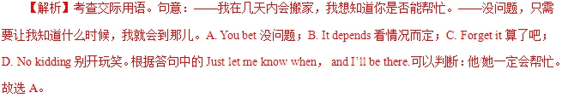
2.【2018·天津】—Wasn't Joan supposed to be here by now?
一She will be here in about twenty minutes.z.x.xk
A. All right B. Don't worry
C. No wonder D. Enjoy yourself
【答案】B
【解析】考查交际用语。句意：——琼现在不是应该在这儿吗？——不用担心，在大约20分钟内她将会到这儿的。A. all right好，行；B. Don’t worry别担心；C. No wonder难怪；D. Enjoy yourself玩得开心。根据答句中的She will be there in about twenty minutes.可以判断：不需要担心琼，她一会儿就到。故选B。
3.【2018·江苏】—What happened? Your boss seems to _______
—Didn’t you know his secretary leaked the secret report to the press?
A. be over the moon B. laugh his head off
C. be all ears D. fly off the handle
【答案】D
【解析】考查习惯用语。句意：——发生什么了？你老板看起来勃然大怒。——你难道不知道他的秘书把秘密报告泄露给新闻界了吗？A. be over the moon非常高兴；B. laugh his head off笑的要死；C. be all ears洗耳恭听；D. fly off the handle勃然大怒。故选D。
4.【2018·江苏】—You know what? I’ve got a New Year concert ticket
—Oh， _______ You’re kidding.
A. so what? B. go ahead.
C. come on. D. what for?
【答案】C
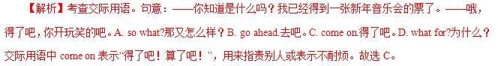
1． [2017·江苏卷] —What does the stuff on your Tshirt mean?
—It's nothing. Just something ________．
A．as clear as day
B．off the top of my head
C．under my nose
D． beyond my wildest dreams
【答案】B 【解析】off the top of one’s head不假思索地，即兴地，符合语境，符合句意；as clear as day一清二楚的；under one’s nose在某人鼻子底下，公然；beyond one’s wildest dreams超越梦想。句意：——你T恤上的东西是什么意思？——没什么。不过是即兴而为的东西。
2． [2017·江苏卷] —Going to watch the Women's Volleyball Match on Wednesday?
—________！Will you go with me?
A．You there B．You bet
C．You got me D．You know better
【答案】B 【解析】考查情景交际。You bet“当然，肯定地”，符合句意。You there说你呢；You got me你难住我了；You know better你更清楚。句意：“星期三去看女子排球比赛吗？”“当然！你能同我一起去吗？”
3． [2017·天津卷] —Albert's birthday is on next Saturday, and I'm planning a surprise party for him
—________. I'll bring some wine.
A．Sounds like fun B．It depends
C．Just a minute D．You are welcome
【答案】A 【解析】考查情景交际。根据回答“I'll bring some wine.”可知对方比较感兴趣，故选A。Sounds(like)fun.意为“听起来有趣。”It depends.视情况而定。Just a minute.请稍等。You are welcome.不客气。句意：“艾伯特在下周六过生日，我正筹划一个聚会，要给他一个惊喜。”“听起来有趣(Sounds like fun.)。我会带一些酒来。”
4． [2017·天津卷] —Michael was late for Mr Smith's chemistry class this morning.
—________？ As far as I know, he never came late to class.
A．So what B．Why not
C．Who cares D．How come
【答案】D
【解析】句意：—今天上午迈克尔在斯密斯老师的化学课迟到了。—怎么会呢？据我所知，他上课从不迟到。A.那又怎么样呢；B.为什么不呢；C谁在意呢；D.怎么会呢。根据语境，故选D。
1.【2016·天津】1. ---It was a wonderful trip. So, which city did you like better, Paris or Rome?
---______. There were good things and bad things about them.
A. It’s hard to say B. I didn’t get it
C. You must be kidding D. Couldn’t be better
【答案】A
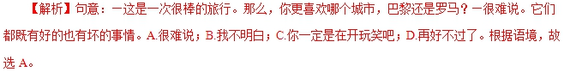
2.【2016·浙江】1. --Are you sure you're ready for the best?
--_________. I'm well prepared for it.
A. I'm afraid not B. No problem C. Hard to say D. Not really
【答案】B
【解析】句意：—你确定你准备好考试了吗？—没问题。我已经做好准备了。A.恐怕不；B.没问题；C.很难说；D.不是真的。根据语境，故选B。
1.【2015·重庆】15. —Hello Jenny, can I see Ms. Lewis?
—____. I’ll tell you’re here.
A. With pleasure B. Never mind C. You’re welcome D. Just a minute
【答案】D
【解析】句意：你好，简妮，我能找一下路易斯女士吗？请稍等，我给你叫她。根据语境可知这是在打电话，故选D项。
2.【2015·重庆】5. —I can drive you home.
—____ , but are you sure it’s not too much trouble?
A. That would be great B. Don’t bother
C. I’m afraid not D. Take care
【答案】A
【解析】句意：我载你回家。太好了，但你确定没给添麻烦吗？根据are you sure it’s not too much trouble?可知表示同意，故选A项。
3.【2015·浙江】1. ——Hi, John. Are you busy?
——
A. Yes.I do agree. B. Yes.That would be nice.
C. No.Are you sure? D. No.What’s up?
【答案】D
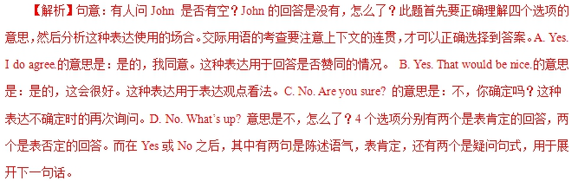
4.【2015·天津】1. —Sorry, Liz. I think I was a bit rude to you.
—______, but don’t do that again!
A. Go ahead B. Forget it C. It depends D. With pleasure
【答案】B
【解析】句意:——对不起，Liz。我想刚才我对你有点粗鲁。——算了吧，不过不要再那样做了。A. Go ahead 好吧，行啊；B. Forget it算了吧，不必在意； C. It depends 那还得看情况了；D. With pleasure乐意效劳。根据句意可知选B。
5.【2015·天津】4. —Jack, you seem excited.
—______? I won the first prize in the English speech contest.
A. Guess what B. So what
C. Pardon me D. Who cares
【答案】A
【解析】句意：——杰克，你看起来很兴奋。——猜猜看？我在英语演讲比赛中获得第一名。A. Guess what 猜猜看；B. So what那又怎么样； C. Pardon me 请问刚才你说的什么；D. Who care谁管它呢。根据句意可知选A。
6.【2015·安徽】21. — Can you come to a party on Saturday, Peter?
— Oh, ______I'm already going out, I'm afraid.
- what a pity! B. don't ask! C. how come? D. so what?
【答案】A
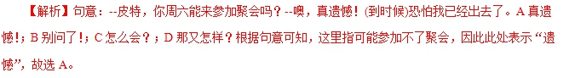
1．(2014·大纲全国卷)—I'm sorry for breaking the cup.
—Oh, ________. I've got plenty.(forget it, my pleasure, help yourself, pardon me)
【答案】forget it
【解析】本题考查交际用语。句意：“不好意思，我打破了杯子。”“噢，没关系，我有很多呢。”forget it是道歉的应答语，意思是“没关系，别在意”，符合语境。help yourself“随便吃，别客气”。
2．(2014·重庆卷)—Jack, I'd like to have your opinions about my written report.
—________. But I have one suggestion.(That's a good idea, You are too modest, It looks fine to me, You should check it first)
【答案】It looks fine to me
【解析】本题考查情景交际。句意：“杰克，我想听听你关于我的书面报告的意见。”“________。但是我有个建议。”That's a good idea意为“那是个好主意”；You are too modest意为“你太谦虚了”；It looks fine to me意为“我觉得看上去不错”；You should check it first意为“你应该先检查一下”。根据But...可知设空处应该在总体上对该报告予以肯定，然后说出自己的意见。
3．(2014·重庆卷)—Why not stay here a little longer?
—________， but I really have to go.(Never mind, I'd love to, Pleased to meet you, I can't find any reason)
【答案】I'd love to
【解析】本题考查情景交际。句意：“为什么不在这儿再多待一会儿呢？”“ ________，但是我确实得走了。”Never mind意为“不要紧，没关系”；I'd love to意为“我想(多待一段时间)”；Pleased to meet you意为“很高兴见到你”；I can't find any reason意为“我找不到任何理由”。由答语中的连词but可知，前后两个分句之间存在转折关系，but前面的分句应表达“自己愿意再待一会儿”。此题还可以通过would love to(主观上愿意)与have to(客观上不得不)之间存在的对比关系来作为解题的突破口。
4．(2014·江苏卷)—________！Somebody has left the lab door open.
—Don't look at me.(Dear me/ Hi, there/ Thank goodness/ Come on)
【答案】Dear me
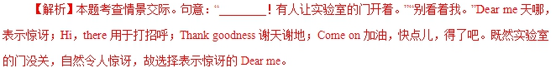
5．(2014·福建卷)—I can't remember those grammar rules!
—________. Practice more.(You're not alone, It's hard to say, I'm afraid not, It's up to you)
【答案】You're not alone
【解析】本题考查情景交际。句意：“我记不住那些语法规则！”“________。多练习。”You're not alone. 不止你自己这样；It's hard to say. 很难说；I'm afraid not. 恐怕不行；It's up to you. 由你决定。根据答语中的关键词Practice more. 可知空格处是安慰对方“不止你自己这样(You're not alone)”。
6．(2014·四川卷)—How about dinner tonight？It's on me.
—________.(You are welcome/Oh, I'd like to/Well, I'm afraid so/That's all right)
【答案】Oh, I'd like to
【解析】本题考查交际用语。“今晚一起去吃饭，怎么样？我请客。”“哦，我愿意去。”You are welcome“不用谢”；Oh，I'd like to“哦，我愿意去”；Well, I'm afraid so“哦，恐怕是这样的”；That's all right“别客气，没关系”。
7．(2014·安徽卷)—I get at least half an hour of exercise almost every day.
—Oh great！________.(Good luck, Cheer up, Same to you, Keep it up)
【答案】Keep it up
【解析】本题考查交际用语。Good luck“祝你好运”；Cheer up“振作起来，打起精神”；Same to you“你也一样”；Keep it up“坚持下去”。对方话语“I get at least half an hour of exercise almost every day”说的是自己的好习惯，回答时自然是鼓励其将该习惯坚持下去。句意：“我每天至少要锻炼半小时。”“哦，真不错！坚持下去。”
8．(2014·安徽卷)—Reading is the best way to pass time on the train.
—________. I never go traveling without a book.(You are joking, That's true, I don't think so, It sounds like fun)
【答案】That's true
【解析】本题考查交际用语。第二个人说的话中“I never go traveling without a book”使用的是双重否定，即为肯定，与第一个人说的话“Reading is the best way to pass time on the train”相照应，说明其对第一个人的话是赞同的。句意：“在火车上阅读是打发时间的最好方式。”“的确如此。我出行绝对不会不带书。”
9．(2014·陕西卷)—You know, I met my girlfriend's parents for the first time only yesterday.
—________？I thought you'd met them before.(So what, Pardon, Really, What for)
【答案】Really
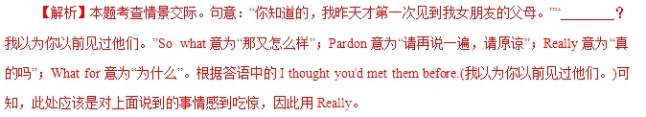
10．(2014·陕西卷)—I got that job I wanted at the public library.
—________！That's good news.(Go ahead, Cheers, Congratulations, Come on)
【答案】Congratulations
【解析】本题考查情景交际。句意：“我得到了那份我想要的在公共图书馆的工作。”“________！那是个好消息。”Go ahead意为“干吧，说吧，做吧”；Cheers意为“(举杯敬酒时的常用语)干杯”；Congratulations意为“祝贺”；Come on意为“(用于命令)快，加油，加把劲；(表示知道某人所说的话不正确)得了吧”。根据That's good news. (那是个好消息。)以及I got that job I wanted at the public library. (我得到了那份我想要的在公共图书馆的工作。)可知，此处应该对其表示祝贺。

